**MICROSOFT QUESTIONS**

Question 1 ( Single Topic )

A company employs a team of customer service agents to provide telephone and email support to customers.  
The company develops a webchat bot to provide automated answers to common customer queries.  
Which business benefit should the company expect as a result of creating the webchat bot solution?

* **A.**increased sales
* **B. a reduced workload for the customer service agents**
* **C.**improved product reliability

2)For a machine learning progress, how should you split data for training and evaluation?

* **A.**Use features for training and labels for evaluation.
* **B. Randomly split the data into rows for training and rows for evaluation.**
* **C.**Use labels for training and features for evaluation.
* **D.**Randomly split the data into columns for training and columns for evaluation.

3)You build a machine learning model by using the automated machine learning user interface (UI).  
You need to ensure that the model meets the Microsoft transparency principle for responsible AI.  
What should you do?

* **A.**Set Validation type to Auto.
* **B. Enable Explain best model.**
* **C.**Set Primary metric to accuracy.
* **D.**Set Max concurrent iterations to 0.

4)HOTSPOT -  
You are developing a model to predict events by using classification.  
You have a confusion matrix for the model scored on test data as shown in the following exhibit.  
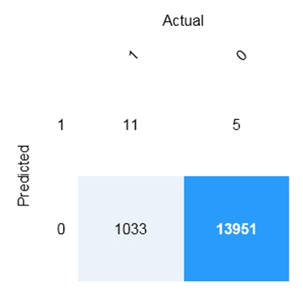  
Use the drop-down menus to select the answer choice that completes each statement based on the information presented in the graphic.  
NOTE: Each correct selection is worth one point.  
Hot Area:

ANS: 5, 11, 1033 , 13951

5)HOTSPOT -  
For each of the following statements, select Yes if the statement is true. Otherwise, select No.  
NOTE: Each correct selection is worth one point.  
Hot Area:  
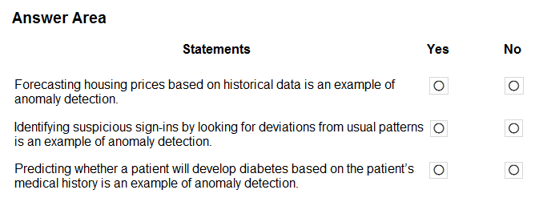

**ANSWER: NO , YES , NO**

6) HOTSPOT -  
To complete the sentence, select the appropriate option in the answer area.  
Hot Area:  
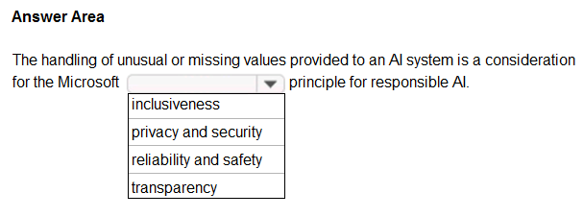

**ANSWER : RELIABILITY and SAFETY**

DRAG DROP -  
Match the types of AI workloads to the appropriate scenarios.  
To answer, drag the appropriate workload type from the column on the left to its scenario on the right. Each workload type may be used once, more than once, or not at all.  
NOTE: Each correct selection is worth one point.  
Select and Place:  
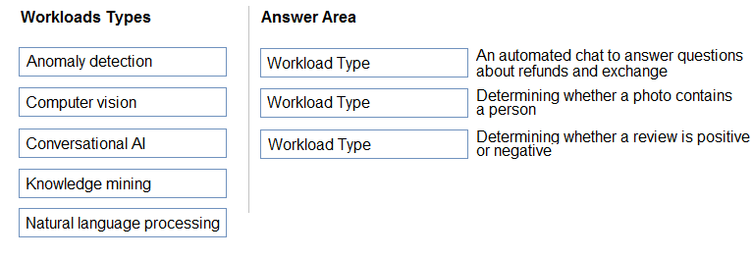

**ANS: 1) Conversational Ai**

**2) Computer Vision**

**3) NLP**

You are designing an AI system that empowers everyone, including people who have hearing, visual, and other impairments.  
This is an example of which Microsoft guiding principle for responsible AI?

* **A.**fairness
* **B. inclusiveness**
* **C.**reliability and safety
* **D.**accountability

DRAG DROP -  
Match the Microsoft guiding principles for responsible AI to the appropriate descriptions.  
To answer, drag the appropriate principle from the column on the left to its description on the right. Each principle may be used once, more than once, or not at all.  
NOTE: Each correct selection is worth one point.  
Select and Place:  
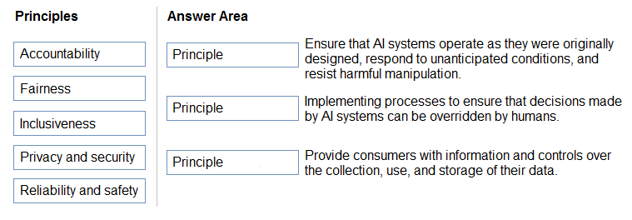

**Answer: 1) reliability and safety**

**2) accountability**

**3) privacy and Safety**

HOTSPOT -  
To complete the sentence, select the appropriate option in the answer area.  
Hot Area:  
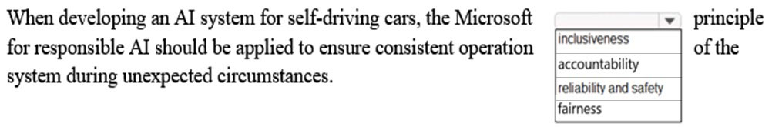

**ANSWER :Reliability and safety**

You are building an AI system.  
Which task should you include to ensure that the service meets the Microsoft transparency principle for responsible AI?

* **A.**Ensure that all visuals have an associated text that can be read by a screen reader.
* **B.**Enable autoscaling to ensure that a service scales based on demand.
* **C. Provide documentation to help developers debug code.**
* **D.**Ensure that a training dataset is representative of the population.
* DRAG DROP -  
  Match the types of AI workloads to the appropriate scenarios.  
  To answer, drag the appropriate workload type from the column on the left to its scenario on the right. Each workload type may be used once, more than once, or not at all.  
  NOTE: Each correct selection is worth one point.  
  Select and Place:  
  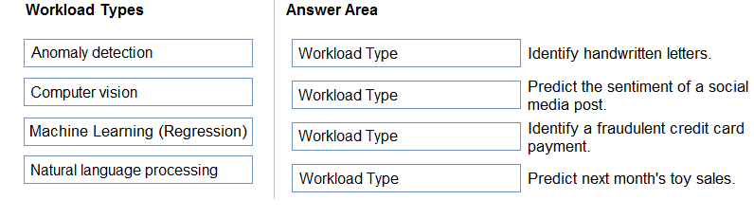

**ANSWER : 1) computer vision**

**2) NLP**

**3) Analomy detection**

**4) Machine learning(regression)**

Your company is exploring the use of voice recognition technologies in its smart home devices. The company wants to identify any barriers that might unintentionally leave out specific user groups.  
This an example of which Microsoft guiding principle for responsible AI?

* **A.**accountability
* **B.**fairness
* **C. inclusiveness**
* **D.**privacy and security

What are three Microsoft guiding principles for responsible AI? Each correct answer presents a complete solution.  
NOTE: Each correct selection is worth one point.

* **A.**knowledgeability
* **B.**decisiveness
* **C. inclusiveness**
* **D. fairness**
* **E.**opinionatedness
* **F. reliability and safety**

HOTSPOT -  
To complete the sentence, select the appropriate option in the answer area.  
Hot Area:  
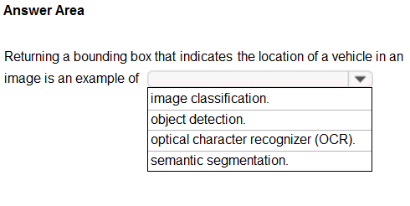

**ANSWER: Object detection**

HOTSPOT -  
To complete the sentence, select the appropriate option in the answer area.  
Hot Area:  
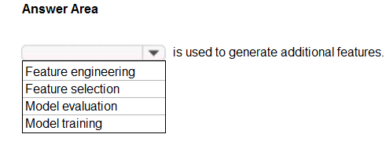

**ANSWER:FEATURE ENGINEERING**

You run a charity event that involves posting photos of people wearing sunglasses on Twitter.  
You need to ensure that you only retweet photos that meet the following requirements:  
✑ Include one or more faces.  
✑ Contain at least one person wearing sunglasses.  
What should you use to analyze the images?

* **A.**the Verify operation in the Face service
* B. the Detect operation in the Face service
* **C.**the Describe Image operation in the Computer Vision service
* **D. the Analyze Image operation in the Computer Vision service**

When you design an AI system to assess whether loans should be approved, the factors used to make the decision should be explainable.  
This is an example of which Microsoft guiding principle for responsible AI?

* **A. transparency**
* **B.**inclusiveness
* **C.**fairness
* **D.**privacy and security
* HOTSPOT -  
  For each of the following statements, select Yes if the statement is true. Otherwise, select No.  
  NOTE: Each correct selection is worth one point.  
  Hot Area:  
  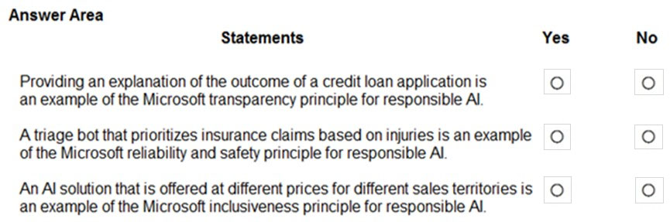

**ANS: YES NO NO**

DRAG DROP -  
Match the principles of responsible AI to appropriate requirements.  
To answer, drag the appropriate principles from the column on the left to its requirement on the right. Each principle may be used once, more than once, or not at all. You may need to drag the split bar between panes or scroll to view content.  
NOTE: Each correct selection is worth one point.  
Select and Place:  
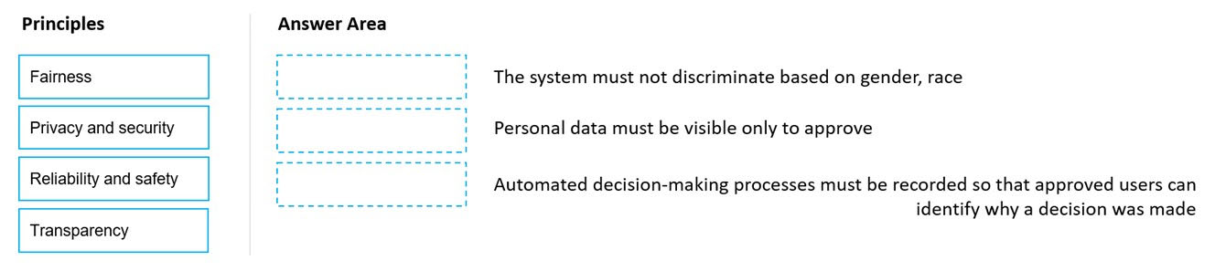

**Ans: fairness , privacy and security , transparency**

DRAG DROP -  
You plan to deploy an Azure Machine Learning model as a service that will be used by client applications.  
Which three processes should you perform in sequence before you deploy the model? To answer, move the appropriate processes from the list of processes to the answer area and arrange them in the correct order.  
Select and Place:  
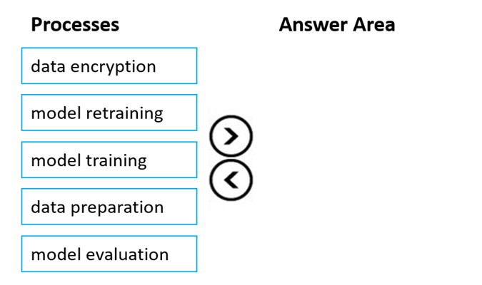

**ANS: Data Preparation , Model training , Model Evaluation**

You are building an AI-based app.  
You need to ensure that the app uses the principles for responsible AI.  
Which two principles should you follow? Each correct answer presents part of the solution.  
NOTE: Each correct selection is worth one point.

* **A.**Implement an Agile software development methodology
* **B. Implement a process of AI model validation as part of the software review process**
* **C. Establish a risk governance committee that includes members of the legal team,** members of the risk management team, and a privacy officer
* **D.**Prevent the disclosure of the use of AI-based algorithms for automated decision making

HOTSPOT -  
To complete the sentence, select the appropriate option in the answer area.  
Hot Area:  
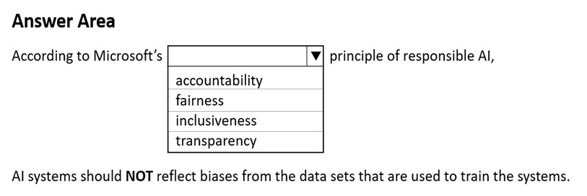

**ANSWER: FAIRNESS**

##### Question 25 ( Single Topic )

DRAG DROP -  
Match the types of AI workloads to the appropriate scenarios.  
To answer, drag the appropriate workload type from the column on the left to its scenario on the right. Each workload type may be used once, more than once, or not at all.  
NOTE: Each correct selection is worth one point.  
Select and Place:  
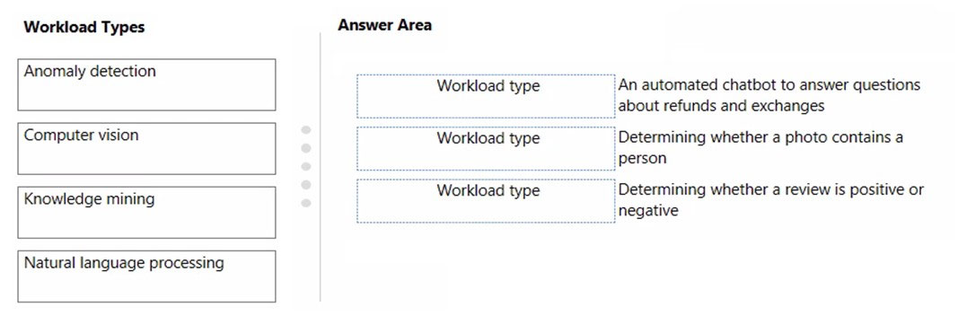

**ANS : Knowledge mining , computer vision , NLP**

DRAG DROP -  
Match the machine learning tasks to the appropriate scenarios.  
To answer, drag the appropriate task from the column on the left to its scenario on the right. Each task may be used once, more than once, or not at all.  
NOTE: Each correct selection is worth one point.  
Select and Place:  
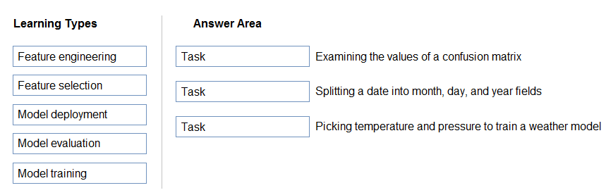

**ANS: model evaluation , feature engineering , frature Selection**

HOTSPOT -  
To complete the sentence, select the appropriate option in the answer area.  
Hot Area:  
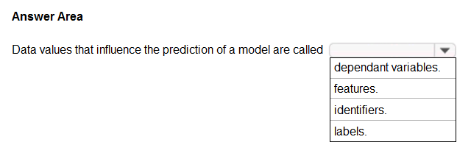

**ANS: features**

You have the Predicted vs. True chart shown in the following exhibit.  
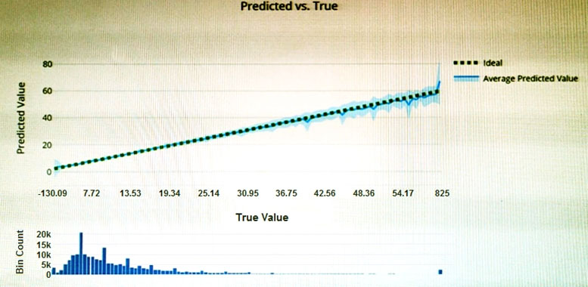  
Which type of model is the chart used to evaluate?

* **A.**classification
* **B. regression**
* **C.**clustering

Which type of machine learning should you use to predict the number of gift cards that will be sold next month?

* **A.**classification
* **B. regression**
* **C.**clustering

You have a dataset that contains information about taxi journeys that occurred during a given period.  
You need to train a model to predict the fare of a taxi journey.  
What should you use as a feature?

* **A.**the number of taxi journeys in the dataset
* **B. the trip distance of individual taxi journeys**
* **C.**the fare of individual taxi journeys
* **D.**the trip ID of individual taxi journeys

You need to predict the sea level in meters for the next 10 years.  
Which type of machine learning should you use?

* **A.**classification
* **B. regression**
* **C.**clustering

HOTSPOT -  
For each of the following statements, select Yes if the statement is true. Otherwise, select No.  
NOTE: Each correct selection is worth one point.  
Hot Area:  
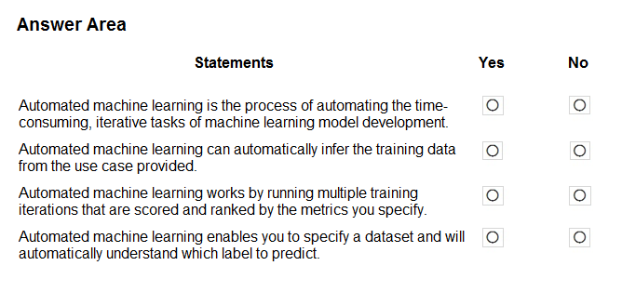

**ANS: Yes no yes no**

HOTSPOT -  
To complete the sentence, select the appropriate option in the answer area.  
Hot Area:  
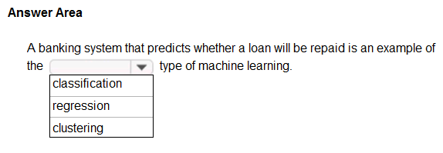

**ANS: classification**

HOTSPOT -  
For each of the following statements, select Yes if the statement is true. Otherwise, select No.  
NOTE: Each correct selection is worth one point.  
Hot Area:

**ANSWER**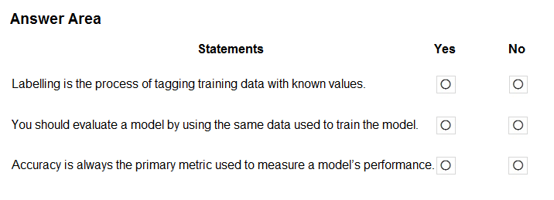

**ANSWER: YES NO NO**

Which service should you use to extract text, key/value pairs, and table data automatically from scanned documents?

* **A. Form Recognizer**
* **B.**Text Analytics
* **C.**Language Understanding
* **D.**Custom Vision

HOTSPOT -  
To complete the sentence, select the appropriate option in the answer area.  
Hot Area:  
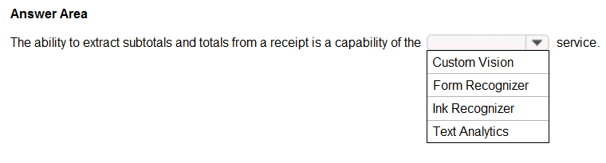

**ANSWER: FORM RECOGNIZER**

You use Azure Machine Learning designer to publish an inference pipeline.  
Which two parameters should you use to access the web service? Each correct answer presents part of the solution.  
NOTE: Each correct selection is worth one point.

* **A.**the model name
* **B.**the training endpoint
* **C. the authentication key**
* **D. the REST endpoint**
* HOTSPOT -  
  To complete the sentence, select the appropriate option in the answer area.  
  Hot Area:  
  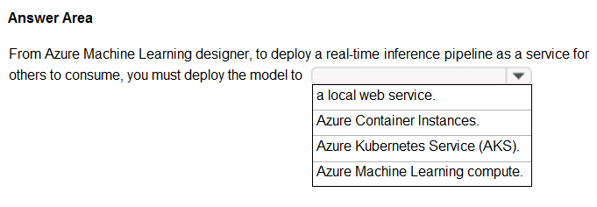
* ANSWER: AKS

HOTSPOT -  
To complete the sentence, select the appropriate option in the answer area.  
Hot Area:  
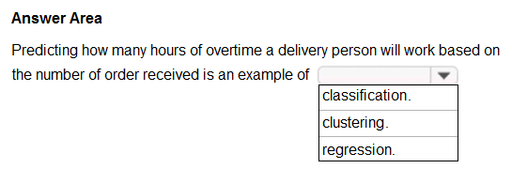

**ANSWER: regression**

HOTSPOT -  
For each of the following statements, select Yes if the statement is true. Otherwise, select No.  
NOTE: Each correct selection is worth one point.  
Hot Area:  
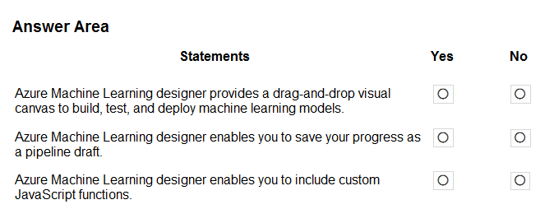

**ANSWER: YES YES NO**

HOTSPOT -  
You have the following dataset.  
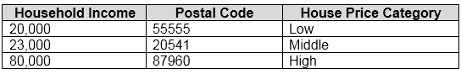  
You plan to use the dataset to train a model that will predict the house price categories of houses.  
What are Household Income and House Price Category? To answer, select the appropriate option in the answer area.  
NOTE: Each correct selection is worth one point.  
Hot Area:  
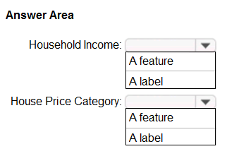

**INCOME- A FEATURE**

**PRICE CATEGORY: A LABEL**

HOTSPOT -  
To complete the sentence, select the appropriate option in the answer area.  
Hot Area:  
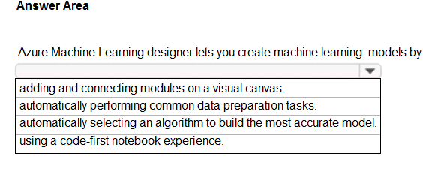

**ANSWER: Adding and connecting … canvas**

HOTSPOT -  
For each of the following statements, select Yes if the statement is true. Otherwise, select No.  
NOTE: Each correct selection is worth one point.  
Hot Area:  
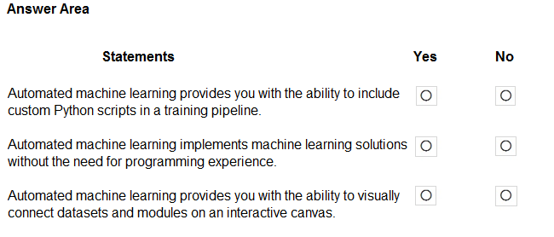

**ANSWER: YES YES YES**

A medical research project uses a large anonymized dataset of brain scan images that are categorized into predefined brain haemorrhage types.  
You need to use machine learning to support early detection of the different brain haemorrhage types in the images before the images are reviewed by a person.  
This is an example of which type of machine learning?

* **A.**clustering
* **B.**regression
* **C. classification**

When training a model, why should you randomly split the rows into separate subsets?

* **A.**to train the model twice to attain better accuracy
* **B.**to train multiple models simultaneously to attain better performance
* **C. to test the model by using data that was not used to train the model**

Which two scenarios are examples of a conversational AI workload? Each correct answer presents a complete solution.  
NOTE: Each correct selection is worth one point.



a smart device in the home that responds to questions such as What will the weather be like today?



a website that uses a knowledge base to interactively respond to users' questions



assembly line machinery that autonomously inserts headlamps into cars



monitoring the temperature of machinery to turn on a fan when the temperature reaches a specific threshold

You need to build an app that will read recipe instructions aloud to support users who have reduced vision.  
Which version service should you use?



Language service



Translator



Speech



Personalizer

**Question: 3**

**[CertyIQ](https://certyiq.com/papers)**

Which type of machine learning should you use to predict the number of gift cards that will be sold next month?



classification



regression



clustering

**Question: 4**

**[CertyIQ](https://certyiq.com/papers)**

You have a dataset that contains information about taxi journeys that occurred during a given period.  
You need to train a model to predict the fare of a taxi journey.  
What should you use as a feature?



the number of taxi journeys in the dataset



the trip distance of individual taxi journeys



the fare of individual taxi journeys



the trip ID of individual taxi journeys

**Question: 5**

**[CertyIQ](https://certyiq.com/papers)**

A medical research project uses a large anonymized dataset of brain scan images that are categorized into predefined brain haemorrhage types.  
You need to use machine learning to support early detection of the different brain haemorrhage types in the images before the images are reviewed by a person.  
This is an example of which type of machine learning?



clustering



regression



classification

**Question: 6**

**[CertyIQ](https://certyiq.com/papers)**

Which metric can you use to evaluate a classification model?



true positive rate



mean absolute error (MAE)



coefficient of determination (R2)



root mean squared error (RMSE)

**Question: 7**

**[CertyIQ](https://certyiq.com/papers)**

Which two actions are performed during the data ingestion and data preparation stage of an Azure Machine Learning process? Each correct answer presents part of the solution.  
NOTE: Each correct selection is worth one point.



Calculate the accuracy of the model.



Score test data by using the model.



Combine multiple datasets.



Use the model for real-time predictions.



Remove records that have missing values.

**Question: 8**

**[CertyIQ](https://certyiq.com/papers)**

You need to develop a mobile app for employees to scan and store their expenses while travelling.  
Which type of computer vision should you use?



semantic segmentation



image classification



object detection



optical character recognition (OCR)

**Question: 9**

**[CertyIQ](https://certyiq.com/papers)**

You need to determine the location of cars in an image so that you can estimate the distance between the cars.  
Which type of computer vision should you use?



optical character recognition (OCR)



object detection



image classification



face detection

**Question: 10**

**[CertyIQ](https://certyiq.com/papers)**

In which two scenarios can you use the Form Recognizer service? Each correct answer presents a complete solution.  
NOTE: Each correct selection is worth one point.



Identify the retailer from a receipt



Translate from French to English



Extract the invoice number from an invoice



Find images of products in a catalog

**Question: 11**

**[CertyIQ](https://certyiq.com/papers)**

In which two scenarios can you use speech recognition? Each correct answer presents a complete solution.  
NOTE: Each correct selection is worth one point.



an in-car system that reads text messages aloud



providing closed captions for recorded or live videos



creating an automated public address system for a train station



creating a transcript of a telephone call or meeting

**Question: 12**

**[CertyIQ](https://certyiq.com/papers)**

You plan to develop a bot that will enable users to query a knowledge base by using natural language processing.  
Which two services should you include in the solution? Each correct answer presents part of the solution.  
NOTE: Each correct selection is worth one point.



QnA Maker



Azure Bot Service



Form Recognizer



Anomaly Detector

**Question: 13**

**[CertyIQ](https://certyiq.com/papers)**

In which two scenarios can you use a speech synthesis solution? Each correct answer presents a complete solution.  
NOTE: Each correct selection is worth one point.



an automated voice that reads back a credit card number entered into a telephone by using a numeric keypad



generating live captions for a news broadcast



extracting key phrases from the audio recording of a meeting



an AI character in a computer game that speaks audibly to a player

**Question: 14**

**[CertyIQ](https://certyiq.com/papers)**

In which scenario should you use key phrase extraction?



identifying whether reviews of a restaurant are positive or negative



generating captions for a video based on the audio track



identifying which documents provide information about the same topics



translating a set of documents from English to German

**Question: 15**

**[CertyIQ](https://certyiq.com/papers)**

You have insurance claim reports that are stored as text.  
You need to extract key terms from the reports to generate summaries.  
Which type of AI workload should you use?



natural language processing



conversational AI



anomaly detection



computer vision

**Question: 16**

**[CertyIQ](https://certyiq.com/papers)**

Which two scenarios are examples of a natural language processing workload? Each correct answer presents a complete solution.  
NOTE: Each correct selection is worth one point.



monitoring the temperature of machinery to turn on a fan when the temperature reaches a specific threshold



a smart device in the home that responds to questions such as, "What will the weather be like today?"



a website that uses a knowledge base to interactively respond to users' questions



assembly line machinery that autonomously inserts headlamps into cars

**Question: 17**

**[CertyIQ](https://certyiq.com/papers)**

You have an AI solution that provides users with the ability to control smart devices by using verbal commands.  
Which two types of natural language processing (NLP) workloads does the solution use? Each correct answer presents part of the solution.  
NOTE: Each correct selection is worth one point.



text-to-speech



key phrase extraction



speech-to-text



language modeling



translation

**Question: 18**

**[CertyIQ](https://certyiq.com/papers)**

You need to build an app that will read recipe instructions aloud to support users who have reduced vision.  
Which version service should you use?



Language service



Translator



Speech



Personalizer

**Question: 19**

**[CertyIQ](https://certyiq.com/papers)**

Which two scenarios are examples of a conversational AI workload? Each correct answer presents a complete solution.  
NOTE: Each correct selection is worth one point.



a smart device in the home that responds to questions such as What will the weather be like today?



a website that uses a knowledge base to interactively respond to users' questions



assembly line machinery that autonomously inserts headlamps into cars



monitoring the temperature of machinery to turn on a fan when the temperature reaches a specific threshold

**Question: 20**

**[CertyIQ](https://certyiq.com/papers)**

You have the process shown in the following exhibit.  
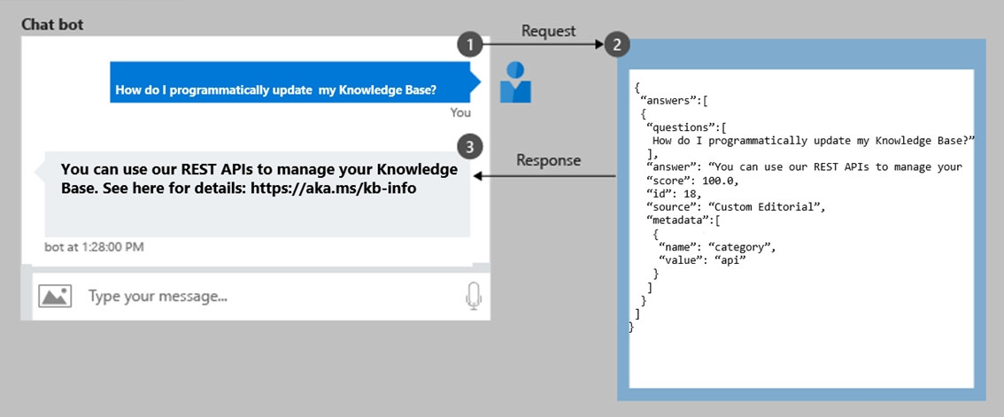  
Which type of AI solution is shown in the diagram?



a sentiment analysis solution



a chatbot



a machine learning model



a computer vision application

**Question: 2**

**[CertyIQ](https://certyiq.com/papers)**

You have the Predicted vs. True chart shown in the following exhibit.  
  
Which type of model is the chart used to evaluate?



classification



regression



clustering

**Question: 1**

**[CertyIQ](https://certyiq.com/papers)**

For a machine learning progress, how should you split data for training and evaluation?



Use features for training and labels for evaluation.



Randomly split the data into rows for training and rows for evaluation.



Use labels for training and features for evaluation.



Randomly split the data into columns for training and columns for evaluation.

**Question: 2**

**[CertyIQ](https://certyiq.com/papers)**

When you design an AI system to assess whether loans should be approved, the factors used to make the decision should be explainable.  
This is an example of which Microsoft guiding principle for responsible AI?



transparency



inclusiveness



fairness



privacy and security

**Question: 3**

**[CertyIQ](https://certyiq.com/papers)**

You have the Predicted vs. True chart shown in the following exhibit.  
  
Which type of model is the chart used to evaluate?



classification



regression



clustering

**Question: 4**

**[CertyIQ](https://certyiq.com/papers)**

Which type of machine learning should you use to predict the number of gift cards that will be sold next month?



classification



regression



clustering

**Question: 5**

**[CertyIQ](https://certyiq.com/papers)**

Which service should you use to extract text, key/value pairs, and table data automatically from scanned documents?



Form Recognizer



Text Analytics



Language Understanding



Custom Vision

**Question: 6**

**[CertyIQ](https://certyiq.com/papers)**

You use Azure Machine Learning designer to publish an inference pipeline.  
Which two parameters should you use to access the web service? Each correct answer presents part of the solution.  
NOTE: Each correct selection is worth one point.



the model name



the training endpoint



the authentication key



the REST endpoint

**Question: 7**

**[CertyIQ](https://certyiq.com/papers)**

You are building a tool that will process images from retail stores and identify the products of competitors.  
The solution will use a custom model.  
Which Azure Cognitive Services service should you use?



Custom Vision



Form Recognizer



Face



Computer Vision

**Question: 8**

**[CertyIQ](https://certyiq.com/papers)**

Which two components can you drag onto a canvas in Azure Machine Learning designer? Each correct answer presents a complete solution.  
NOTE: Each correct selection is worth one point.



dataset



compute



pipeline



module

**Question: 9**

**[CertyIQ](https://certyiq.com/papers)**

Which two actions are performed during the data ingestion and data preparation stage of an Azure Machine Learning process? Each correct answer presents part of the solution.  
NOTE: Each correct selection is worth one point.



Calculate the accuracy of the model.



Score test data by using the model.



Combine multiple datasets.



Use the model for real-time predictions.



Remove records that have missing values.

**Question: 10**

**[CertyIQ](https://certyiq.com/papers)**

You need to determine the location of cars in an image so that you can estimate the distance between the cars.  
Which type of computer vision should you use?



optical character recognition (OCR)



object detection



image classification



face detection

**Question: 11**

**[CertyIQ](https://certyiq.com/papers)**

You send an image to a Computer Vision API and receive back the annotated image shown in the exhibit.  
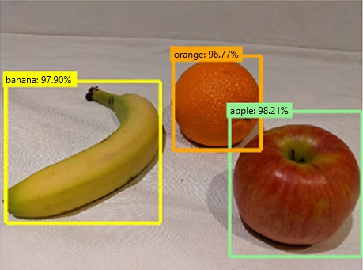  
Which type of computer vision was used?



object detection



face detection



optical character recognition (OCR)



image classification

**Question: 12**

**[CertyIQ](https://certyiq.com/papers)**

What are two tasks that can be performed by using the Computer Vision service? Each correct answer presents a complete solution.  
NOTE: Each correct selection is worth one point.



Train a custom image classification model.



Detect faces in an image.



Recognize handwritten text.



Translate the text in an image between languages.

**Question: 13**

**[CertyIQ](https://certyiq.com/papers)**

In which two scenarios can you use the Form Recognizer service? Each correct answer presents a complete solution.  
NOTE: Each correct selection is worth one point.



Identify the retailer from a receipt



Translate from French to English



Extract the invoice number from an invoice



Find images of products in a catalog

**Question: 14**

**[CertyIQ](https://certyiq.com/papers)**

In which two scenarios can you use speech recognition? Each correct answer presents a complete solution.  
NOTE: Each correct selection is worth one point.



an in-car system that reads text messages aloud



providing closed captions for recorded or live videos



creating an automated public address system for a train station



creating a transcript of a telephone call or meeting

**Question: 15**

**[CertyIQ](https://certyiq.com/papers)**

Your website has a chatbot to assist customers.  
You need to detect when a customer is upset based on what the customer types in the chatbot.  
Which type of AI workload should you use?



anomaly detection



computer vision



regression



natural language processing

**Question: 16**

**[CertyIQ](https://certyiq.com/papers)**

In which two scenarios can you use a speech synthesis solution? Each correct answer presents a complete solution.  
NOTE: Each correct selection is worth one point.



an automated voice that reads back a credit card number entered into a telephone by using a numeric keypad



generating live captions for a news broadcast



extracting key phrases from the audio recording of a meeting



an AI character in a computer game that speaks audibly to a player

**Question: 17**

**[CertyIQ](https://certyiq.com/papers)**

Which two scenarios are examples of a natural language processing workload? Each correct answer presents a complete solution.  
NOTE: Each correct selection is worth one point.



monitoring the temperature of machinery to turn on a fan when the temperature reaches a specific threshold



a smart device in the home that responds to questions such as, "What will the weather be like today?"



a website that uses a knowledge base to interactively respond to users' questions



assembly line machinery that autonomously inserts headlamps into cars

**Question: 18**

**[CertyIQ](https://certyiq.com/papers)**

You have an AI solution that provides users with the ability to control smart devices by using verbal commands.  
Which two types of natural language processing (NLP) workloads does the solution use? Each correct answer presents part of the solution.  
NOTE: Each correct selection is worth one point.



text-to-speech



key phrase extraction



speech-to-text



language modeling



translation

**Question: 19**

**[CertyIQ](https://certyiq.com/papers)**

You need to build an app that will read recipe instructions aloud to support users who have reduced vision.  
Which version service should you use?



Language service



Translator



Speech



Personalizer

**Question: 20**

**[CertyIQ](https://certyiq.com/papers)**

You have the process shown in the following exhibit.  
  
Which type of AI solution is shown in the diagram?



a sentiment analysis solution



a chatbot



a machine learning model



a computer vision application

**Question: 1**

**[CertyIQ](https://certyiq.com/papers)**

For a machine learning progress, how should you split data for training and evaluation?



Use features for training and labels for evaluation.



Randomly split the data into rows for training and rows for evaluation.



Use labels for training and features for evaluation.



Randomly split the data into columns for training and columns for evaluation.

**Question: 2**

**[CertyIQ](https://certyiq.com/papers)**

You are designing an AI system that empowers everyone, including people who have hearing, visual, and other impairments.  
This is an example of which Microsoft guiding principle for responsible AI?



fairness



inclusiveness



reliability and safety



accountability

**Question: 3**

**[CertyIQ](https://certyiq.com/papers)**

You are building an AI system.  
Which task should you include to ensure that the service meets the Microsoft transparency principle for responsible AI?



Ensure that all visuals have an associated text that can be read by a screen reader.



Enable autoscaling to ensure that a service scales based on demand.



Provide documentation to help developers debug code.



Ensure that a training dataset is representative of the population.

**Question: 4**

**[CertyIQ](https://certyiq.com/papers)**

Your company is exploring the use of voice recognition technologies in its smart home devices. The company wants to identify any barriers that might unintentionally leave out specific user groups.  
This an example of which Microsoft guiding principle for responsible AI?



accountability



fairness



inclusiveness



privacy and security

**Question: 5**

**[CertyIQ](https://certyiq.com/papers)**

You run a charity event that involves posting photos of people wearing sunglasses on Twitter.  
You need to ensure that you only retweet photos that meet the following requirements:  
✑ Include one or more faces.  
✑ Contain at least one person wearing sunglasses.  
What should you use to analyze the images?



the Verify operation in the Face service



the Detect operation in the Face service



the Describe Image operation in the Computer Vision service



the Analyze Image operation in the Computer Vision service

**Question: 6**

**[CertyIQ](https://certyiq.com/papers)**

Which type of machine learning should you use to predict the number of gift cards that will be sold next month?



classification



regression



clustering

**Question: 7**

**[CertyIQ](https://certyiq.com/papers)**

You need to predict the sea level in meters for the next 10 years.  
Which type of machine learning should you use?



classification



regression



clustering

**Question: 8**

**[CertyIQ](https://certyiq.com/papers)**

Which service should you use to extract text, key/value pairs, and table data automatically from scanned documents?



Form Recognizer



Text Analytics



Language Understanding



Custom Vision

**Question: 9**

**[CertyIQ](https://certyiq.com/papers)**

You are building a tool that will process images from retail stores and identify the products of competitors.  
The solution will use a custom model.  
Which Azure Cognitive Services service should you use?



Custom Vision



Form Recognizer



Face



Computer Vision

**Question: 10**

**[CertyIQ](https://certyiq.com/papers)**

Which metric can you use to evaluate a classification model?



true positive rate



mean absolute error (MAE)



coefficient of determination (R2)



root mean squared error (RMSE)

**Question: 11**

**[CertyIQ](https://certyiq.com/papers)**

You need to predict the animal population of an area.  
Which Azure Machine Learning type should you use?



regression



clustering



classification

**Question: 12**

**[CertyIQ](https://certyiq.com/papers)**

Your website has a chatbot to assist customers.  
You need to detect when a customer is upset based on what the customer types in the chatbot.  
Which type of AI workload should you use?



anomaly detection



computer vision



regression



natural language processing

**Question: 13**

**[CertyIQ](https://certyiq.com/papers)**

You plan to develop a bot that will enable users to query a knowledge base by using natural language processing.  
Which two services should you include in the solution? Each correct answer presents part of the solution.  
NOTE: Each correct selection is worth one point.



QnA Maker



Azure Bot Service



Form Recognizer



Anomaly Detector

**Question: 14**

**[CertyIQ](https://certyiq.com/papers)**

You have insurance claim reports that are stored as text.  
You need to extract key terms from the reports to generate summaries.  
Which type of AI workload should you use?



natural language processing



conversational AI



anomaly detection



computer vision

**Question: 15**

**[CertyIQ](https://certyiq.com/papers)**

You have an AI solution that provides users with the ability to control smart devices by using verbal commands.  
Which two types of natural language processing (NLP) workloads does the solution use? Each correct answer presents part of the solution.  
NOTE: Each correct selection is worth one point.



text-to-speech



key phrase extraction



speech-to-text



language modeling



translation

**Question: 16**

**[CertyIQ](https://certyiq.com/papers)**

You need to build an app that will read recipe instructions aloud to support users who have reduced vision.  
Which version service should you use?



Language service



Translator



Speech



Personalizer

**Question: 17**

**[CertyIQ](https://certyiq.com/papers)**

Which two scenarios are examples of a conversational AI workload? Each correct answer presents a complete solution.  
NOTE: Each correct selection is worth one point.



a smart device in the home that responds to questions such as What will the weather be like today?



a website that uses a knowledge base to interactively respond to users' questions



assembly line machinery that autonomously inserts headlamps into cars



monitoring the temperature of machinery to turn on a fan when the temperature reaches a specific threshold

**Question: 18**

**[CertyIQ](https://certyiq.com/papers)**

You need to develop a web-based AI solution for a customer support system. Users must be able to interact with a web app that will guide them to the best resource or answer.  
Which service should you use?



Custom Vision



QnA Maker



Translator Text



Face

**Question: 19**

**[CertyIQ](https://certyiq.com/papers)**

You have an Azure Machine Learning pipeline that contains a Split Data module.  
The Split Data module outputs to a Train Model module and a Score Model module.  
What is the function of the Split Data module?



scaling numeric variables so that they are within a consistent numeric range



creating training and validation datasets



diverting records that have missing data



selecting columns that must be included in the model

**Question: 20**

**[CertyIQ](https://certyiq.com/papers)**

Which statement is an example of a Microsoft responsible AI principle?



AI systems must use only publicly available data



AI systems must be transparent and inclusive



AI systems must keep personal details public



AI systems must protect the interests of the company

Your website has a chatbot to assist customers. You need to detect when a customer is upset based on what the customer types in the chatbot. Which type of AI workload should you use? A. anomaly detection B. semantic segmentation C. regression D. natural language processing **Correct Answer: D** Natural language processing (NLP) is used for tasks such as sentiment analysis, topic detection, language detection, key phrase extraction, and document cate

NEW QUESTION 1 - (Exam Topic 1) You run a charity event that involves posting photos of people wearing sunglasses on Twitter. You need to ensure that you only retweet photos that meet the following requirements: Include one or more faces. Contain at least one person wearing sunglasses. What should you use to analyze the images? A. the Verify operation in the Face service B. the Detect operation in the Face service C. the Describe Image operation in the Computer Vision service D. the Analyze Image operation in the Computer Vision service **Answer: B**

Microsoft AI-900 Exam

**Certification Provider: Microsoft**

**Exam: Microsoft Azure AI Fundamentals**

**Duration: 2 Hours**

**Number of questions in the database: 73**

**Exam Version: Feb. 2, 2021**

**Exam Topics:**

**Topic 1: Single Topic**

**Topic 2: More Questions.**

**Question #41**

*Topic 1*

**Your website has a chatbot to assist customers.**

**You need to detect when a customer is upset based on what the customer types in the chatbot. Which type of AI workload should you use?**

1. **anomaly detection**
2. **semantic segmentation**
3. **regression**
4. **natural language processing**

**Correct Answer:** *D*

**Natural language processing (NLP) is used for tasks such as sentiment analysis, topic detection, language detection, key phrase extraction, and document categorization.**

**Sentiment Analysis is the process of determining whether a piece of writing is positive, negative or neutral. Reference:**

**https://docs.microsoft.com/en-us/azure/architecture/data-guide/technology-choices/natural-language-processing**

**Question #42** *Topic 1*

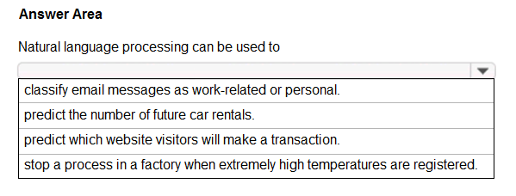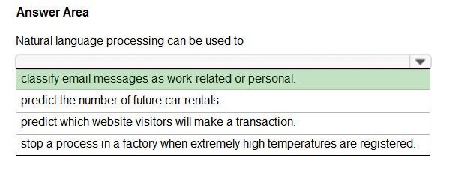

HOTSPOT -

To complete the sentence, select the appropriate option in the answer area. Hot Area:

Correct Answer:

Natural language processing (NLP) is used for tasks such as sentiment analysis, topic detection, language detection, key phrase extraction, and document categorization.

Reference:

https://docs.microsoft.com/en-us/azure/architecture/data-guide/technology-choices/natural-language-processing

**Question #43**

*Topic 1*

**Which AI service can you use to interpret the meaning of a user input such as "Call me back later?"**

1. **Translator Text**
2. **Text Analytics**
3. **Speech**
4. **Language Understanding (LUIS)**

**Correct Answer:** *B*

**Text Analytics is an AI service that uncovers insights such as sentiment, entities, and key phrases in unstructured text. Incorrect Answers:**

**D: Language Understanding (LUIS) is a cloud-based API service, not an AI service, that applies custom machine-learning intelligence to a user's conversational, natural language text to predict overall meaning, and pull out relevant, detailed information.**

**Reference:**

**https://azure.microsoft.com/en-us/services/cognitive-services/text-analytics/ https://docs.microsoft.com/en-us/azure/cognitive- services/luis/what-is-luis**

**Question #44**

*Topic 1*

**You are developing a chatbot solution in Azure.**

**Which service should you use to determine a user's intent?**

1. **Translator Text**
2. **QnA Maker**
3. **Speech**
4. **Language Understanding (LUIS)**

**Correct Answer:** *D*

**Language Understanding (LUIS) is a cloud-based API service that applies custom machine-learning intelligence to a user's conversational, natural language text to predict overall meaning, and pull out relevant, detailed information.**

**Design your LUIS model with categories of user intentions called intents. Each intent needs examples of user utterances. Each utterance can provide data that needs to be extracted with machine-learning entities.**

**Reference:**

**https://docs.microsoft.com/en-us/azure/cognitive-services/luis/what-is-luis**



[**Previous Questions**](https://www.examtopics.com/exams/microsoft/ai-900/view/10/)

[**Next Questions**](https://www.examtopics.com/exams/microsoft/ai-900/view/12/)

**Question #11**

*Topic 2*

**Which scenario is an example of a webchat bot?**

1. **Determine whether reviews entered on a website for a concert are positive or negative, and then add a thumbs up or thumbs down emoji to the reviews.**
2. **Translate into English questions entered by customers at a kiosk so that the appropriate person can call the customers back.**
3. **Accept questions through email, and then route the email messages to the correct person based on the content of the message.**
4. **From a website interface, answer common questions about scheduled events and ticket purchases for a music festival.**

**Correct Answer:** *D*

**Question #1**

*Topic 2*

**You are building an AI system.**

**Which task should you include to ensure that the service meets the Microsoft transparency principle for responsible AI?**

1. **Ensure that all visuals have an associated text that can be read by a screen reader.**
2. **Enable autoscaling to ensure that a service scales based on demand.**
3. **Provide documentation to help developers debug code.**



[**Previous Questions**](https://www.examtopics.com/exams/microsoft/ai-900/view/18/)

**Question #61**

*Topic 1*

**Which AI service should you use to create a bot from a frequently asked questions (FAQ) document?**

1. **QnA Maker**
2. **Language Understanding (LUIS)**
3. **Text Analytics**
4. **Speech**

**Correct Answer:** *A*

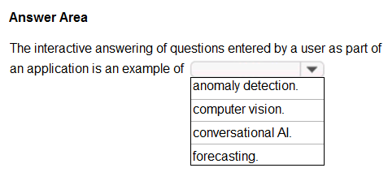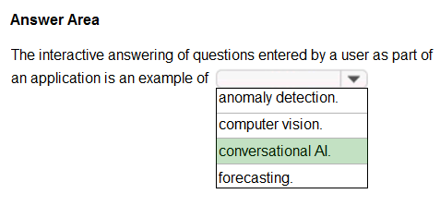

**Question #62**

*Topic 1*

**HOTSPOT -**

**To complete the sentence, select the appropriate option in the answer area. Hot Area:**

**Correct Answer:**

**With Microsoft's Conversational AI tools developers can build, connect, deploy, and manage intelligent bots that naturally interact with their users on a website, app, Cortana, Microsoft Teams, Skype, Facebook Messenger, Slack, and more.**

**Reference:**

**https://azure.microsoft.com/en-in/blog/microsoft-conversational-ai-tools-enable-developers-to-build-connect-and-manage-intelligent-bots**

**Topic 2 - More Questions.**

**D. Ensure that a training dataset is representative of the population.**

**Correct Answer:** *C*

**Reference:**

**https://docs.microsoft.com/en-us/learn/modules/responsible-ai-principles/4-guiding-principles**

**Question #2**

*Topic 2*

**Your company is exploring the use of voice recognition technologies in its smart home devices. The company wants to identify any barriers that might unintentionally leave out specific user groups.**

**This an example of which Microsoft guiding principle for responsible AI?**

1. **accountability**
2. **fairness**
3. **inclusiveness**
4. **privacy and security**

**Correct Answer:** *C*

**Reference:**

**https://docs.microsoft.com/en-us/learn/modules/responsible-ai-principles/4-guiding-principles**



[**Previous Questions**](https://www.examtopics.com/exams/microsoft/ai-900/view/15/)

[**Next Questions**](https://www.examtopics.com/exams/microsoft/ai-900/view/17/)

**Question #7**

*Topic 2*

**You are evaluating whether to use a basic workspace or an enterprise workspace in Azure Machine Learning.**

**What are two tasks that require an enterprise workspace? Each correct answer presents a complete solution. NOTE: Each correct selection is worth one point.**

1. **Use a graphical user interface (GUI) to run automated machine learning experiments.**
2. **Create a compute instance to use as a workstation.**
3. **Use a graphical user interface (GUI) to define and run machine learning experiments from Azure Machine Learning designer.**
4. **Create a dataset from a comma-separated value (CSV) file.**

**Correct Answer:** *AC*

**Note: Enterprise workspaces are no longer available as of September 2020. The basic workspace now has all the functionality of the enterprise workspace.**

**Reference:**

**https:/**[**/www.azure.cn/en-us/pricing/details/machine-learning/**](http://www.azure.cn/en-us/pricing/details/machine-learning/)

**https://docs.microsoft.com/en-us/azure/machine-learning/concept-workspace**



[**Previous Questions**](https://www.examtopics.com/exams/microsoft/ai-900/view/17/)

[**Next Questions**](https://www.examtopics.com/exams/microsoft/ai-900/view/19/)

**Question #57**

*Topic 1*

**You need to reduce the load on telephone operators by implementing a chatbot to answer simple questions with predefined answers. Which two AI service should you use to achieve the goal? Each correct answer presents part of the solution.**

**NOTE: Each correct selection is worth one point.**

**Question #8**

*Topic 2*

**In which two scenarios can you use the Form Recognizer service? Each correct answer presents a complete solution.**

**NOTE: Each correct selection is worth one point.**

1. **Extract the invoice number from an invoice.**
2. **Translate a form from French to English.**
3. **Find image of product in a catalog.**
4. **Identity the retailer from a receipt.**

**Correct Answer:** *AD*

**Reference:**

**https://azure.microsoft.com/en-gb/services/cognitive-services/form-recognizer/#features**

**Question #9**

*Topic 2*

**In which two scenarios can you use speech recognition? Each correct answer presents a complete solution.**

**NOTE: Each correct selection is worth one point.**

1. **an in-car system that reads text messages aloud**
2. **providing closed captions for recorded or live videos**
3. **creating an automated public address system for a train station**
4. **creating a transcript of a telephone call or meeting**

**Correct Answer:** *BD*

**Reference:**

**https://azure.microsoft.com/en-gb/services/cognitive-services/speech-to-text/#features**

**Question #10**

*Topic 2*

**You need to build an app that will read recipe instructions aloud to support users who have reduced vision.**

**Which version service should you use?**

1. **Text Analytics**
2. **Translator Text**
3. **Speech**
4. **Language Understanding (LUIS)**

**Correct Answer:** *C*

**Reference:**

**https://azure.microsoft.com/en-us/services/cognitive-services/text-to-speech/#features**

1. **Text Analytics**
2. **QnA Maker**
3. **Azure Bot Service**
4. **Translator Text**

**Correct Answer:** *BC*

**Bots are a popular way to provide support through multiple communication channels. You can use the QnA Maker service and Azure Bot Service to create a bot that answers user questions.**

**Reference:**

**https://docs.microsoft.com/en-us/learn/modules/build-faq-chatbot-qna-maker-azure-bot-service/**

**Question #58**

*Topic 1*

**Which two scenarios are examples of a conversational AI workload? Each correct answer presents a complete solution.**

**NOTE: Each correct selection is worth one point.**

1. **a smart device in the home that responds to questions such as "What will the weather be like today?"**
2. **a website that uses a knowledge base to interactively respond to users' questions**
3. **assembly line machinery that autonomously inserts headlamps into cars**
4. **monitoring the temperature of machinery to turn on a fan when the temperature reaches a specific threshold**

**Correct Answer:** *AB*

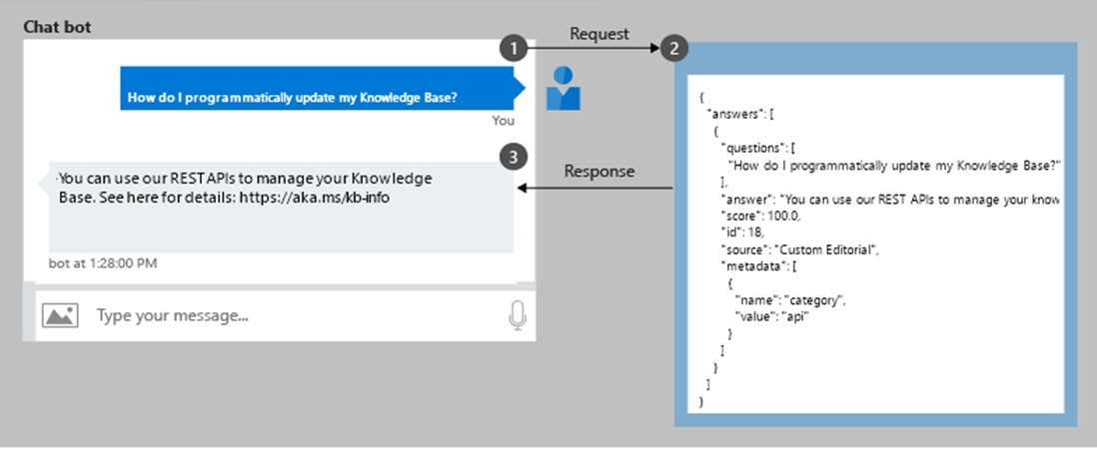

**Question #59**

*Topic 1*

**You have the process shown in the following exhibit.**

**Which type AI solution is shown in the diagram?**

1. **a sentiment analysis solution**
2. **a chatbot**
3. **a machine learning model**
4. **a computer vision application**

**Correct Answer:** *B*

**Question #60** *Topic 1*

You need to develop a web-based AI solution for a customer support system. Users must be able to interact with a web app that will guide them to the best resource or answer.

Which service should you use?

1. **Custom Vision**
2. **QnA Maker**
3. **Translator Text**
4. **Face**

Correct Answer: *B*

QnA Maker is a cloud-based API service that lets you create a conversational question-and-answer layer over your existing data. Use it to build a knowledge base by extracting questions and answers from your semi-structured content, including FAQs, manuals, and documents. Answer

users' questions with the best answers from the QnAs in your knowledge base""automatically. Your knowledge base gets smarter, too, as it continually learns from user behavior.

Incorrect Answers:

A: Azure Custom Vision is a cognitive service that lets you build, deploy, and improve your own image classifiers. An image classifier is an AI service that applies labels (which represent classes) to images, according to their visual characteristics. Unlike the Computer Vision service, Custom Vision allows you to specify the labels to apply.

D: Azure Cognitive Services Face Detection API: At a minimum, each detected face corresponds to a faceRectangle field in the response. This set of pixel coordinates for the left, top, width, and height mark the located face. Using these coordinates, you can get the location of the face and its size. In the API response, faces are listed in size order from largest to smallest.

Reference:

https://azure.microsoft.com/en-us/services/cognitive-services/qna-maker/



[**Previous Questions**](https://www.examtopics.com/exams/microsoft/ai-900/view/14/)

[**Next Questions**](https://www.examtopics.com/exams/microsoft/ai-900/view/16/)

**Question #53**

*Topic 1*

**Which two scenarios are examples of a conversational AI workload? Each correct answer presents a complete solution.**

**NOTE: Each correct selection is worth one point.**

1. **a telephone answering service that has a pre-recorder message**
2. **a chatbot that provides users with the ability to find answers on a website by themselves**
3. **telephone voice menus to reduce the load on human resources**
4. **a service that creates frequently asked questions (FAQ) documents by crawling public websites**

**Correct Answer:** *BC*

**B: A bot is an automated software program designed to perform a particular task. Think of it as a robot without a body.**

**C: Automated customer interaction is essential to a business of any size. In fact, 61% of consumers prefer to communicate via speech, and**

**most of them prefer self-service. Because customer satisfaction is a priority for all businesses, self-service is a critical facet of any customer- facing communications strategy.**

**Incorrect Answers:**

**D: Early bots were comparatively simple, handling repetitive and voluminous tasks with relatively straightforward algorithmic logic. An example would be web crawlers used by search engines to automatically explore and catalog web content.**

**Reference:**

**https://docs.microsoft.com/en-us/azure/architecture/data-guide/big-data/ai-overview https://docs.microsoft.com/en- us/azure/architecture/solution-ideas/articles/interactive-voice-response-bot**

**Question #54** *Topic 1*

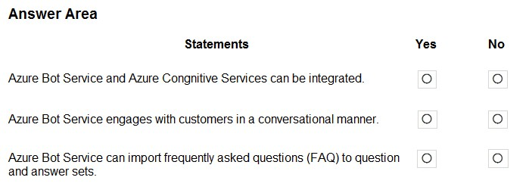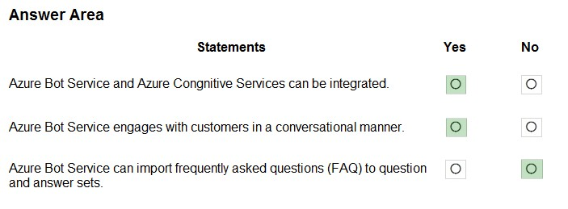

HOTSPOT -

For each of the following statements, select Yes if the statement is true. Otherwise, select No. NOTE: Each correct selection is worth one point.

Hot Area:

Correct Answer:

Box 1: Yes -

Azure bot service can be integrated with the powerful AI capabilities with Azure Cognitive Services.

Box 2: Yes -

Azure bot service engages with customers in a conversational manner.

Box 3: No -

The QnA Maker service creates knowledge base, not question and answers sets.

Note: You can use the QnA Maker service and a knowledge base to add question-and-answer support to your bot. When you create your knowledge base, you seed it with questions and answers.

Reference:

https://docs.microsoft.com/en-us/azure/bot-service/bot-builder-tutorial-add-qna

/

**Question #55**

*Topic 1*

**You need to provide content for a business chatbot that will help answer simple user queries**



[**Previous Questions**](https://www.examtopics.com/exams/microsoft/ai-900/view/13/)

[**Next Questions**](https://www.examtopics.com/exams/microsoft/ai-900/view/15/)

**Question #49**

*Topic 1*

**You are developing a natural language processing solution in Azure. The solution will analyze customer reviews and determine how positive or negative each review is.**

**This is an example of which type of natural language processing workload?**

1. **language detection**
2. **sentiment analysis**
3. **key phrase extraction**
4. **entity recognition**

**Correct Answer:** *B*

**Sentiment Analysis is the process of determining whether a piece of writing is positive, negative or neutral. Reference:**

**https://docs.microsoft.com/en-us/azure/architecture/data-guide/technology-choices/natural-language-processing**

**What are three ways to create question and answer text by using QnA Maker? Each correct answer presents a complete solution.**

**NOTE: Each correct selection is worth one point.**

1. **Generate the questions and answers from an existing webpage.**
2. **Use automated machine learning to train a model based on a file that contains the questions.**
3. **Manually enter the questions and answers.**
4. **Connect the bot to the Cortana channel and ask questions by using Cortana.**
5. **Import chit-chat content from a predefined data source.**

**Correct Answer:** *ACE*

**Automatic extraction -**

**Extract question-answer pairs from semi-structured content, including FAQ pages, support websites, excel files, SharePoint documents, product manuals and policies.**

**Reference:**

**https://docs.microsoft.com/en-us/azure/cognitive-services/qnamaker/concepts/content-types**

**Question #56**

*Topic 1*

**You have a frequently asked questions (FAQ) PDF file.**

**You need to create a conversational support system based on the FAQ. Which service should you use?**

1. **QnA Maker**
2. **Text Analytics**
3. **Computer Vision**
4. **Language Understanding (LUIS)**

**Correct Answer:** *A*

**QnA Maker is a cloud-based API service that lets you create a conversational question-and-answer layer over your existing data. Use it to build a knowledge base by extracting questions and answers from your semi-structured content, including FAQs, manuals, and documents.**

**Reference:**

**https://azure.microsoft.com/en-us/services/cognitive-services/qna-maker/**

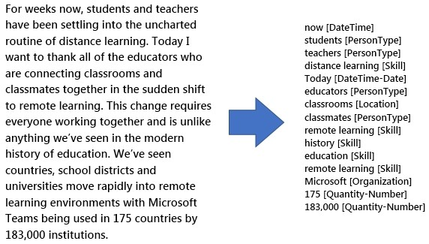

**Question #50**

*Topic 1*

**You use natural language processing to process text from a Microsoft news story.**

**You receive the output shown in the following exhibit.**

**Which type of natural languages processing was performed?**

1. **entity recognition**
2. **key phrase extraction**
3. **sentiment analysis**
4. **translation**

**Correct Answer:** *B*

**Key phrase extraction/ Broad entity extraction: Identify important concepts in text, including key phrases and named entities such as people, places, and organizations.**

**Reference:**

**https://azure.microsoft.com/en-us/services/cognitive-services/text-analytics**

**Question #52**

*Topic 1*

DRAG DROP -

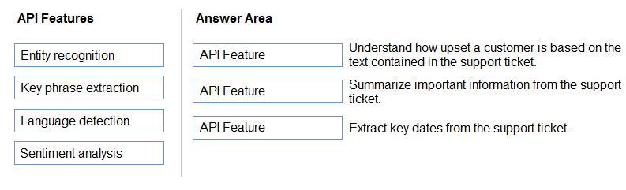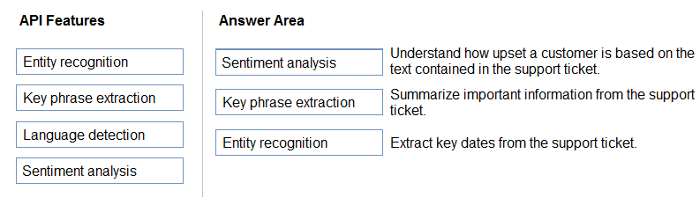

You plan to apply Text Analytics API features to a technical support ticketing system.

Match the Text Analytics API features to the appropriate natural language processing scenarios.

To answer, drag the appropriate feature from the column on the left to its scenario on the right. Each feature may be used once, more than once, or not at all.

NOTE: Each correct selection is worth one point. Select and Place:

Correct Answer:

Box1: Sentiment analysis -

Sentiment Analysis is the process of determining whether a piece of writing is positive, negative or neutral.

Box 2: Broad entity extraction -

Broad entity extraction: Identify important concepts in text, including key

Key phrase extraction/ Broad entity extraction: Identify important concepts in text, including key phrases and named entities such as people, places, and organizations.

Box 3: Entity Recognition -

Named Entity Recognition: Identify and categorize entities in your text as people, places, organizations, date/time, quantities, percentages, currencies, and more.

Well-known entities are also recognized and linked to more information on the web. Reference:

https://docs.microsoft.com/en-us/azure/architecture/data-guide/technology-choices/natural-language-processing https://azure.microsoft.com/en-us/services/cognitive-services/text-analytics

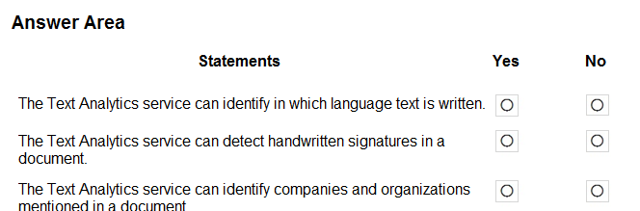

**Question #46**

*Topic 1*

**HOTSPOT -**

**For each of the following statements, select Yes if the statement is true. Otherwise, select No. NOTE: Each correct selection is worth one point.**

**Hot Area:**

**You are developing a solution that uses the Text Analytics service.**

**You need to identify the main talking points in a collection of documents. Which type of natural language processing should you use?**

1. **entity recognition**
2. **key phrase extraction**
3. **sentiment analysis**
4. **language detection**

**Correct Answer:** *B*

**Broad entity extraction: Identify important concepts in text, including key**

**Key phrase extraction/ Broad entity extraction: Identify important concepts in text, including key phrases and named entities such as people, places, and organizations.**

**Reference:**

**https://docs.microsoft.com/en-us/azure/architecture/data-guide/technology-choices/natural-language-processing**



[**Previous Questions**](https://www.examtopics.com/exams/microsoft/ai-900/view/12/)

[**Next Questions**](https://www.examtopics.com/exams/microsoft/ai-900/view/14/)

**Question #45**

*Topic 1*

**You need to make the press releases of your company available in a range of languages.**

**Which service should you use?**

1. **Translator Text**
2. **Text Analytics**
3. **Speech**
4. **Language Understanding (LUIS)**

**Correct Answer:** *A*

**Translator is a cloud-based machine translation service you can use to translate text in near real-time through a simple REST API call. The service uses modern neural machine translation technology and offers statistical machine translation technology. Custom Translator is an**

**extension of Translator, which allows you to build neural translation systems. Reference:**

**https://docs.microsoft.com/en-us/azure/cognitive-services/translator/**

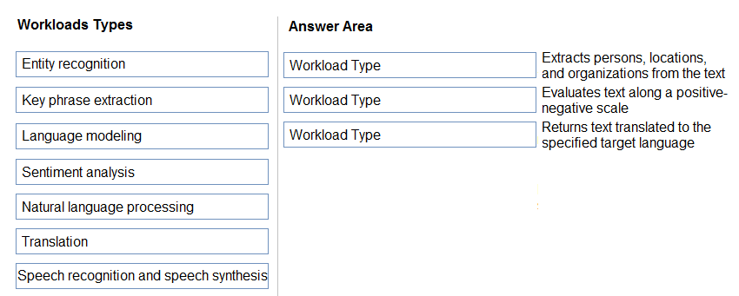

**Question #47**

*Topic 1*

**DRAG DROP -**

**Match the types of natural languages processing workloads to the appropriate scenarios.**

**To answer, drag the appropriate workload type from the column on the left to its scenario on the right. Each workload type may be used once, more than once, or not at all.**

**NOTE: Each correct selection is worth one point.**

**Select and Place:**

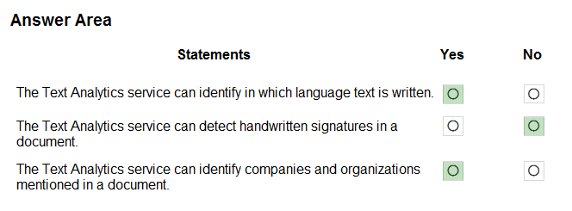

**Correct Answer:**

**The Text Analytics API is a cloud-based service that provides advanced natural language processing over raw text, and includes four main**

**functions: sentiment analysis, key phrase extraction, named entity recognition, and language detection.**

**Box 1: Yes -**

**You can detect which language the input text is written in and report a single language code for every document submitted on the request in a wide range of languages, variants, dialects, and some regional/cultural languages. The language code is paired with a score indicating the**

**strength of the score.**

**Box 2: No -**

**Box 3: Yes -**

**Named Entity Recognition: Identify and categorize entities in your text as people, places, organizations, date/time, quantities, percentages, currencies, and more.**

**Well-known entities are also recognized and linked to more information on the web. Reference:**

**https://docs.microsoft.com/en-us/azure/cognitive-services/text-analytics/overview**

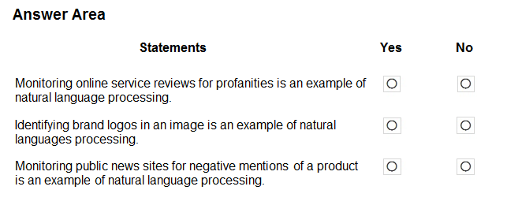

**Question #48**

*Topic 1*

**HOTSPOT -**

**For each of the following statements, select Yes if the statement is true. Otherwise, select No. NOTE: Each correct selection is worth one point.**

**Hot Area:**

Correct Answer:

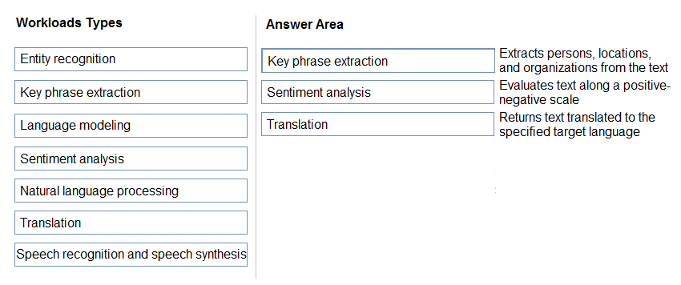

Box 1: Key phrase extraction -

Broad entity extraction: Identify important concepts in text, including key phrases and named entities such as people, places, and organizations.

Box 2: Sentiment analysis -

Sentiment Analysis is the process of determining whether a piece of writing is positive, negative or neutral.

Box 3: Translation -

Using Microsoft's Translator text API

This versatile API from Microsoft can be used for the following:

Translate text from one language to another. Transliterate text from one script to another. Detecting language of the input text.

Find alternate translations to specific text. Determine the sentence length.

Incorrect Answers:

Not Natural language processing (NLP), which is used for tasks such as sentiment analysis, topic detection, language detection, key phrase extraction, and document categorization.

Reference:

https://azure.microsoft.com/en-us/services/cognitive-services/text-analytics

**Question #38**

*Topic 1*

**What is a use case for classification?**

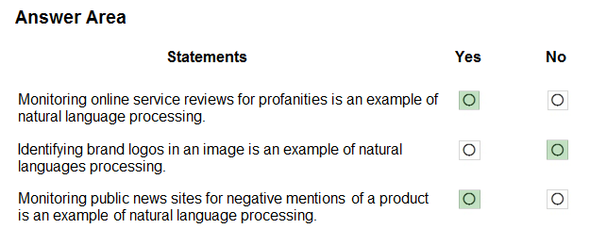

**Correct Answer:**

**Box 1: Yes -**

**Content Moderator is part of Microsoft Cognitive Services allowing businesses to use machine assisted moderation of text, images, and videos that augment human review.**

**The text moderation capability now includes a new machine-learning based text classification feature which uses a trained model to identify**

**possible abusive, derogatory or discriminatory language such as slang, abbreviated words, offensive, and intentionally misspelled words for review.**

**Box 2: No -**

**Azure's Computer Vision service gives you access to advanced algorithms that process images and return information based on the visual features you're interested in. For example, Computer Vision can determine whether an image contains adult content, find specific brands or objects, or find human faces.**

**Box 3: Yes -**

**Natural language processing (NLP) is used for tasks such as sentiment analysis, topic detection, language detection, key phrase extraction, and document categorization.**

**Sentiment Analysis is the process of determining whether a piece of writing is positive, negative or neutral. Reference:**

**https://azure.microsoft.com/es-es/blog/machine-assisted-text-classification-on-content-moderator-public-preview/**

**https://docs.microsoft.com/en-us/azure/architecture/data-guide/technology-choices/natural-language-processing**



[**Previous Questions**](https://www.examtopics.com/exams/microsoft/ai-900/view/11/)

[**Next Questions**](https://www.examtopics.com/exams/microsoft/ai-900/view/13/)

**Question #37**

*Topic 1*

**What are two tasks that can be performed by using the Computer Vision service? Each correct answer presents a complete solution.**

**NOTE: Each correct selection is worth one point.**

1. **Train a custom image classification model.**
2. **Detect faces in an image.**
3. **Recognize handwritten text.**
4. **Translate the text in an image between languages.**

**Correct Answer:** *BC*

**B: Azure's Computer Vision service provides developers with access to advanced algorithms that process images and return information based on the visual features you're interested in. For example, Computer Vision can determine whether an image contains adult content, find specific brands or objects, or find human faces.**

**C: Computer Vision includes Optical Character Recognition (OCR) capabilities. You can use the new Read API to extract printed and handwritten**

**text from images and documents. Reference:**

**https://docs.microsoft.com/en-us/azure/cognitive-services/computer-vision/home**

1. **predicting how many cups of coffee a person will drink based on how many hours the person slept the previous night.**
2. **analyzing the contents of images and grouping images that have similar colors**
3. **predicting whether someone uses a bicycle to travel to work based on the distance from home to work**
4. **predicting how many minutes it will take someone to run a race based on past race times**

**Correct Answer:** *B*

**Classification is a machine learning method that uses data to determine the category, type, or class of an item or row of data. Reference:**

**https://docs.microsoft.com/en-us/azure/machine-learning/algorithm-module-reference/linear-regression https://docs.microsoft.com/en-**

**us/azure/machine-learning/studio-module-reference/machine-learning-initialize-model-clustering**

**Question #39** *Topic 1*

What are two tasks that can be performed by using computer vision? Each correct answer presents a complete solution. NOTE: Each correct selection is worth one point.

1. **Predict stock prices.**
2. **Detect brands in an image.**
3. **Detect the color scheme in an image**
4. **Translate text between languages.**
5. **Extract key phrases.**

Correct Answer: *BE*

B: Azure's Computer Vision service gives you access to advanced algorithms that process images and return information based on the visual features you're interested in. For example, Computer Vision can determine whether an image contains adult content, find specific brands or

objects, or find human faces.

E: Computer Vision includes Optical Character Recognition (OCR) capabilities. You can use the new Read API to extract printed and handwritten text from images and documents. It uses the latest models and works with text on a variety of surfaces and backgrounds. These include

receipts, posters, business cards, letters, and whiteboards. The two OCR APIs support extracting printed text in several languages. Reference:

https://docs.microsoft.com/en-us/azure/cognitive-services/computer-vision/overview

/

**Question #40**

*Topic 1*

**Your company wants to build a recycling machine for bottles. The recycling machine must automatically identify bottles of the correct shape and reject all other items.**

**Which type of AI workload should the company use?**

1. **anomaly detection**
2. **conversational AI**
3. **computer vision**

**D. natural language processing**

**Correct Answer:** *C*

**Azure's Computer Vision service gives you access to advanced algorithms that process images and return information based on the visual features you're interested in. For example, Computer Vision can determine whether an image contains adult content, find specific brands or objects, or find human faces.**

**Reference:**

**https://docs.microsoft.com/en-us/azure/cognitive-services/computer-vision/overview**

[Previous Questions](https://www.examtopics.com/exams/microsoft/ai-900/view/9/) [Next Questions](https://www.examtopics.com/exams/microsoft/ai-900/view/11/)

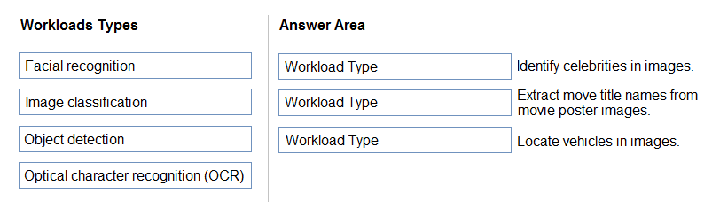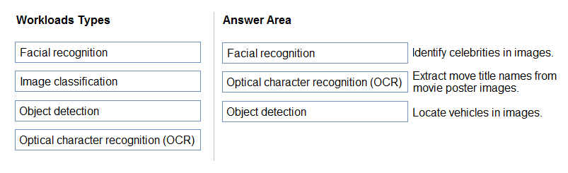

**Question #33** *Topic 1*

DRAG DROP -

Match the types of computer vision to the appropriate scenarios.

To answer, drag the appropriate workload type from the column on the left to its scenario on the right. Each workload type may be used once, more than once, or not at all.

NOTE: Each correct selection is worth one point. Select and Place:

Correct Answer:

Box 1: Facial recognition -

Face detection that perceives faces and attributes in an image; person identification that matches an individual in your private repository of up to 1 million people; perceived emotion recognition that detects a range of facial expressions like happiness, contempt, neutrality, and fear; and recognition and grouping of similar faces in images.

Box 2: OCR - /

**Box 3: Objection detection -**

**Object detection is similar to tagging, but the API returns the bounding box coordinates (in pixels) for each object found. For example, if an**

**image contains a dog, cat and person, the Detect operation will list those objects together with their coordinates in the image. You can use this functionality to process the relationships between the objects in an image. It also lets you determine whether there are multiple instances of**

**the same tag in an image.**

**The Detect API applies tags based on the objects or living things identified in the image. There is currently no formal relationship between the tagging taxonomy and the object detection taxonomy. At a conceptual level, the Detect API only finds objects and living things, while the Tag API can also include contextual terms like "indoor", which can't be localized with bounding boxes.**

**Reference:**

**https://azure.microsoft.com/en-us/services/cognitive-services/face/ https://docs.microsoft.com/en-us/azure/cognitive-services/computer- vision/concept-object-detection**

**Question #34** *Topic 1*

You need to determine the location of cars in an image so that you can estimate the distance between the cars. Which type of computer vision should you use?

1. **optical character recognition (OCR)**
2. **object detection**
3. **image classification**
4. **face detection**

Correct Answer: *B*

Object detection is similar to tagging, but the API returns the bounding box coordinates (in pixels) for each object found. For example, if an

image contains a dog, cat and person, the Detect operation will list those objects together with their coordinates in the image. You can use this functionality to process the relationships between the objects in an image. It also lets you determine whether there are multiple instances of

the same tag in an image.

The Detect API applies tags based on the objects or living things identified in the image. There is currently no formal relationship between the tagging taxonomy and the object detection taxonomy. At a conceptual level, the Detect API only finds objects and living things, while the Tag API can also include contextual terms like "indoor", which can't be localized with bounding boxes.

Reference:

https://docs.microsoft.com/en-us/azure/cognitive-services/computer-vision/concept-object-detection

/

/

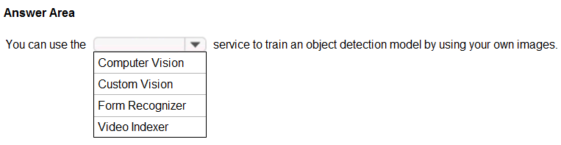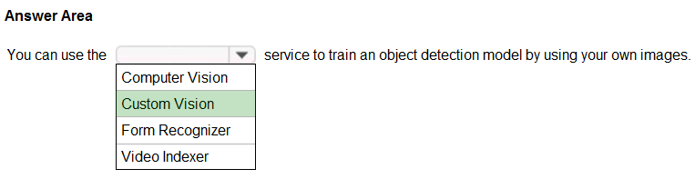

**Question #35**

*Topic 1*

**HOTSPOT -**

**To complete the sentence, select the appropriate option in the answer area. Hot Area:**

**Correct Answer:**

**Azure Custom Vision is a cognitive service that lets you build, deploy, and improve your own image classifiers. An image classifier is an AI**

**service that applies labels (which represent classes) to images, according to their visual characteristics. Unlike the Computer Vision service, Custom Vision allows you to specify the labels to apply.**

**Note: The Custom Vision service uses a machine learning algorithm to apply labels to images. You, the developer, must submit groups of**

**images that feature and lack the characteristics in question. You label the images yourself at the time of submission. Then the algorithm trains to this data and calculates its own accuracy by testing itself on those same images. Once the algorithm is trained, you can test, retrain, and eventually use it to classify new images according to the needs of your app. You can also export the model itself for offline use.**

**Incorrect Answers:**

**Computer Vision:**

**Azure's Computer Vision service provides developers with access to advanced algorithms that process images and return information based on the visual features you're interested in. For example, Computer Vision can determine whether an image contains adult content, find specific**

**brands or objects, or find human faces. Reference:**

**https://docs.microsoft.com/en-us/azure/cognitive-services/custom-vision-service/home**

/

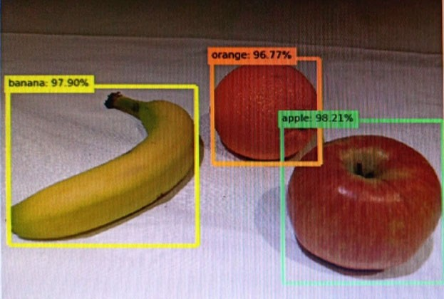

**Question #36**

*Topic 1*

**You send an image to a Computer Vision API and receive back the annotated image shown in the exhibit.**

**Which type of computer vision was used?**

1. **object detection**
2. **semantic segmentation**
3. **optical character recognition (OCR)**
4. **image classification**

**Correct Answer:** *A*

**Object detection is similar to tagging, but the API returns the bounding box coordinates (in pixels) for each object found. For example, if an**

**image contains a dog, cat and person, the Detect operation will list those objects together with their coordinates in the image. You can use this**

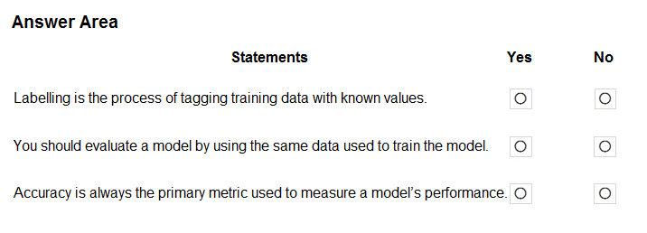

**Question #30**

*Topic 1*

**HOTSPOT -**

**For each of the following statements, select Yes if the statement is true. Otherwise, select No. NOTE: Each correct selection is worth one point.**

**Hot Area:**

**functionality to process the relationships between the objects in an image. It also lets you determine whether there are multiple instances of the same tag in an image.**

**The Detect API applies tags based on the objects or living things identified in the image. There is currently no formal relationship between the tagging taxonomy and the object detection taxonomy. At a conceptual level, the Detect API only finds objects and living things, while the Tag API can also include contextual terms like "indoor", which can't be localized with bounding boxes.**

**Reference:**

**https://docs.microsoft.com/en-us/azure/cognitive-services/computer-vision/concept-object-detection**

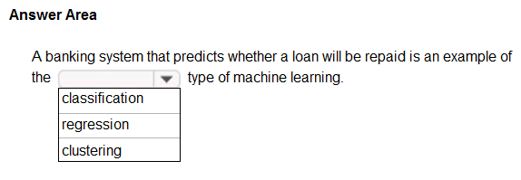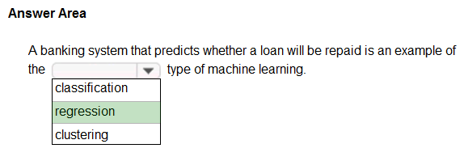

[**Previous Questions**](https://www.examtopics.com/exams/microsoft/ai-900/view/8/)

[**Next Questions**](https://www.examtopics.com/exams/microsoft/ai-900/view/10/)

**Question #29**

*Topic 1*

**HOTSPOT -**

**To complete the sentence, select the appropriate option in the answer area. Hot Area:**

**Correct Answer:**

**In the most basic sense, regression refers to prediction of a numeric target.**

**Example: Regression Model: A Boosted Decision Tree algorithm was used to create and train the model for predicting the repayment rate. Reference:**

**https://gallery.azure.ai/Experiment/Student-Loan-Repayment-Rate-Prediction**

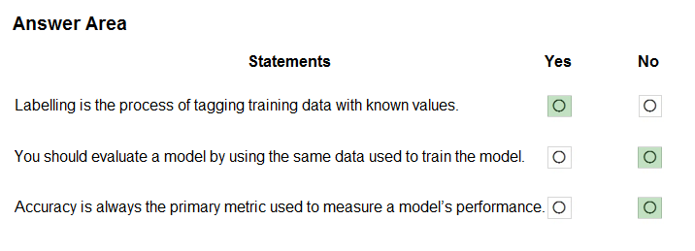

**Correct Answer:**

**Box 1: Yes -**

**In machine learning, if you have labeled data, that means your data is marked up, or annotated, to show the target, which is the answer you want your machine learning model to predict.**

**In general, data labeling can refer to tasks that include data tagging, annotation, classification, moderation, transcription, or processing.**

**Box 2: No -**

**Box 3: No -**

**Accuracy is simply the proportion of correctly classified instances. It is usually the first metric you look at when evaluating a classifier. However, when the test data is unbalanced (where most of the instances belong to one of the classes), or you are more interested in the performance on either one of the classes, accuracy doesn't really capture the effectiveness of a classifier.**

**Reference:**

**https:/**[**/www.cloudfactor**](http://www.cloudfactory.com/data-labeling-guide)**y**[**.com/data-labeling-guide**](http://www.cloudfactory.com/data-labeling-guide)

**https://docs.microsoft.com/en-us/azure/machine-learning/studio/evaluate-model-performance**

**Question #31**

*Topic 1*

**You need to develop a mobile app for employees to scan and store their expenses while travelling.**

**Which type of computer vision should you use?**

1. **semantic segmentation**
2. **image classification**
3. **object detection**
4. **optical character recognition (OCR)**

**Correct Answer:** *D*

**Azure's Computer Vision API includes Optical Character Recognition (OCR) capabilities that extract printed or handwritten text from images. You can extract text from images, such as photos of license plates or containers with serial numbers, as well as from documents - invoices, bills, financial reports, articles, and more.**

**Reference:**

**https://docs.microsoft.com/en-us/azure/cognitive-services/computer-vision/concept-recognizing-text**

/

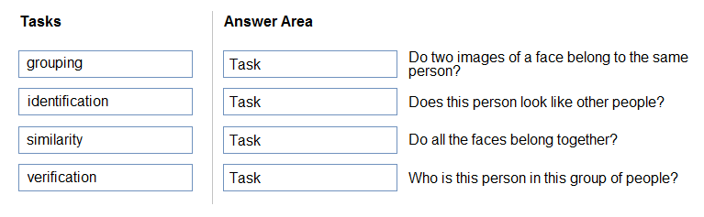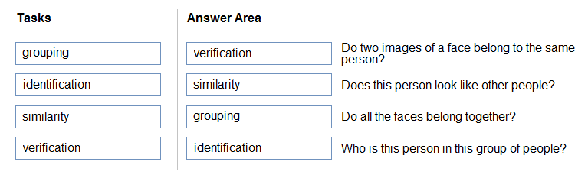

**Question #32**

*Topic 1*

**DRAG DROP -**

**Match the facial recognition tasks to the appropriate questions.**

**To answer, drag the appropriate task from the column on the left to its question on the right. Each task may be used once, more than once, or not at all.**

**NOTE: Each correct selection is worth one point.**

**Select and Place:**

**Correct Answer:**

**Box 1: verification -**

**Face verification: Check the likelihood that two faces belong to the same person and receive a confidence score.**

**Box 2: similarity -**

**Box 3: Grouping -**

**Box 4: identification -**

**Face detection: Detect one or more human faces along with attributes such as: age, emotion, pose, smile, and facial hair, including 27 landmarks for each face in the image.**

**Reference:**

**https://azure.microsoft.com/en-us/services/cognitive-services/face/#features**



[**Previous Questions**](https://www.examtopics.com/exams/microsoft/ai-900/view/7/)

[**Next Questions**](https://www.examtopics.com/exams/microsoft/ai-900/view/9/)

**Question #25**

*Topic 1*

**Which type of machine learning should you use to predict the number of gift cards that will be sold next month?**

1. **classification**
2. **regression**
3. **clustering**

**Correct Answer:** *C*

**Clustering, in machine learning, is a method of grouping data points into similar clusters. It is also called segmentation.**

**Over the years, many clustering algorithms have been developed. Almost all clustering algorithms use the features of individual items to find similar items. For example, you might apply clustering to find similar people by demographics. You might use clustering with text analysis to group sentences with similar topics or sentiment.**

**Reference:**

**https://docs.microsoft.com/en-us/azure/machine-learning/studio-module-reference/machine-learning-initialize-model-clustering**

**Question #26** *Topic 1*

You have a dataset that contains information about taxi journeys that occurred during a given period. You need to train a model to predict the fare of a taxi journey.

What should you use as a feature?

1. **the number of taxi journeys in the dataset**
2. **the trip distance of individual taxi journeys**
3. **the fare of individual taxi journeys**
4. **the trip ID of individual taxi journeys**

Correct Answer: *B*

The label is the column you want to predict. The identified Featuresare the inputs you give the model to predict the Label. Example:

The provided data set contains the following columns:

vendor_id: The ID of the taxi vendor is a feature.

rate_code: The rate type of the taxi trip is a feature.

passenger_count: The number of passengers on the trip is a feature. trip_time_in_secs: The amount of time the trip took. You want to predict

the fare of the trip before the trip is completed. At that moment, you don't know how long the trip would take. Thus, the trip time is not a feature and you'll exclude this column from the model. trip_distance: The distance of the trip is a feature. payment_type: The payment method (cash or credit card) is a feature. fare_amount: The total taxi fare paid is the label.

Reference:

https://docs.microsoft.com/en-us/dotnet/machine-learning/tutorials/predict-prices

**Question #27**

*Topic 1*

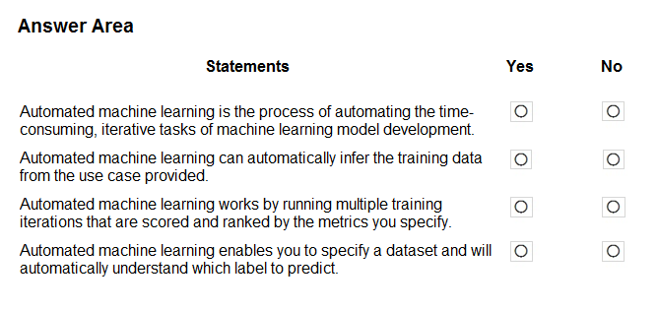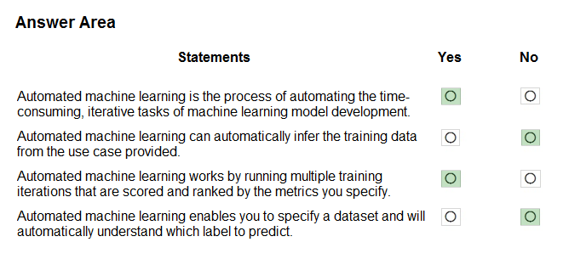

**Question #28**

*Topic 1*

**HOTSPOT -**

**For each of the following statements, select Yes if the statement is true. Otherwise, select No. NOTE: Each correct selection is worth one point.**

**Hot Area:**

**Correct Answer:**

**You need to predict the sea level in meters for the next 10 years.**

**Which type of machine learning should you use?**

1. **classification**
2. **regression**
3. **clustering**

**Correct Answer:** *B*

**In the most basic sense, regression refers to prediction of a numeric target.**

**Linear regression attempts to establish a linear relationship between one or more independent variables and a numeric outcome, or dependent variable.**

**You use this module to define a linear regression method, and then train a model using a labeled dataset. The trained model can then be used to make predictions.**

**Reference:**

**https://docs.microsoft.com/en-us/azure/machine-learning/studio-module-reference/linear-regression**



**Box 1: Yes -**

**Automated machine learning, also referred to as automated ML or AutoML, is the process of automating the time consuming, iterative tasks of machine learning model development. It allows data scientists, analysts, and developers to build ML models with high scale, efficiency, and productivity all while sustaining model quality.**

**Box 2: No -**

**Box 3: Yes -**

**During training, Azure Machine Learning creates a number of pipelines in parallel that try different algorithms and parameters for you. The service iterates through**

**ML algorithms paired with feature selections, where each iteration produces a model with a training score. The higher the score, the better the**

**model is considered to "fit" your data. It will stop once it hits the exit criteria defined in the experiment.**

**Box 4: No -**

**Apply automated ML when you want Azure Machine Learning to train and tune a model for you using the target metric you specify. The label is the column you want to predict.**

**Reference:**

**https://azure.microsoft.com/en-us/services/machine-learning/automatedml/#features**

/

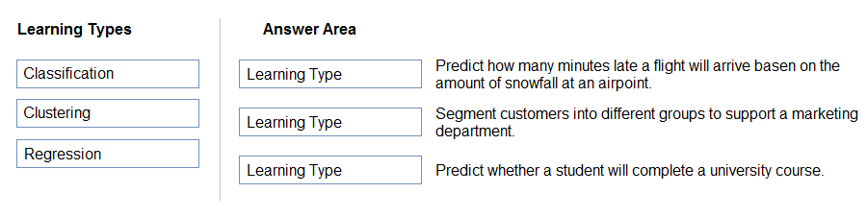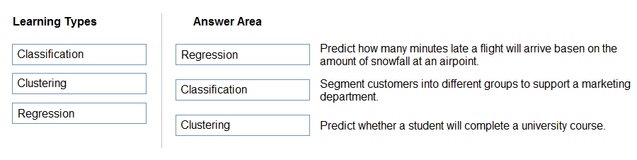

[**Previous Questions**](https://www.examtopics.com/exams/microsoft/ai-900/view/6/)

[**Next Questions**](https://www.examtopics.com/exams/microsoft/ai-900/view/8/)

**Question #21**

*Topic 1*

**DRAG DROP -**

**Match the types of machine learning to the appropriate scenarios.**

**To answer, drag the appropriate machine learning type from the column on the left to its scenario on the right. Each machine learning type may be used once, more than once, or not at all.**

**NOTE: Each correct selection is worth one point.**

**Select and Place:**

**Correct Answer:**

**Box 1: Regression -**

**In the most basic sense, regression refers to prediction of a numeric target.**

**Linear regression attempts to establish a linear relationship between one or more independent variables and a numeric outcome, or dependent**

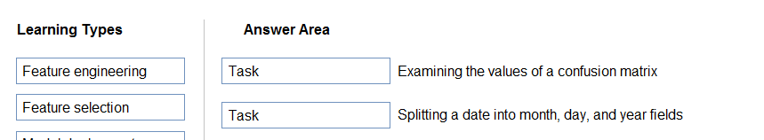

**Question #22**

*Topic 1*

**DRAG DROP -**

**Match the machine learning tasks to the appropriate scenarios.**

**To answer, drag the appropriate task from the column on the left to its scenario on the right. Each task may be used once, more than once, or not at all.**

**NOTE: Each correct selection is worth one point.**

**Select and Place:**

**variable.**

**You use this module to define a linear regression method, and then train a model using a labeled dataset. The trained model can then be used to make predictions.**

**Box 2: Classification -**

**Classification is a machine learning method that uses data to determine the category, type, or class of an item or row of data.**

**Box 3: Clustering -**

**Clustering, in machine learning, is a method of grouping data points into similar clusters. It is also called segmentation.**

**Over the years, many clustering algorithms have been developed. Almost all clustering algorithms use the features of individual items to find similar items. For example, you might apply clustering to find similar people by demographics. You might use clustering with text analysis to group sentences with similar topics or sentiment.**

**Reference:**

**https://docs.microsoft.com/en-us/azure/machine-learning/studio-module-reference/linear-regression**

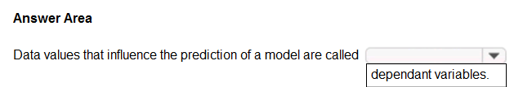

**Question #23**

*Topic 1*

**HOTSPOT -**

**To complete the sentence, select the appropriate option in the answer area. Hot Area:**

Correct Answer:

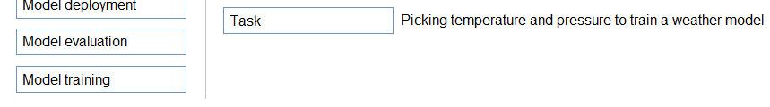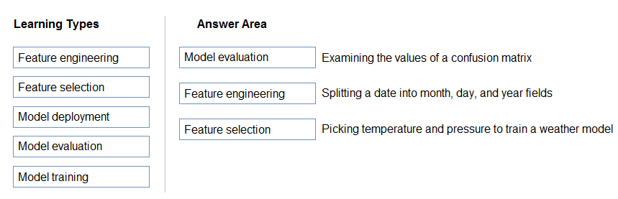

Box 1: Model evaluation -

The Model evaluation module outputs a confusion matrix showing the number of true positives, false negatives, false positives, and true negatives, as well as

ROC, Precision/Recall, and Lift curves.

Box 2: Feature engineering -

Feature engineering is the process of using domain knowledge of the data to create features that help ML algorithms learn better. In Azure Machine Learning, scaling and normalization techniques are applied to facilitate feature engineering. Collectively, these techniques and feature engineering are referred to as featurization.

Note: Often, features are created from raw data through a process of feature engineering. For example, a time stamp in itself might not be useful for modeling until the information is transformed into units of days, months, or categories that are relevant to the problem, such as holiday versus working day.

Box 3: Feature selection -

In machine learning and statistics, feature selection is the process of selecting a subset of relevant, useful features to use in building an

analytical model. Feature selection helps narrow the field of data to the most valuable inputs. Narrowing the field of data helps reduce noise and improve training performance.

Reference:

https://docs.microsoft.com/en-us/azure/machine-learning/studio/evaluate-model-performance https://docs.microsoft.com/en- us/azure/machine-learning/concept-automated-ml

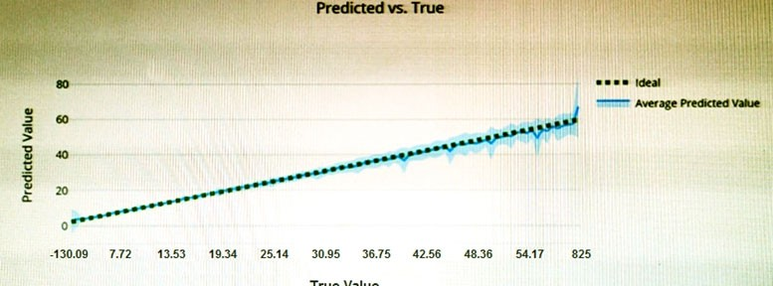

**Question #24**

*Topic 1*

**You have the Predicted vs. True chart shown in the following exhibit.**

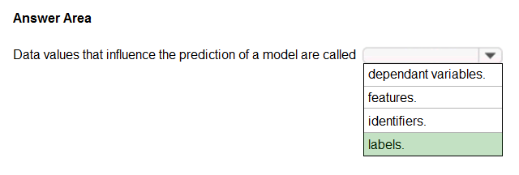

**Correct Answer:**

**In machine learning, if you have labeled data, that means your data is marked up, or annotated, to show the target, which is the answer you want your machine learning model to predict.**

**In general, data labeling can refer to tasks that include data tagging, annotation, classification, moderation, transcription, or processing. Incorrect Answers:**

**Not features: In machine learning and statistics, feature selection is the process of selecting a subset of relevant, useful features to use in building an analytical model. Feature selection helps narrow the field of data to the most valuable inputs. Narrowing the field of data helps reduce noise and improve training performance.**

**Reference:**

**https:/**[**/www.cloudfactor**](http://www.cloudfactory.com/data-labeling-guide)**y**[**.com/data-labeling-guide**](http://www.cloudfactory.com/data-labeling-guide)

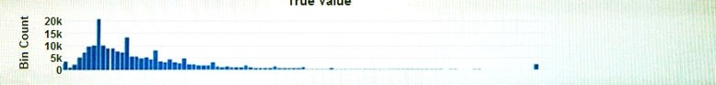

**Which type of model is the chart used to evaluate?**

1. **classification**
2. **regression**
3. **clustering**

**Correct Answer:** *B*

**What is a Predicted vs. True chart?**

**Predicted vs. True shows the relationship between a predicted value and its correlating true value for a regression problem. This graph can be used to measure performance of a model as the closer to the y=x line the predicted values are, the better the accuracy of a predictive model. Reference:**

**https://docs.microsoft.com/en-us/azure/machine-learning/how-to-understand-automated-m**

[Previous Questions](https://www.examtopics.com/exams/microsoft/ai-900/view/5/) [Next Questions](https://www.examtopics.com/exams/microsoft/ai-900/view/7/)

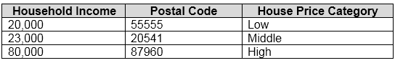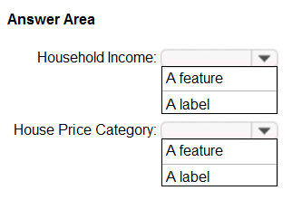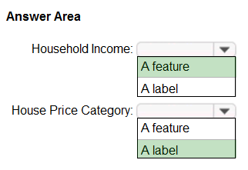

**Question #17** *Topic 1*

HOTSPOT -

You have the following dataset.

You plan to use the dataset to train a model that will predict the house price categories of houses.

What are Household Income and House Price Category? To answer, select the appropriate option in the answer area.

NOTE: Each correct selection is worth one point. Hot Area:

Correct Answer:

Reference: /

**Question #20**

*Topic 1*

**You need to create a training dataset and validation dataset from an existing dataset.**

**Which module in the Azure Machine Learning designer should you use?**

**https://docs.microsoft.com/en-us/azure/machine-learning/studio/interpret-model-results**

**Question #18**

*Topic 1*

**Which metric can you use to evaluate a classification model?**

1. **true positive rate**
2. **mean absolute error (MAE)**
3. **coefficient of determination (R2)**
4. **root mean squared error (RMSE)**

**Correct Answer:** *A*

**What does a good model look like?**

**An ROC curve that approaches the top left corner with 100% true positive rate and 0% false positive rate will be the best model. A random model would display as a flat line from the bottom left to the top right corner. Worse than random would dip below the y=x line.**

**Reference:**

**https://docs.microsoft.com/en-us/azure/machine-learning/how-to-understand-automated-ml#classification**

**Question #19**

*Topic 1*

**Which two components can you drag onto a canvas in Azure Machine Learning designer? Each correct answer presents a complete solution.**

**NOTE: Each correct selection is worth one point.**

1. **dataset**
2. **compute**
3. **pipeline**
4. **module**

**Correct Answer:** *AD*

**You can drag-and-drop datasets and modules onto the canvas. Reference:**

**https://docs.microsoft.com/en-us/azure/machine-learning/concept-designer**

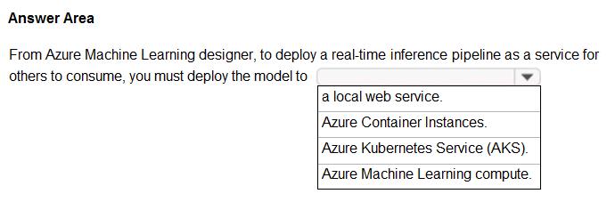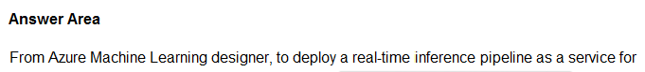

**Question #14**

*Topic 1*

**HOTSPOT -**

**To complete the sentence, select the appropriate option in the answer area. Hot Area:**

1. **Select Columns in Dataset**
2. **Add Rows**
3. **Split Data**
4. **Join Data**

**Correct Answer:** *C*

**A common way of evaluating a model is to divide the data into a training and test set by using Split Data, and then validate the model on the training data.**

**Use the Split Data module to divide a dataset into two distinct sets. The studio currently supports training/validation data splits**

**Reference:**

**https://docs.microsoft.com/en-us/azure/machine-learning/how-to-configure-cross-validation-data-splits**



[**Previous Questions**](https://www.examtopics.com/exams/microsoft/ai-900/view/4/)

[**Next Questions**](https://www.examtopics.com/exams/microsoft/ai-900/view/6/)

**Question #13**

*Topic 1*

**You use Azure Machine Learning designer to publish an inference pipeline.**

**Which two parameters should you use to consume the pipeline? Each correct answer presents part of the solution. NOTE: Each correct selection is worth one point.**

1. **the model name**
2. **the training endpoint**
3. **the authentication key**
4. **the REST endpoint**

**Correct Answer:** *AD*

**A: The trained model is stored as a Dataset module in the module palette. You can find it under My Datasets.**

**Azure Machine Learning designer lets you visually connect datasets and modules on an interactive canvas to create machine learning models. D: You can consume a published pipeline in the Published pipelines page. Select a published pipeline and find the REST endpoint of it.**

**Reference:**

**https://docs.microsoft.com/en-us/azure/machine-learning/how-to-run-batch-predictions-designer https://docs.microsoft.com/en- us/azure/machine-learning/concept-designer**

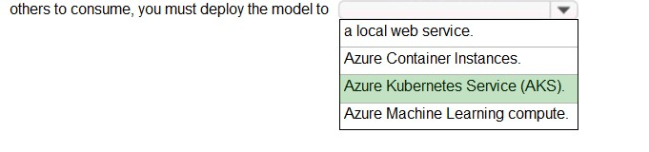

**Correct Answer:**

**To perform real-time inferencing, you must deploy a pipeline as a real-time endpoint. Real-time endpoints must be deployed to an Azure Kubernetes Service cluster.**

**Reference:**

**https://docs.microsoft.com/en-us/azure/machine-learning/concept-designer#deploy**

/

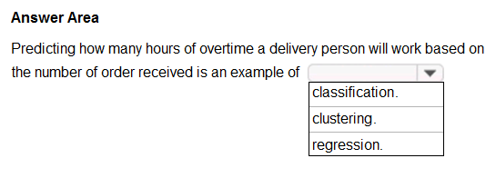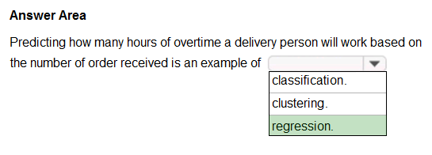

**Question #15**

*Topic 1*

**HOTSPOT -**

**To complete the sentence, select the appropriate option in the answer area. Hot Area:**

**Correct Answer:**

**In the most basic sense, regression refers to prediction of a numeric target.**

**Linear regression attempts to establish a linear relationship between one or more independent variables and a numeric outcome, or dependent variable.**

**You use this module to define a linear regression method, and then train a model using a labeled dataset. The trained model can then be used**

**to make predictions. Incorrect Answers:**

✑ **Classification is a machine learning method that uses data to determine the category, type, or class of an item or row of data.**

✑ **Clustering, in machine learning, is a method of grouping data points into similar clusters. It is also called segmentation.**

**Over the years, many clustering algorithms have been developed. Almost all clustering algorithms use the features of individual items to find similar items. For example, you might apply clustering to find similar people by demographics. You might use clustering with text analysis to group sentences with similar topics or sentiment.**

**Reference:**

**https://docs.microsoft.com/en-us/azure/machine-learning/algorithm-module-reference/linear-regression https://docs.microsoft.com/en- us/azure/machine-learning/studio-module-reference/machine-learning-initialize-model-clustering**

/

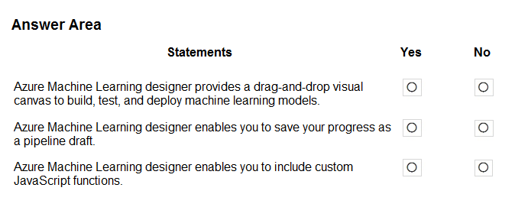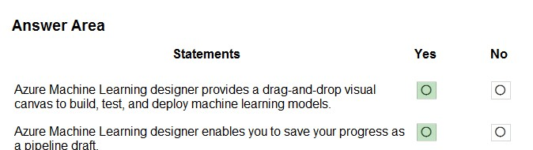

**Question #16**

*Topic 1*

**HOTSPOT -**

**For each of the following statements, select Yes if the statement is true. Otherwise, select No. NOTE: Each correct selection is worth one point.**

**Hot Area:**

**Correct Answer:**

/

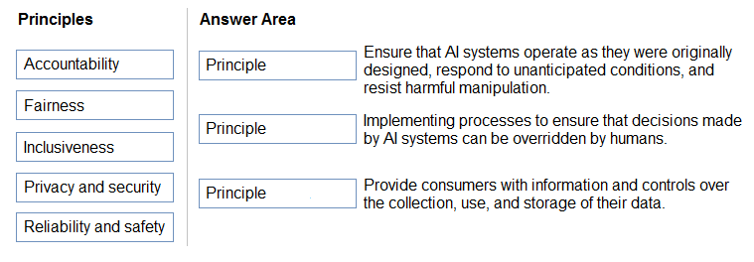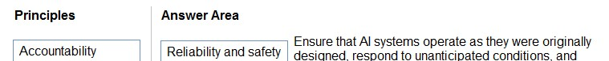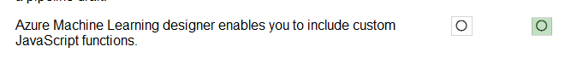

**Box 1: Yes -**

**Azure Machine Learning designer lets you visually connect datasets and modules on an interactive canvas to create machine learning models.**

**Box 2: Yes -**

**With the designer you can connect the modules to create a pipeline draft.**

**As you edit a pipeline in the designer, your progress is saved as a pipeline draft.**

**Box 3: No - Reference:**

**https://docs.microsoft.com/en-us/azure/machine-learning/concept-designer**

[Previous Questions](https://www.examtopics.com/exams/microsoft/ai-900/view/3/) [Next Questions](https://www.examtopics.com/exams/microsoft/ai-900/view/5/)

**Question #9** *Topic 1*

DRAG DROP -

Match the Microsoft guiding principles for responsible AI to the appropriate descriptions.

To answer, drag the appropriate principle from the column on the left to its description on the right. Each principle may be used once, more than once, or not at all.

NOTE: Each correct selection is worth one point. Select and Place:

/

Correct Answer:

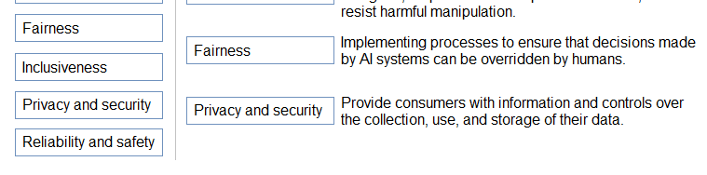

Box 1: Reliability and safety -

To build trust, it's critical that AI systems operate reliably, safely, and consistently under normal circumstances and in unexpected conditions.

These systems should be able to operate as they were originally designed, respond safely to unanticipated conditions, and resist harmful manipulation.

Box 2: Fairness -

Fairness: AI systems should treat everyone fairly and avoid affecting similarly situated groups of people in different ways. For example, when AI systems provide guidance on medical treatment, loan applications, or employment, they should make the same recommendations to everyone with similar symptoms, financial circumstances, or professional qualifications.

We believe that mitigating bias starts with people understanding the implications and limitations of AI predictions and recommendations.

Ultimately, people should supplement AI decisions with sound human judgment and be held accountable for consequential decisions that affect others.

Box 3: Privacy and security -

As AI becomes more prevalent, protecting privacy and securing important personal and business information is becoming more critical and complex. With AI, privacy and data security issues require especially close attention because access to data is essential for AI systems to make accurate and informed predictions and decisions about people. AI systems must comply with privacy laws that require transparency about the collection, use, and storage of data and mandate that consumers have appropriate controls to choose how their data is used

Reference:

https://docs.microsoft.com/en-us/learn/modules/responsible-ai-principles/4-guiding-principles

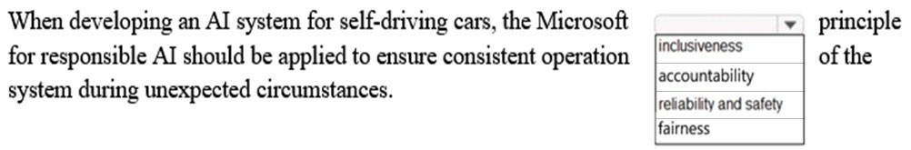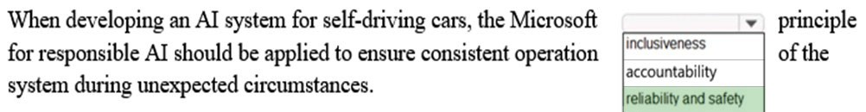

**Question #10**

*Topic 1*

**HOTSPOT -**

**To complete the sentence, select the appropriate option in the answer area. Hot Area:**

**Correct Answer:**

/



**Reliability and safety: To build trust, it's critical that AI systems operate reliably, safely, and consistently under normal circumstances and in unexpected conditions.**

**These systems should be able to operate as they were originally designed, respond safely to unanticipated conditions, and resist harmful manipulation.**

**Reference:**

**https://docs.microsoft.com/en-us/learn/modules/responsible-ai-principles/4-guiding-principles**

**Question #11**

*Topic 1*

**Which service should you use to extract text, key/value pairs, and table data automatically from scanned documents?**

1. **Form Recognizer**
2. **Text Analytics**
3. **Ink Recognizer**
4. **Custom Vision**

**Correct Answer:** *A*

**Accelerate your business processes by automating information extraction. Form Recognizer applies advanced machine learning to accurately extract text, key/ value pairs, and tables from documents. With just a few samples, Form Recognizer tailors its understanding to your documents, both on-premises and in the cloud. Turn forms into usable data at a fraction of the time and cost, so you can focus more time**

**acting on the information rather than compiling it. Reference:**

**https://azure.microsoft.com/en-us/services/cognitive-services/form-recognizer/**

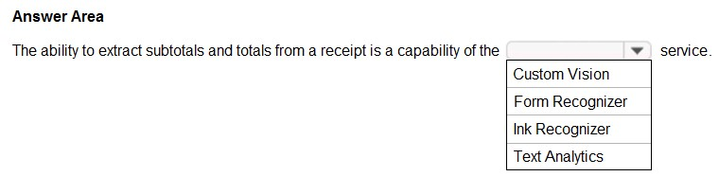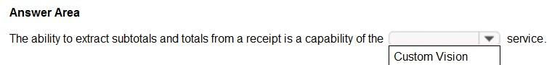

**Question #12**

*Topic 1*

**HOTSPOT -**

**To complete the sentence, select the appropriate option in the answer area. Hot Area:**



**Correct Answer:**

**Accelerate your business processes by automating information extraction. Form Recognizer applies advanced machine learning to accurately extract text, key/ value pairs, and tables from documents. With just a few samples, Form Recognizer tailors its understanding to your documents, both on-premises and in the cloud. Turn forms into usable data at a fraction of the time and cost, so you can focus more time**

**acting on the information rather than compiling it. Reference:**

**https://azure.microsoft.com/en-us/services/cognitive-services/form-recognizer/**

[Previous Questions](https://www.examtopics.com/exams/microsoft/ai-900/view/2/) [Next Questions](https://www.examtopics.com/exams/microsoft/ai-900/view/4/)

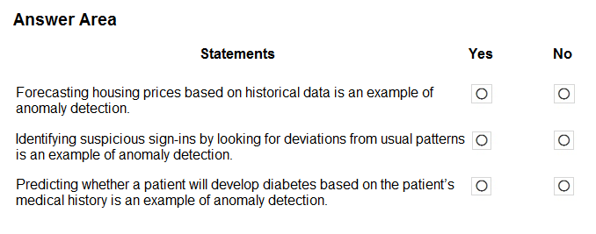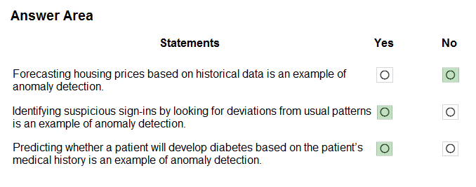

**Question #5** *Topic 1*

HOTSPOT -

For each of the following statements, select Yes if the statement is true. Otherwise, select No. NOTE: Each correct selection is worth one point.

Hot Area:

Correct Answer:

Anomaly detection encompasses many important tasks in machine learning: Identifying transactions that are potentially fraudulent.

Learning patterns that indicate that a network intrusion has occurred. Finding abnormal clusters of patients.

Checking values entered into a system. Reference:

https://docs.microsoft.com/en-us/azure/machine-learning/studio-module-reference/anomaly-detection

/

**Question #6**

*Topic 1*

/

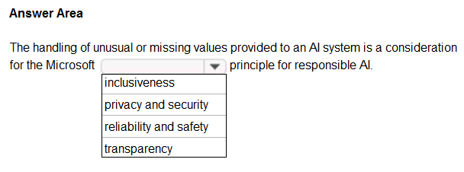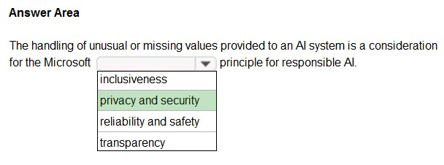

**HOTSPOT -**

**To complete the sentence, select the appropriate option in the answer area. Hot Area:**

**Correct Answer:**

**Privacy and security.**

**As AI becomes more prevalent, protecting privacy and securing important personal and business information is becoming more critical and complex. With AI, privacy and data security issues require especially close attention because access to data is essential for AI systems to make accurate and informed predictions and decisions about people. AI systems must comply with privacy laws that require transparency about the collection, use, and storage of data and mandate that consumers have appropriate controls to choose how their data is used. At Microsoft, we are continuing to research privacy and security breakthroughs (see next unit) and invest in robust compliance processes to ensure that data collected and used by our AI systems is handled responsibly.**

**Reference:**

**https://docs.microsoft.com/en-us/learn/modules/responsible-ai-principles/4-guiding-principles**

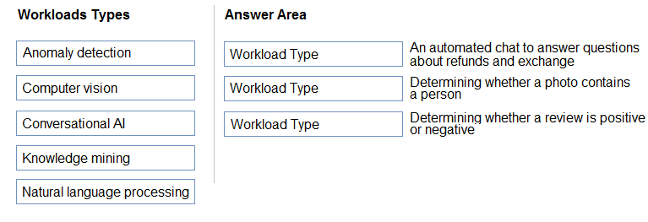

**Question #7**

*Topic 1*

**DRAG DROP -**

**Match the types of AI workloads to the appropriate scenarios.**

**To answer, drag the appropriate workload type from the column on the left to its scenario on the right. Each workload type may be used once, more than once, or not at all.**

**NOTE: Each correct selection is worth one point.**

**Select and Place:**

/

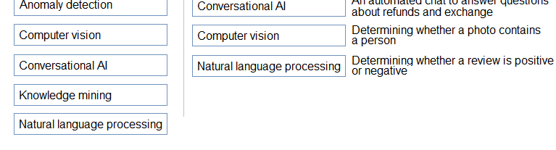

**Correct Answer:**

**Box 3: Natural language processing**

**Natural language processing (NLP) is used for tasks such as sentiment analysis, topic detection, language detection, key phrase extraction, and document categorization.**

**Reference:**

**https://docs.microsoft.com/en-us/azure/architecture/data-guide/technology-choices/natural-language-processing**

**Question #8**

*Topic 1*

**You are designing an AI system that empowers everyone, including people who have hearing, visual, and other impairments.**

**This is an example of which Microsoft guiding principle for responsible AI?**

1. **fairness**
2. **inclusiveness**
3. **reliability and safety**
4. **accountability**

**Correct Answer:** *B*

**Inclusiveness: At Microsoft, we firmly believe everyone should benefit from intelligent technology, meaning it must incorporate and address a broad range of human needs and experiences. For the 1 billion people with disabilities around the world, AI technologies can be a game- changer.**

**Reference:**

**https://docs.microsoft.com/en-us/learn/modules/responsible-ai-principles/4-guiding-principles**



[**Previous Questions**](https://www.examtopics.com/exams/microsoft/ai-900/view/1/)

[**Next Questions**](https://www.examtopics.com/exams/microsoft/ai-900/view/3/)

**Topic 1 - Single Topic**

**Question #1**

*Topic 1*

**A company employs a team of customer service agents to provide telephone and email support to customers. The company develops a webchat bot to provide automated answers to common customer queries.**

**Which business benefit should the company expect as a result of creating the webchat bot solution?**

/

1. **increased sales**
2. **a reduced workload for the customer service agents**
3. **improved product reliability**

**Correct Answer:** *B*

**Question #2**

*Topic 1*

**For a machine learning progress, how should you split data for training and evaluation?**

1. **Use features for training and labels for evaluation.**
2. **Randomly split the data into rows for training and rows for evaluation.**
3. **Use labels for training and features for evaluation.**
4. **Randomly split the data into columns for training and columns for evaluation.**

**Correct Answer:** *D*

**In Azure Machine Learning, the percentage split is the available technique to split the data. In this technique, random data of a given percentage will be split to train and test data.**

**Reference:**

**https:/**[**/www.sqlshack.com/prediction-in-azure-machine-learning/**](http://www.sqlshack.com/prediction-in-azure-machine-learning/)



**Question #3**

*Topic 1*

**HOTSPOT -**

**You are developing a model to predict events by using classification.**

**You have a confusion matrix for the model scored on test data as shown in the following exhibit.**

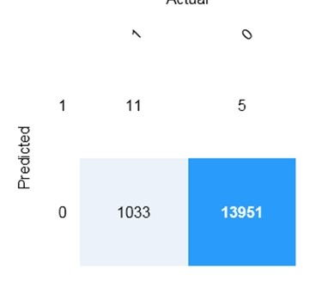

/

Use the drop-down menus to select the answer choice that completes each statement based on the information presented in the graphic. NOTE: Each correct selection is worth one point.

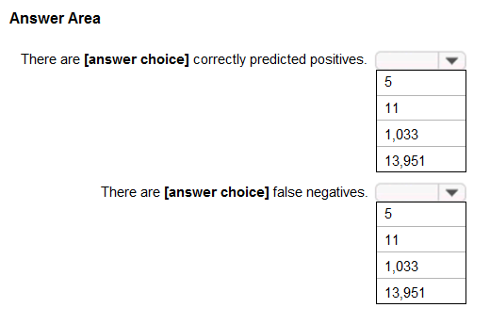Hot Area:

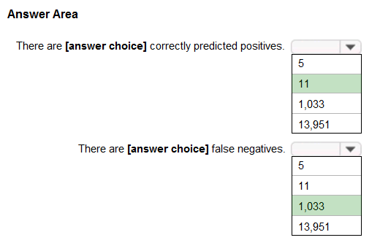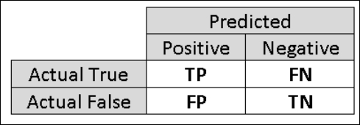

**Correct Answer:**

**Box 1: 11 -**

**TP = True Positive.**

**The class labels in the training set can take on only two possible values, which we usually refer to as positive or negative. The positive and negative instances that a classifier predicts correctly are called true positives (TP) and true negatives (TN), respectively. Similarly, the**

**incorrectly classified instances are called false positives (FP) and false negatives (FN).**

**Box 2: 1,033 -**

**FN = False Negative -**

/

**Reference:**

**https://docs.microsoft.com/en-us/azure/machine-learning/studio/evaluate-model-performance**

**Question #4** *Topic 1*

You build a machine learning model by using the automated machine learning user interface (UI). You need to ensure that the model meets the Microsoft transparency principle for responsible AI. What should you do?

1. **Set Validation type to Auto.**
2. **Enable Explain best model.**
3. **Set Primary metric to accuracy.**
4. **Set Max concurrent iterations to 0.**

Correct Answer: *B*

Model Explain Ability.

Most businesses run on trust and being able to open the ML "black box" helps build transparency and trust. In heavily regulated industries like healthcare and banking, it is critical to comply with regulations and best practices. One key aspect of this is understanding the relationship between input variables (features) and model output. Knowing both the magnitude and direction of the impact each feature (feature

importance) has on the predicted value helps better understand and explain the model. With model explain ability, we enable you to understand feature importance as part of automated ML runs.

Reference:

https://azure.microsoft.com/en-us/blog/

**Question #61**

*Topic 1*

**Which AI service should you use to create a bot from a frequently asked questions (FAQ) document?**

1. **QnA Maker**
2. **Language Understanding (LUIS)**
3. **Text Analytics**
4. **Speech**

**Correct Answer:** *A*



**Question #62**

*Topic 1*

**HOTSPOT -**

**To complete the sentence, select the appropriate option in the answer area. Hot Area:**

**Correct Answer:**

**With Microsoft's Conversational AI tools developers can build, connect, deploy, and manage intelligent bots that naturally interact with their users on a website, app, Cortana, Microsoft Teams, Skype, Facebook Messenger, Slack, and more.**

**Reference:**

**https://azure.microsoft.com/en-in/blog/microsoft-conversational-ai-tools-enable-developers-to-build-connect-and-manage-intelligent-bots**



[**Previous Questions**](https://www.examtopics.com/exams/microsoft/ai-900/view/15/)

**Question #57**

*Topic 1*

**You need to reduce the load on telephone operators by implementing a chatbot to answer simple questions with predefined answers. Which two AI service should you use to achieve the goal? Each correct answer presents part of the solution.**

**NOTE: Each correct selection is worth one point.**

1. **Text Analytics**
2. **QnA Maker**
3. **Azure Bot Service**
4. **Translator Text**

**Correct Answer:** *BC*

**Bots are a popular way to provide support through multiple communication channels. You can use the QnA Maker service and Azure Bot Service to create a bot that answers user questions.**

**Reference:**

**https://docs.microsoft.com/en-us/learn/modules/build-faq-chatbot-qna-maker-azure-bot-service/**

**Question #58**

*Topic 1*

**Which two scenarios are examples of a conversational AI workload? Each correct answer presents a complete solution.**

**NOTE: Each correct selection is worth one point.**

1. **a smart device in the home that responds to questions such as "What will the weather be like today?"**
2. **a website that uses a knowledge base to interactively respond to users' questions**
3. **assembly line machinery that autonomously inserts headlamps into cars**
4. **monitoring the temperature of machinery to turn on a fan when the temperature reaches a specific threshold**

**Correct Answer:** *AB*



**Question #59**

*Topic 1*

**You have the process shown in the following exhibit.**

**Which type AI solution is shown in the diagram?**

1. **a sentiment analysis solution**
2. **a chatbot**
3. **a machine learning model**
4. **a computer vision application**

**Correct Answer:** *B*

**Question #60**

*Topic 1*

**You need to develop a web-based AI solution for a customer support system. Users must be able to interact with a web app that will guide them to the best resource or answer.**

**Which service should you use?**

1. **Custom Vision**
2. **QnA Maker**
3. **Translator Text**
4. **Face**



[**Previous Questions**](https://www.examtopics.com/exams/microsoft/ai-900/view/14/)



[**Next Questions**](https://www.examtopics.com/exams/microsoft/ai-900/view/16/)

**Question #53** *Topic 1*

Which two scenarios are examples of a conversational AI workload? Each correct answer presents a complete solution. NOTE: Each correct selection is worth one point.

1. **a telephone answering service that has a pre-recorder message**
2. **a chatbot that provides users with the ability to find answers on a website by themselves**
3. **telephone voice menus to reduce the load on human resources**
4. **a service that creates frequently asked questions (FAQ) documents by crawling public websites**

Correct Answer: *BC*

B: A bot is an automated software program designed to perform a particular task. Think of it as a robot without a body.

C: Automated customer interaction is essential to a business of any size. In fact, 61% of consumers prefer to communicate via speech, and most of them prefer self-service. Because customer satisfaction is a priority for all businesses, self-service is a critical facet of any

customer-facing communications strategy. Incorrect Answers:

D: Early bots were comparatively simple, handling repetitive and voluminous tasks with relatively straightforward algorithmic logic. An example would be web crawlers used by search engines to automatically explore and catalog web content.

Reference:

https://docs.microsoft.com/en-us/azure/architecture/data-guide/big-data/ai-overview https://docs.microsoft.com/en- us/azure/architecture/solution-ideas/articles/interactive-voice-response-bot

**Question #54** *Topic 1*



HOTSPOT -

For each of the following statements, select Yes if the statement is true. Otherwise, select No. NOTE: Each correct selection is worth one point.

Hot Area:

Correct Answer:

Box 1: Yes -

Azure bot service can be integrated with the powerful AI capabilities with Azure Cognitive Services.

Box 2: Yes -

Azure bot service engages with customers in a conversational manner.

Box 3: No -

The QnA Maker service creates knowledge base, not question and answers sets.

Note: You can use the QnA Maker service and a knowledge base to add question-and-answer support to your bot. When you create your knowledge base, you seed it with questions and answers.

Reference:

https://docs.microsoft.com/en-us/azure/bot-service/bot-builder-tutorial-add-qna

**Question #55**

*Topic 1*

**You need to provide content for a business chatbot that will help answer simple user queries.**

**What are three ways to create question and answer text by using QnA Maker? Each correct answer presents a complete solution. NOTE: Each correct selection is worth one point.**

1. **Generate the questions and answers from an existing webpage.**
2. **Use automated machine learning to train a model based on a file that contains the questions.**
3. **Manually enter the questions and answers.**
4. **Connect the bot to the Cortana channel and ask questions by using Cortana.**
5. **Import chit-chat content from a predefined data source.**

**Correct Answer:** *ACE*

**Automatic extraction -**

**Extract question-answer pairs from semi-structured content, including FAQ pages, support websites, excel files, SharePoint documents, product manuals and policies.**

**Reference:**

**https://docs.microsoft.com/en-us/azure/cognitive-services/qnamaker/concepts/content-types**

**Question #56**

*Topic 1*

**You have a frequently asked questions (FAQ) PDF file.**

**You need to create a conversational support system based on the FAQ. Which service should you use?**

1. **QnA Maker**
2. **Text Analytics**
3. **Computer Vision**
4. **Language Understanding (LUIS)**

**Correct Answer:** *A*

**QnA Maker is a cloud-based API service that lets you create a conversational question-and-answer layer over your existing data. Use it to build a knowledge base by extracting questions and answers from your semi-structured content, including FAQs, manuals, and documents. Reference:**

**https://azure.microsoft.com/en-us/services/cognitive-services/qna-maker/**



[**Previous Questions**](https://www.examtopics.com/exams/microsoft/ai-900/view/13/)



[**Next Questions**](https://www.examtopics.com/exams/microsoft/ai-900/view/15/)

**Question #49**

*Topic 1*

**You are developing a natural language processing solution in Azure. The solution will analyze customer reviews and determine how positive or negative each review is.**

**This is an example of which type of natural language processing workload?**

1. **language detection**
2. **sentiment analysis**
3. **key phrase extraction**
4. **entity recognition**

**Correct Answer:** *B*

**Sentiment Analysis is the process of determining whether a piece of writing is positive, negative or neutral. Reference:**

**https://docs.microsoft.com/en-us/azure/architecture/data-guide/technology-choices/natural-language-processing**



**Question #50**

*Topic 1*

**You use natural language processing to process text from a Microsoft news story.**

**You receive the output shown in the following exhibit.**

**Which type of natural languages processing was performed?**

1. **entity recognition**
2. **key phrase extraction**
3. **sentiment analysis**
4. **translation**

**Correct Answer:** *B*

**Key phrase extraction/ Broad entity extraction: Identify important concepts in text, including key phrases and named entities such as people, places, and organizations.**

**Reference:**

**https://azure.microsoft.com/en-us/services/cognitive-services/text-analytics**

**Question #51** *Topic 1*



DRAG DROP -

You plan to apply Text Analytics API features to a technical support ticketing system.

Match the Text Analytics API features to the appropriate natural language processing scenarios.

To answer, drag the appropriate feature from the column on the left to its scenario on the right. Each feature may be used once, more than once, or not at all.

NOTE: Each correct selection is worth one point. Select and Place:

Correct Answer:

Box1: Sentiment analysis -

Sentiment Analysis is the process of determining whether a piece of writing is positive, negative or neutral.

Box 2: Broad entity extraction -

Broad entity extraction: Identify important concepts in text, including key

Key phrase extraction/ Broad entity extraction: Identify important concepts in text, including key phrases and named entities such as people, places, and organizations.

Box 3: Entity Recognition -

Named Entity Recognition: Identify and categorize entities in your text as people, places, organizations, date/time, quantities, percentages, currencies, and more.

Well-known entities are also recognized and linked to more information on the web. Reference:

https://docs.microsoft.com/en-us/azure/architecture/data-guide/technology-choices/natural-language-processing https://azure.microsoft.com/en-us/services/cognitive-services/text-analytics

**Question #52**

*Topic 1*

**You are developing a solution that uses the Text Analytics service.**

**You need to identify the main talking points in a collection of documents. Which type of natural language processing should you use?**

1. **entity recognition**
2. **key phrase extraction**
3. **sentiment analysis**
4. **language detection**

**Correct Answer:** *B*

**Broad entity extraction: Identify important concepts in text, including key**

**Key phrase extraction/ Broad entity extraction: Identify important concepts in text, including key phrases and named entities such as people, places, and organizations.**

**Reference:**

**https://docs.microsoft.com/en-us/azure/architecture/data-guide/technology-choices/natural-language-processing**



[**Previous Questions**](https://www.examtopics.com/exams/microsoft/ai-900/view/12/)

[**Next Questions**](https://www.examtopics.com/exams/microsoft/ai-900/view/14/)

**Question #45**

*Topic 1*

**You need to make the press releases of your company available in a range of languages.**

**Which service should you use?**

1. **Translator Text**
2. **Text Analytics**
3. **Speech**
4. **Language Understanding (LUIS)**

**Correct Answer:** *A*

**Translator is a cloud-based machine translation service you can use to translate text in near real-time through a simple REST API call. The service uses modern neural machine translation technology and offers statistical machine translation technology. Custom Translator is an extension of Translator, which allows you to build neural translation systems.**

**Reference:**

**https://docs.microsoft.com/en-us/azure/cognitive-services/translator/**

**Question #46** *Topic 1*

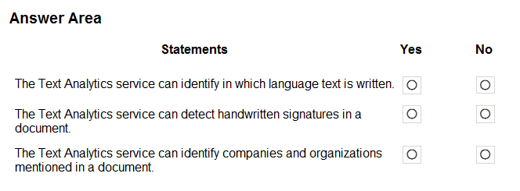

HOTSPOT -

For each of the following statements, select Yes if the statement is true. Otherwise, select No. NOTE: Each correct selection is worth one point.

Hot Area:

Correct Answer:

The Text Analytics API is a cloud-based service that provides advanced natural language processing over raw text, and includes four main functions: sentiment analysis, key phrase extraction, named entity recognition, and language detection.

Box 1: Yes -

You can detect which language the input text is written in and report a single language code for every document submitted on the request in a wide range of languages, variants, dialects, and some regional/cultural languages. The language code is paired with a score indicating the strength of the score.

Box 2: No -

Box 3: Yes -

Named Entity Recognition: Identify and categorize entities in your text as people, places, organizations, date/time, quantities, percentages, currencies, and more.

Well-known entities are also recognized and linked to more information on the web. Reference:

https://docs.microsoft.com/en-us/azure/cognitive-services/text-analytics/overview

**Question #47** *Topic 1*

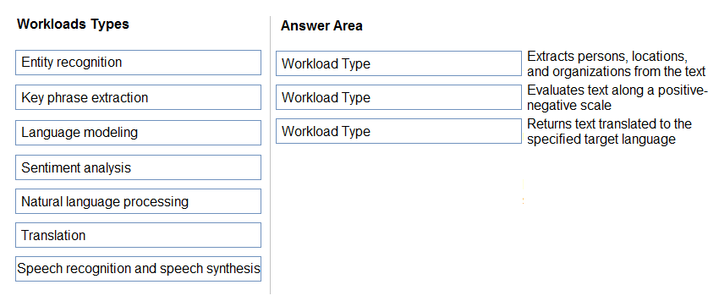

DRAG DROP -

Match the types of natural languages processing workloads to the appropriate scenarios.

To answer, drag the appropriate workload type from the column on the left to its scenario on the right. Each workload type may be used once, more than once, or not at all.

NOTE: Each correct selection is worth one point. Select and Place:

Correct Answer:

Box 1: Key phrase extraction -

Broad entity extraction: Identify important concepts in text, including key phrases and named entities such as people, places, and organizations.

Box 2: Sentiment analysis -

Sentiment Analysis is the process of determining whether a piece of writing is positive, negative or neutral.

Box 3: Translation -

Using Microsoft's Translator text API

This versatile API from Microsoft can be used for the following:

Translate text from one language to another. Transliterate text from one script to another. Detecting language of the input text.

Find alternate translations to specific text. Determine the sentence length.

Incorrect Answers:

Not Natural language processing (NLP), which is used for tasks such as sentiment analysis, topic detection, language detection, key phrase extraction, and document categorization.

Reference:

https://azure.microsoft.com/en-us/services/cognitive-services/text-analytics

**Question #48** *Topic 1*



HOTSPOT -

For each of the following statements, select Yes if the statement is true. Otherwise, select No. NOTE: Each correct selection is worth one point.

Hot Area:

Correct Answer:

Box 1: Yes -

Content Moderator is part of Microsoft Cognitive Services allowing businesses to use machine assisted moderation of text, images, and videos that augment human review.

The text moderation capability now includes a new machine-learning based text classification feature which uses a trained model to

identify possible abusive, derogatory or discriminatory language such as slang, abbreviated words, offensive, and intentionally misspelled words for review.

Box 2: No -

Azure's Computer Vision service gives you access to advanced algorithms that process images and return information based on the visual features you're interested in. For example, Computer Vision can determine whether an image contains adult content, find specific brands or objects, or find human faces.

Box 3: Yes -

Natural language processing (NLP) is used for tasks such as sentiment analysis, topic detection, language detection, key phrase extraction, and document categorization.

Sentiment Analysis is the process of determining whether a piece of writing is positive, negative or neutral. Reference:

https://azure.microsoft.com/es-es/blog/machine-assisted-text-classification-on-content-moderator-public-preview/ https://docs.microsoft.com/en-us/azure/architecture/data-guide/technology-choices/natural-language-processing



[**Previous Questions**](https://www.examtopics.com/exams/microsoft/ai-900/view/11/)



[**Next Questions**](https://www.examtopics.com/exams/microsoft/ai-900/view/13/)

**Question #41**

*Topic 1*

**Your website has a chatbot to assist customers.**

**You need to detect when a customer is upset based on what the customer types in the chatbot. Which type of AI workload should you use?**

1. **anomaly detection**
2. **semantic segmentation**
3. **regression**
4. **natural language processing**

**Correct Answer:** *D*

**Natural language processing (NLP) is used for tasks such as sentiment analysis, topic detection, language detection, key phrase extraction, and document categorization.**

**Sentiment Analysis is the process of determining whether a piece of writing is positive, negative or neutral. Reference:**

**https://docs.microsoft.com/en-us/azure/architecture/data-guide/technology-choices/natural-language-processing**



**Question #42**

*Topic 1*

**HOTSPOT -**

**To complete the sentence, select the appropriate option in the answer area. Hot Area:**

**Correct Answer:**

**Natural language processing (NLP) is used for tasks such as sentiment analysis, topic detection, language detection, key phrase extraction, and document categorization.**

**Reference:**

**https://docs.microsoft.com/en-us/azure/architecture/data-guide/technology-choices/natural-language-processing**

**Question #43**

*Topic 1*

**Which AI service can you use to interpret the meaning of a user input such as "Call me back later?"**

1. **Translator Text**
2. **Text Analytics**
3. **Speech**
4. **Language Understanding (LUIS)**

**Correct Answer:** *B*

**Text Analytics is an AI service that uncovers insights such as sentiment, entities, and key phrases in unstructured text. Incorrect Answers:**

**D: Language Understanding (LUIS) is a cloud-based API service, not an AI service, that applies custom machine-learning intelligence to a user's conversational, natural language text to predict overall meaning, and pull out relevant, detailed information.**

**Reference:**

**https://azure.microsoft.com/en-us/services/cognitive-services/text-analytics/ https://docs.microsoft.com/en-us/azure/cognitive- services/luis/what-is-luis**

**Question #44**

*Topic 1*

**You are developing a chatbot solution in Azure.**

**Which service should you use to determine a user's intent?**

1. **Translator Text**
2. **QnA Maker**
3. **Speech**
4. **Language Understanding (LUIS)**

**Correct Answer:** *D*

**Language Understanding (LUIS) is a cloud-based API service that applies custom machine-learning intelligence to a user's conversational, natural language text to predict overall meaning, and pull out relevant, detailed information.**

**Design your LUIS model with categories of user intentions called intents. Each intent needs examples of user utterances. Each utterance can provide data that needs to be extracted with machine-learning entities.**

**Reference:**

**https://docs.microsoft.com/en-us/azure/cognitive-services/luis/what-is-luis**



[**Previous Questions**](https://www.examtopics.com/exams/microsoft/ai-900/view/10/)



[**Next Questions**](https://www.examtopics.com/exams/microsoft/ai-900/view/12/)

**Question #37**

*Topic 1*

**What are two tasks that can be performed by using the Computer Vision service? Each correct answer presents a complete solution.**

**NOTE: Each correct selection is worth one point.**

1. **Train a custom image classification model.**
2. **Detect faces in an image.**
3. **Recognize handwritten text.**
4. **Translate the text in an image between languages.**

**Correct Answer:** *BC*

**B: Azure's Computer Vision service provides developers with access to advanced algorithms that process images and return information based on the visual features you're interested in. For example, Computer Vision can determine whether an image contains adult content, find specific brands or objects, or find human faces.**

**C: Computer Vision includes Optical Character Recognition (OCR) capabilities. You can use the new Read API to extract printed and handwritten text from images and documents.**

**Reference:**

**https://docs.microsoft.com/en-us/azure/cognitive-services/computer-vision/home**

**Question #38**

*Topic 1*

**What is a use case for classification?**

1. **predicting how many cups of coffee a person will drink based on how many hours the person slept the previous night.**
2. **analyzing the contents of images and grouping images that have similar colors**
3. **predicting whether someone uses a bicycle to travel to work based on the distance from home to work**
4. **predicting how many minutes it will take someone to run a race based on past race times**

**Correct Answer:** *B*

**Classification is a machine learning method that uses data to determine the category, type, or class of an item or row of data. Reference:**

**https://docs.microsoft.com/en-us/azure/machine-learning/algorithm-module-reference/linear-regression https://docs.microsoft.com/en-**

**us/azure/machine-learning/studio-module-reference/machine-learning-initialize-model-clustering**

**Question #39** *Topic 1*

What are two tasks that can be performed by using computer vision? Each correct answer presents a complete solution. NOTE: Each correct selection is worth one point.

1. **Predict stock prices.**
2. **Detect brands in an image.**
3. **Detect the color scheme in an image**
4. **Translate text between languages.**
5. **Extract key phrases.**

Correct Answer: *BE*

B: Azure's Computer Vision service gives you access to advanced algorithms that process images and return information based on the visual features you're interested in. For example, Computer Vision can determine whether an image contains adult content, find specific brands or objects, or find human faces.

E: Computer Vision includes Optical Character Recognition (OCR) capabilities. You can use the new Read API to extract printed and

handwritten text from images and documents. It uses the latest models and works with text on a variety of surfaces and backgrounds. These include receipts, posters, business cards, letters, and whiteboards. The two OCR APIs support extracting printed text in several languages.

Reference:

https://docs.microsoft.com/en-us/azure/cognitive-services/computer-vision/overview

**Question #40**

*Topic 1*

**Your company wants to build a recycling machine for bottles. The recycling machine must automatically identify bottles of the correct shape and reject all other items.**

**Which type of AI workload should the company use?**

1. **anomaly detection**
2. **conversational AI**
3. **computer vision**
4. **natural language processing**

**Correct Answer:** *C*

**Azure's Computer Vision service gives you access to advanced algorithms that process images and return information based on the visual features you're interested in. For example, Computer Vision can determine whether an image contains adult content, find specific brands or objects, or find human faces.**

**Reference:**

**https://docs.microsoft.com/en-us/azure/cognitive-services/computer-vision/overview**



[**Previous Questions**](https://www.examtopics.com/exams/microsoft/ai-900/view/9/)



[**Next Questions**](https://www.examtopics.com/exams/microsoft/ai-900/view/11/)



**Question #33** *Topic 1*

DRAG DROP -

Match the types of computer vision to the appropriate scenarios.

To answer, drag the appropriate workload type from the column on the left to its scenario on the right. Each workload type may be used once, more than once, or not at all.

NOTE: Each correct selection is worth one point. Select and Place:

Correct Answer:

Box 1: Facial recognition -

Face detection that perceives faces and attributes in an image; person identification that matches an individual in your private repository

of up to 1 million people; perceived emotion recognition that detects a range of facial expressions like happiness, contempt, neutrality, and fear; and recognition and grouping of similar faces in images.

Box 2: OCR -

Box 3: Objection detection -

Object detection is similar to tagging, but the API returns the bounding box coordinates (in pixels) for each object found. For example, if an image contains a dog, cat and person, the Detect operation will list those objects together with their coordinates in the image. You can use this functionality to process the relationships between the objects in an image. It also lets you determine whether there are multiple

instances of the same tag in an image.

The Detect API applies tags based on the objects or living things identified in the image. There is currently no formal relationship between the tagging taxonomy and the object detection taxonomy. At a conceptual level, the Detect API only finds objects and living things, while

the Tag API can also include contextual terms like "indoor", which can't be localized with bounding boxes. Reference:

https://azure.microsoft.com/en-us/services/cognitive-services/face/ https://docs.microsoft.com/en-us/azure/cognitive- services/computer-vision/concept-object-detection

**Question #34** *Topic 1*

You need to determine the location of cars in an image so that you can estimate the distance between the cars. Which type of computer vision should you use?

1. **optical character recognition (OCR)**
2. **object detection**
3. **image classification**
4. **face detection**

Correct Answer: *B*

Object detection is similar to tagging, but the API returns the bounding box coordinates (in pixels) for each object found. For example, if an image contains a dog, cat and person, the Detect operation will list those objects together with their coordinates in the image. You can use this functionality to process the relationships between the objects in an image. It also lets you determine whether there are multiple

instances of the same tag in an image.

The Detect API applies tags based on the objects or living things identified in the image. There is currently no formal relationship between the tagging taxonomy and the object detection taxonomy. At a conceptual level, the Detect API only finds objects and living things, while

the Tag API can also include contextual terms like "indoor", which can't be localized with bounding boxes. Reference:

https://docs.microsoft.com/en-us/azure/cognitive-services/computer-vision/concept-object-detection

**Question #35** *Topic 1*



HOTSPOT -

To complete the sentence, select the appropriate option in the answer area. Hot Area:

Correct Answer:

Azure Custom Vision is a cognitive service that lets you build, deploy, and improve your own image classifiers. An image classifier is an AI service that applies labels (which represent classes) to images, according to their visual characteristics. Unlike the Computer Vision

service, Custom Vision allows you to specify the labels to apply.

Note: The Custom Vision service uses a machine learning algorithm to apply labels to images. You, the developer, must submit groups of images that feature and lack the characteristics in question. You label the images yourself at the time of submission. Then the algorithm trains to this data and calculates its own accuracy by testing itself on those same images. Once the algorithm is trained, you can test,

retrain, and eventually use it to classify new images according to the needs of your app. You can also export the model itself for offline use.

Incorrect Answers:

Computer Vision:

Azure's Computer Vision service provides developers with access to advanced algorithms that process images and return information based on the visual features you're interested in. For example, Computer Vision can determine whether an image contains adult content, find specific brands or objects, or find human faces.

Reference:

https://docs.microsoft.com/en-us/azure/cognitive-services/custom-vision-service/home

**Question #36** *Topic 1*



You send an image to a Computer Vision API and receive back the annotated image shown in the exhibit.

Which type of computer vision was used?

1. **object detection**
2. **semantic segmentation**
3. **optical character recognition (OCR)**
4. **image classification**

Correct Answer: *A*

Object detection is similar to tagging, but the API returns the bounding box coordinates (in pixels) for each object found. For example, if an image contains a dog, cat and person, the Detect operation will list those objects together with their coordinates in the image. You can use this functionality to process the relationships between the objects in an image. It also lets you determine whether there are multiple

instances of the same tag in an image.

The Detect API applies tags based on the objects or living things identified in the image. There is currently no formal relationship between the tagging taxonomy and the object detection taxonomy. At a conceptual level, the Detect API only finds objects and living things, while

the Tag API can also include contextual terms like "indoor", which can't be localized with bounding boxes. Reference:

https://docs.microsoft.com/en-us/azure/cognitive-services/computer-vision/concept-object-detection



[**Previous Questions**](https://www.examtopics.com/exams/microsoft/ai-900/view/8/)



[**Next Questions**](https://www.examtopics.com/exams/microsoft/ai-900/view/10/)



**Question #29**

*Topic 1*

**HOTSPOT -**

**To complete the sentence, select the appropriate option in the answer area. Hot Area:**

**Correct Answer:**

**In the most basic sense, regression refers to prediction of a numeric target.**

**Example: Regression Model: A Boosted Decision Tree algorithm was used to create and train the model for predicting the repayment rate. Reference:**

**https://gallery.azure.ai/Experiment/Student-Loan-Repayment-Rate-Prediction**

**Question #30** *Topic 1*

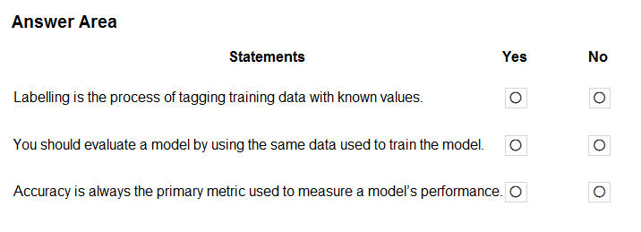

HOTSPOT -

For each of the following statements, select Yes if the statement is true. Otherwise, select No. NOTE: Each correct selection is worth one point.

Hot Area:

Correct Answer:

Box 1: Yes -

In machine learning, if you have labeled data, that means your data is marked up, or annotated, to show the target, which is the answer you want your machine learning model to predict.

In general, data labeling can refer to tasks that include data tagging, annotation, classification, moderation, transcription, or processing. Box 2: No -

Box 3: No -

Accuracy is simply the proportion of correctly classified instances. It is usually the first metric you look at when evaluating a classifier. However, when the test data is unbalanced (where most of the instances belong to one of the classes), or you are more interested in the performance on either one of the classes, accuracy doesn't really capture the effectiveness of a classifier.

Reference:

https:/[/www.cloudfactor](http://www.cloudfactory.com/data-labeling-guide)y[.com/data-labeling-guide](http://www.cloudfactory.com/data-labeling-guide)

https://docs.microsoft.com/en-us/azure/machine-learning/studio/evaluate-model-performance

**Question #31**

*Topic 1*

**You need to develop a mobile app for employees to scan and store their expenses while travelling.**

**Which type of computer vision should you use?**

1. **semantic segmentation**
2. **image classification**
3. **object detection**
4. **optical character recognition (OCR)**

**Correct Answer:** *D*

**Azure's Computer Vision API includes Optical Character Recognition (OCR) capabilities that extract printed or handwritten text from**

**images. You can extract text from images, such as photos of license plates or containers with serial numbers, as well as from documents - invoices, bills, financial reports, articles, and more.**

**Reference:**

**https://docs.microsoft.com/en-us/azure/cognitive-services/computer-vision/concept-recognizing-text**

**Question #32** *Topic 1*



DRAG DROP -

Match the facial recognition tasks to the appropriate questions.

To answer, drag the appropriate task from the column on the left to its question on the right. Each task may be used once, more than once, or not at all.

NOTE: Each correct selection is worth one point. Select and Place:

Correct Answer:

Box 1: verification -

Face verification: Check the likelihood that two faces belong to the same person and receive a confidence score. Box 2: similarity -

Box 3: Grouping -

Box 4: identification -

Face detection: Detect one or more human faces along with attributes such as: age, emotion, pose, smile, and facial hair, including 27 landmarks for each face in the image.

Reference:

https://azure.microsoft.com/en-us/services/cognitive-services/face/#features



[**Previous Questions**](https://www.examtopics.com/exams/microsoft/ai-900/view/7/)



[**Next Questions**](https://www.examtopics.com/exams/microsoft/ai-900/view/9/)

**Question #25**

*Topic 1*

**Which type of machine learning should you use to predict the number of gift cards that will be sold next month?**

1. **classification**
2. **regression**
3. **clustering**

**Correct Answer:** *C*

**Clustering, in machine learning, is a method of grouping data points into similar clusters. It is also called segmentation.**

**Over the years, many clustering algorithms have been developed. Almost all clustering algorithms use the features of individual items to find similar items. For example, you might apply clustering to find similar people by demographics. You might use clustering with text**

**analysis to group sentences with similar topics or sentiment. Reference:**

**https://docs.microsoft.com/en-us/azure/machine-learning/studio-module-reference/machine-learning-initialize-model-clustering**

**Question #26** *Topic 1*

You have a dataset that contains information about taxi journeys that occurred during a given period. You need to train a model to predict the fare of a taxi journey.

What should you use as a feature?

1. **the number of taxi journeys in the dataset**
2. **the trip distance of individual taxi journeys**
3. **the fare of individual taxi journeys**
4. **the trip ID of individual taxi journeys**

Correct Answer: *B*

The label is the column you want to predict. The identified Featuresare the inputs you give the model to predict the Label. Example:

The provided data set contains the following columns:

vendor_id: The ID of the taxi vendor is a feature.

rate_code: The rate type of the taxi trip is a feature.

passenger_count: The number of passengers on the trip is a feature. trip_time_in_secs: The amount of time the trip took. You want to

predict the fare of the trip before the trip is completed. At that moment, you don't know how long the trip would take. Thus, the trip time is not a feature and you'll exclude this column from the model. trip_distance: The distance of the trip is a feature. payment_type: The

payment method (cash or credit card) is a feature. fare_amount: The total taxi fare paid is the label. Reference:

https://docs.microsoft.com/en-us/dotnet/machine-learning/tutorials/predict-prices

**Question #27**

*Topic 1*

**You need to predict the sea level in meters for the next 10 years.**

**Which type of machine learning should you use?**

1. **classification**
2. **regression**
3. **clustering**

**Correct Answer:** *B*

**In the most basic sense, regression refers to prediction of a numeric target.**

**Linear regression attempts to establish a linear relationship between one or more independent variables and a numeric outcome, or dependent variable.**

**You use this module to define a linear regression method, and then train a model using a labeled dataset. The trained model can then be used to make predictions.**

**Reference:**

**https://docs.microsoft.com/en-us/azure/machine-learning/studio-module-reference/linear-regression**

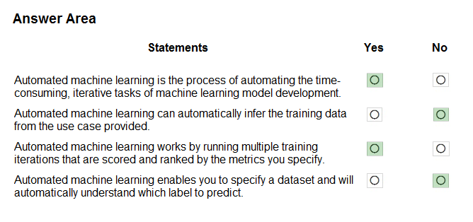

**Question #28** *Topic 1*

HOTSPOT -

For each of the following statements, select Yes if the statement is true. Otherwise, select No. NOTE: Each correct selection is worth one point.

Hot Area:

Correct Answer:

Box 1: Yes -

Automated machine learning, also referred to as automated ML or AutoML, is the process of automating the time consuming, iterative tasks of machine learning model development. It allows data scientists, analysts, and developers to build ML models with high scale, efficiency, and productivity all while sustaining model quality.

Box 2: No -

Box 3: Yes -

During training, Azure Machine Learning creates a number of pipelines in parallel that try different algorithms and parameters for you. The service iterates through

ML algorithms paired with feature selections, where each iteration produces a model with a training score. The higher the score, the better the model is considered to "fit" your data. It will stop once it hits the exit criteria defined in the experiment.

Box 4: No -

Apply automated ML when you want Azure Machine Learning to train and tune a model for you using the target metric you specify. The label is the column you want to predict.

Reference:

https://azure.microsoft.com/en-us/services/machine-learning/automatedml/#features

[Previous Questions](https://www.examtopics.com/exams/microsoft/ai-900/view/6/) [Next Questions](https://www.examtopics.com/exams/microsoft/ai-900/view/8/)



**Question #21** *Topic 1*

DRAG DROP -

Match the types of machine learning to the appropriate scenarios.

To answer, drag the appropriate machine learning type from the column on the left to its scenario on the right. Each machine learning type may be used once, more than once, or not at all.

NOTE: Each correct selection is worth one point. Select and Place:

Correct Answer:

Box 1: Regression -

In the most basic sense, regression refers to prediction of a numeric target.

Linear regression attempts to establish a linear relationship between one or more independent variables and a numeric outcome, or dependent variable.

You use this module to define a linear regression method, and then train a model using a labeled dataset. The trained model can then be used to make predictions.

Box 2: Classification -

Classification is a machine learning method that uses data to determine the category, type, or class of an item or row of data.

Box 3: Clustering -

Clustering, in machine learning, is a method of grouping data points into similar clusters. It is also called segmentation.

Over the years, many clustering algorithms have been developed. Almost all clustering algorithms use the features of individual items to find similar items. For example, you might apply clustering to find similar people by demographics. You might use clustering with text

analysis to group sentences with similar topics or sentiment. Reference:

https://docs.microsoft.com/en-us/azure/machine-learning/studio-module-reference/linear-regression

**Question #22** *Topic 1*

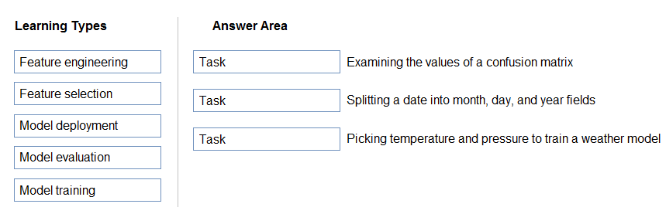

DRAG DROP -

Match the machine learning tasks to the appropriate scenarios.

To answer, drag the appropriate task from the column on the left to its scenario on the right. Each task may be used once, more than once, or not at all.

NOTE: Each correct selection is worth one point. Select and Place:

Correct Answer:

Box 1: Model evaluation -

The Model evaluation module outputs a confusion matrix showing the number of true positives, false negatives, false positives, and true negatives, as well as

ROC, Precision/Recall, and Lift curves.

Box 2: Feature engineering -

Feature engineering is the process of using domain knowledge of the data to create features that help ML algorithms learn better. In Azure Machine Learning, scaling and normalization techniques are applied to facilitate feature engineering. Collectively, these techniques and

feature engineering are referred to as featurization.

Note: Often, features are created from raw data through a process of feature engineering. For example, a time stamp in itself might not be useful for modeling until the information is transformed into units of days, months, or categories that are relevant to the problem, such as holiday versus working day.

Box 3: Feature selection -

In machine learning and statistics, feature selection is the process of selecting a subset of relevant, useful features to use in building an analytical model. Feature selection helps narrow the field of data to the most valuable inputs. Narrowing the field of data helps reduce

noise and improve training performance. Reference:

https://docs.microsoft.com/en-us/azure/machine-learning/studio/evaluate-model-performance https://docs.microsoft.com/en- us/azure/machine-learning/concept-automated-ml

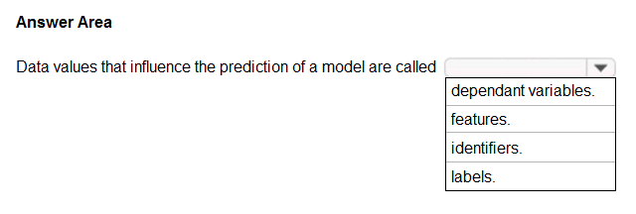

**Question #23**

*Topic 1*

**HOTSPOT -**

**To complete the sentence, select the appropriate option in the answer area. Hot Area:**

**Correct Answer:**

**In machine learning, if you have labeled data, that means your data is marked up, or annotated, to show the target, which is the answer you want your machine learning model to predict.**

**In general, data labeling can refer to tasks that include data tagging, annotation, classification, moderation, transcription, or processing. Incorrect Answers:**

**Not features: In machine learning and statistics, feature selection is the process of selecting a subset of relevant, useful features to use in building an analytical model. Feature selection helps narrow the field of data to the most valuable inputs. Narrowing the field of data helps reduce noise and improve training performance.**

**Reference:**

**https:/**[**/www.cloudfactor**](http://www.cloudfactory.com/data-labeling-guide)**y**[**.com/data-labeling-guide**](http://www.cloudfactory.com/data-labeling-guide)

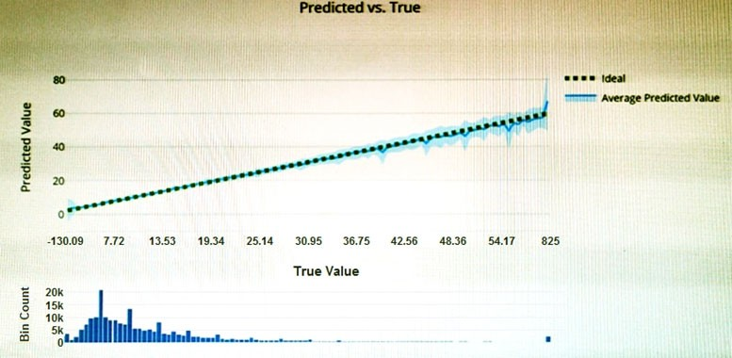

**Question #24**

*Topic 1*

**You have the Predicted vs. True chart shown in the following exhibit.**

**Which type of model is the chart used to evaluate?**

1. **classification**
2. **regression**
3. **clustering**

**Correct Answer:** *B*

**What is a Predicted vs. True chart?**

**Predicted vs. True shows the relationship between a predicted value and its correlating true value for a regression problem. This graph can be used to measure performance of a model as the closer to the y=x line the predicted values are, the better the accuracy of a predictive**

**model.**

**Reference:**

**https://docs.microsoft.com/en-us/azure/machine-learning/how-to-understand-automated-m**



[**Previous Questions**](https://www.examtopics.com/exams/microsoft/ai-900/view/5/)



[**Next Questions**](https://www.examtopics.com/exams/microsoft/ai-900/view/7/)



**Question #17**

*Topic 1*

**HOTSPOT -**

**You have the following dataset.**

**You plan to use the dataset to train a model that will predict the house price categories of houses.**

**What are Household Income and House Price Category? To answer, select the appropriate option in the answer area. NOTE: Each correct selection is worth one point.**

**Hot Area:**

**Correct Answer:**

**Reference:**

**https://docs.microsoft.com/en-us/azure/machine-learning/studio/interpret-model-results**

**Question #18**

*Topic 1*

**Which metric can you use to evaluate a classification model?**

1. **true positive rate**
2. **mean absolute error (MAE)**
3. **coefficient of determination (R2)**
4. **root mean squared error (RMSE)**

**Correct Answer:** *A*

**What does a good model look like?**

**An ROC curve that approaches the top left corner with 100% true positive rate and 0% false positive rate will be the best model. A random model would display as a flat line from the bottom left to the top right corner. Worse than random would dip below the y=x line.**

**Reference:**

**https://docs.microsoft.com/en-us/azure/machine-learning/how-to-understand-automated-ml#classification**

**Question #19**

*Topic 1*

**Which two components can you drag onto a canvas in Azure Machine Learning designer? Each correct answer presents a complete solution.**

**NOTE: Each correct selection is worth one point.**

1. **dataset**
2. **compute**
3. **pipeline**
4. **module**

**Correct Answer:** *AD*

**You can drag-and-drop datasets and modules onto the canvas. Reference:**

**https://docs.microsoft.com/en-us/azure/machine-learning/concept-designer**

**Question #20**

*Topic 1*

**You need to create a training dataset and validation dataset from an existing dataset.**

**Which module in the Azure Machine Learning designer should you use?**

1. **Select Columns in Dataset**
2. **Add Rows**
3. **Split Data**
4. **Join Data**

**Correct Answer:** *C*

**A common way of evaluating a model is to divide the data into a training and test set by using Split Data, and then validate the model on the training data.**

**Use the Split Data module to divide a dataset into two distinct sets. The studio currently supports training/validation data splits**

**Reference:**

**https://docs.microsoft.com/en-us/azure/machine-learning/how-to-configure-cross-validation-data-splits**



[**Previous Questions**](https://www.examtopics.com/exams/microsoft/ai-900/view/4/)



[**Next Questions**](https://www.examtopics.com/exams/microsoft/ai-900/view/6/)

**Question #13**

*Topic 1*

**You use Azure Machine Learning designer to publish an inference pipeline.**

**Which two parameters should you use to consume the pipeline? Each correct answer presents part of the solution. NOTE: Each correct selection is worth one point.**

1. **the model name**
2. **the training endpoint**
3. **the authentication key**
4. **the REST endpoint**

**Correct Answer:** *AD*

**A: The trained model is stored as a Dataset module in the module palette. You can find it under My Datasets.**

**Azure Machine Learning designer lets you visually connect datasets and modules on an interactive canvas to create machine learning models.**

**D: You can consume a published pipeline in the Published pipelines page. Select a published pipeline and find the REST endpoint of it. Reference:**

**https://docs.microsoft.com/en-us/azure/machine-learning/how-to-run-batch-predictions-designer https://docs.microsoft.com/en-**

**us/azure/machine-learning/concept-designer**

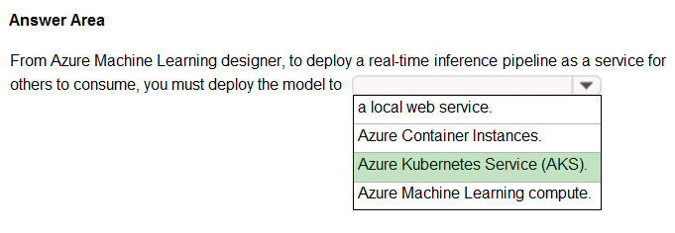

**Question #14**

*Topic 1*

**HOTSPOT -**

**To complete the sentence, select the appropriate option in the answer area. Hot Area:**

**Correct Answer:**

**To perform real-time inferencing, you must deploy a pipeline as a real-time endpoint. Real-time endpoints must be deployed to an Azure Kubernetes Service cluster.**

**Reference:**

**https://docs.microsoft.com/en-us/azure/machine-learning/concept-designer#deploy**

**Question #15** *Topic 1*



HOTSPOT -

To complete the sentence, select the appropriate option in the answer area. Hot Area:

Correct Answer:

In the most basic sense, regression refers to prediction of a numeric target.

Linear regression attempts to establish a linear relationship between one or more independent variables and a numeric outcome, or dependent variable.

You use this module to define a linear regression method, and then train a model using a labeled dataset. The trained model can then be used to make predictions.

Incorrect Answers:

✑ Classification is a machine learning method that uses data to determine the category, type, or class of an item or row of data.

✑ Clustering, in machine learning, is a method of grouping data points into similar clusters. It is also called segmentation.

Over the years, many clustering algorithms have been developed. Almost all clustering algorithms use the features of individual items to find similar items. For example, you might apply clustering to find similar people by demographics. You might use clustering with text

analysis to group sentences with similar topics or sentiment. Reference:

https://docs.microsoft.com/en-us/azure/machine-learning/algorithm-module-reference/linear-regression https://docs.microsoft.com/en- us/azure/machine-learning/studio-module-reference/machine-learning-initialize-model-clustering

**Question #16** *Topic 1*

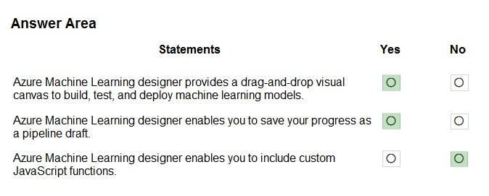

HOTSPOT -

For each of the following statements, select Yes if the statement is true. Otherwise, select No. NOTE: Each correct selection is worth one point.

Hot Area:

Correct Answer:

Box 1: Yes -

Azure Machine Learning designer lets you visually connect datasets and modules on an interactive canvas to create machine learning models.

Box 2: Yes -

With the designer you can connect the modules to create a pipeline draft.

As you edit a pipeline in the designer, your progress is saved as a pipeline draft.

Box 3: No - Reference:

https://docs.microsoft.com/en-us/azure/machine-learning/concept-designer



[**Previous Questions**](https://www.examtopics.com/exams/microsoft/ai-900/view/3/)



[**Next Questions**](https://www.examtopics.com/exams/microsoft/ai-900/view/5/)

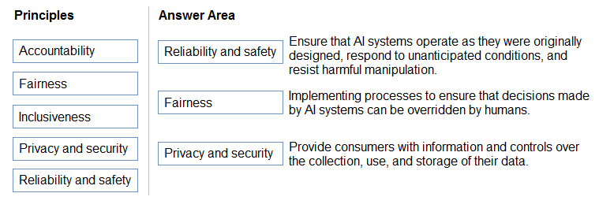

**Question #9** *Topic 1*

DRAG DROP -

Match the Microsoft guiding principles for responsible AI to the appropriate descriptions.

To answer, drag the appropriate principle from the column on the left to its description on the right. Each principle may be used once, more than once, or not at all.

NOTE: Each correct selection is worth one point. Select and Place:

Correct Answer:

Box 1: Reliability and safety -

To build trust, it's critical that AI systems operate reliably, safely, and consistently under normal circumstances and in unexpected conditions. These systems should be able to operate as they were originally designed, respond safely to unanticipated conditions, and resist harmful manipulation.

Box 2: Fairness -

Fairness: AI systems should treat everyone fairly and avoid affecting similarly situated groups of people in different ways. For example, when AI systems provide guidance on medical treatment, loan applications, or employment, they should make the same recommendations to everyone with similar symptoms, financial circumstances, or professional qualifications.

We believe that mitigating bias starts with people understanding the implications and limitations of AI predictions and recommendations. Ultimately, people should supplement AI decisions with sound human judgment and be held accountable for consequential decisions that affect others.

Box 3: Privacy and security -

As AI becomes more prevalent, protecting privacy and securing important personal and business information is becoming more critical and complex. With AI, privacy and data security issues require especially close attention because access to data is essential for AI

systems to make accurate and informed predictions and decisions about people. AI systems must comply with privacy laws that require transparency about the collection, use, and storage of data and mandate that consumers have appropriate controls to choose how their data is used

Reference:

https://docs.microsoft.com/en-us/learn/modules/responsible-ai-principles/4-guiding-principles

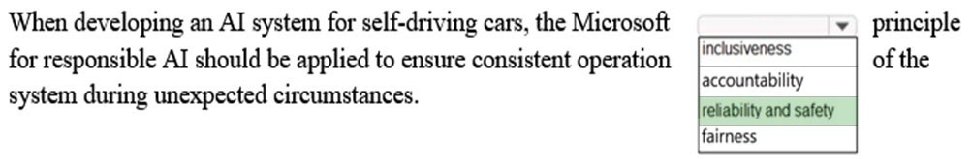

**Question #10**

*Topic 1*

**HOTSPOT -**

**To complete the sentence, select the appropriate option in the answer area. Hot Area:**

**Correct Answer:**

**Reliability and safety: To build trust, it's critical that AI systems operate reliably, safely, and consistently under normal circumstances and in unexpected conditions.**

**These systems should be able to operate as they were originally designed, respond safely to unanticipated conditions, and resist harmful manipulation.**

**Reference:**

**https://docs.microsoft.com/en-us/learn/modules/responsible-ai-principles/4-guiding-principles**

**Question #11**

*Topic 1*

**Which service should you use to extract text, key/value pairs, and table data automatically from scanned documents?**

1. **Form Recognizer**
2. **Text Analytics**
3. **Ink Recognizer**
4. **Custom Vision**

**Correct Answer:** *A*

**Accelerate your business processes by automating information extraction. Form Recognizer applies advanced machine learning to**

**accurately extract text, key/ value pairs, and tables from documents. With just a few samples, Form Recognizer tailors its understanding to your documents, both on-premises and in the cloud. Turn forms into usable data at a fraction of the time and cost, so you can focus more time acting on the information rather than compiling it.**

**Reference:**

**https://azure.microsoft.com/en-us/services/cognitive-services/form-recognizer/**

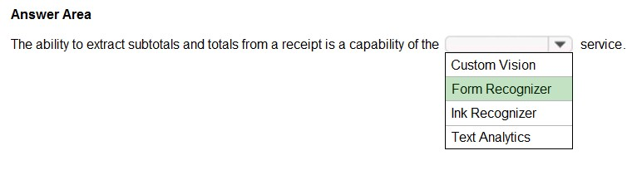

**Question #12**

*Topic 1*

**HOTSPOT -**

**To complete the sentence, select the appropriate option in the answer area. Hot Area:**

**Correct Answer:**

**Accelerate your business processes by automating information extraction. Form Recognizer applies advanced machine learning to**

**accurately extract text, key/ value pairs, and tables from documents. With just a few samples, Form Recognizer tailors its understanding to your documents, both on-premises and in the cloud. Turn forms into usable data at a fraction of the time and cost, so you can focus more time acting on the information rather than compiling it.**

**Reference:**

**https://azure.microsoft.com/en-us/services/cognitive-services/form-recognizer/**

**Topic 1 - Single Topic**

**Question #1**

*Topic 1*

**A company employs a team of customer service agents to provide telephone and email support to customers. The company develops a webchat bot to provide automated answers to common customer queries.**

**Which business benefit should the company expect as a result of creating the webchat bot solution?**

1. **increased sales**
2. **a reduced workload for the customer service agents**
3. **improved product reliability**

**Correct Answer:** *B*

**Question #2**

*Topic 1*

**For a machine learning progress, how should you split data for training and evaluation?**

1. **Use features for training and labels for evaluation.**
2. **Randomly split the data into rows for training and rows for evaluation.**
3. **Use labels for training and features for evaluation.**
4. **Randomly split the data into columns for training and columns for evaluation.**

**Correct Answer:** *D*

**In Azure Machine Learning, the percentage split is the available technique to split the data. In this technique, random data of a given percentage will be split to train and test data.**

**Reference:**

**https:/**[**/www.sqlshack.com/prediction-in-azure-machine-learning/**](http://www.sqlshack.com/prediction-in-azure-machine-learning/)

**Question #3** *Topic 1*

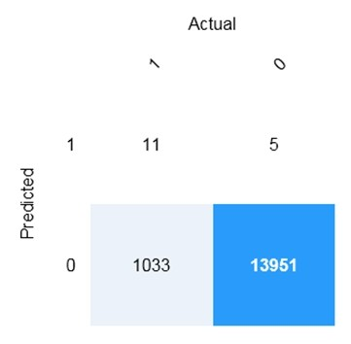

HOTSPOT -

You are developing a model to predict events by using classification.

You have a confusion matrix for the model scored on test data as shown in the following exhibit.

Use the drop-down menus to select the answer choice that completes each statement based on the information presented in the graphic. NOTE: Each correct selection is worth one point.

Hot Area:

Correct Answer:

Box 1: 11 -

TP = True Positive.

The class labels in the training set can take on only two possible values, which we usually refer to as positive or negative. The positive and

**negative instances that a classifier predicts correctly are called true positives (TP) and true negatives (TN), respectively. Similarly, the**

**incorrectly classified instances are called false positives (FP) and false negatives (FN).**

**Box 2: 1,033 -**

**FN = False Negative - Reference:**

**https://docs.microsoft.com/en-us/azure/machine-learning/studio/evaluate-model-performance**

**Question #4** *Topic 1*

You build a machine learning model by using the automated machine learning user interface (UI). You need to ensure that the model meets the Microsoft transparency principle for responsible AI. What should you do?

1. **Set Validation type to Auto.**
2. **Enable Explain best model.**
3. **Set Primary metric to accuracy.**
4. **Set Max concurrent iterations to 0.**

Correct Answer: *B*

Model Explain Ability.

Most businesses run on trust and being able to open the ML "black box" helps build transparency and trust. In heavily regulated industries like healthcare and banking, it is critical to comply with regulations and best practices. One key aspect of this is understanding the relationship between input variables (features) and model output. Knowing both the magnitude and direction of the impact each feature (feature

importance) has on the predicted value helps better understand and explain the model. With model explain ability, we enable you to understand feature importance as part of automated ML runs.

Reference:

https://azure.microsoft.com/en-us/blog/new-automated-machine-learning-capabilities-in-azure-machine-learning-service/



**Question #5**

*Topic 1*

**HOTSPOT -**

**For each of the following statements, select Yes if the statement is true. Otherwise, select No. NOTE: Each correct selection is worth one point.**

**Hot Area:**

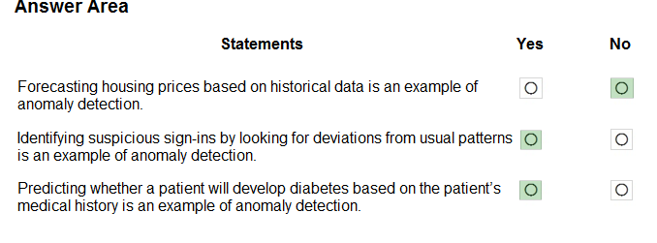

**Correct Answer:**

**Anomaly detection encompasses many important tasks in machine learning:**

**Identifying transactions that are potentially fraudulent.**

**Learning patterns that indicate that a network intrusion has occurred. Finding abnormal clusters of patients.**

**Checking values entered into a system. Reference:**

**https://docs.microsoft.com/en-us/azure/machine-learning/studio-module-reference/anomaly-detection**



**Question #6**

*Topic 1*

**HOTSPOT -**

**To complete the sentence, select the appropriate option in the answer area. Hot Area:**

**Correct Answer:**

**Privacy and security.**

**As AI becomes more prevalent, protecting privacy and securing important personal and business information is becoming more critical and complex. With AI, privacy and data security issues require especially close attention because access to data is essential for AI systems to make accurate and informed predictions and decisions about people. AI systems must comply with privacy laws that require transparency about the collection, use, and storage of data and mandate that consumers have appropriate controls to choose how their data is used. At Microsoft, we are continuing to research privacy and security breakthroughs (see next unit) and invest in robust compliance processes to ensure that data collected and used by our AI systems is handled responsibly.**

**Reference:**

**https://docs.microsoft.com/en-us/learn/modules/responsible-ai-principles/4-guiding-principles**

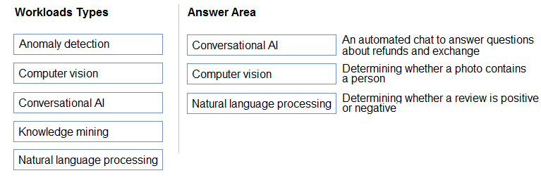

**Question #7** *Topic 1*

DRAG DROP -

Match the types of AI workloads to the appropriate scenarios.

To answer, drag the appropriate workload type from the column on the left to its scenario on the right. Each workload type may be used once, more than once, or not at all.

NOTE: Each correct selection is worth one point. Select and Place:

Correct Answer:

Box 3: Natural language processing

Natural language processing (NLP) is used for tasks such as sentiment analysis, topic detection, language detection, key phrase extraction, and document categorization.

Reference:

https://docs.microsoft.com/en-us/azure/architecture/data-guide/technology-choices/natural-language-processing

**Question #8**

*Topic 1*

**You are designing an AI system that empowers everyone, including people who have hearing, visual, and other impairments.**

**This is an example of which Microsoft guiding principle for responsible AI?**

1. **fairness**
2. **inclusiveness**
3. **reliability and safety**
4. **accountability**

**Correct Answer:** *B*

**Inclusiveness: At Microsoft, we firmly believe everyone should benefit from intelligent technology, meaning it must incorporate and address a broad range of human needs and experiences. For the 1 billion people with disabilities around the world, AI technologies can be a game- changer.**

**Reference:**

**https://docs.microsoft.com/en-us/learn/modules/responsible-ai-principles/4-guiding-principles**

### NEW QUESTION 1

- (Exam Topic 1)

You are building an AI system.

Which task should you include to ensure that the service meets the Microsoft transparency principle for responsible AI?

1. Ensure that all visuals have an associated text that can be read by a screen reader.
2. Enable autoscaling to ensure that a service scales based on demand.
3. Provide documentation to help developers debug code.
4. Ensure that a training dataset is representative of the population.

### Answer: **C**

**Explanation:**

Reference:

https://docs.microsoft.com/en-us/learn/modules/responsible-ai-principles/4-guiding-principles

### NEW QUESTION 2

* (Exam Topic 1)

A company employs a team of customer service agents to provide telephone and email support to customers. The company develops a webchat bot to provide automated answers to common customer queries.

Which business benefit should the company expect as a result of creating the webchat bot solution?

1. increased sales
2. a reduced workload for the customer service agents
3. improved product reliability

### Answer: **B**

**NEW QUESTION 3**

* (Exam Topic 1)

To complete the sentence, select the appropriate option in the answer area.

1. Mastered
2. Not Mastered

### Answer: **A**

**Explanation:**

Privacy and security.

As AI becomes more prevalent, protecting privacy and securing important personal and business information is becoming more critical and complex. With AI, privacy and data security issues require especially close attention because access to data is essential for AI systems to make accurate and informed predictions and decisions about people. AI systems must comply with privacy laws that require transparency about the collection, use, and storage of data and mandate that consumers have appropriate controls to choose how their data is used. At Microsoft, we are continuing to research privacy and security breakthroughs (see next unit) and invest in robust compliance processes to ensure that data collected and used by our AI systems is handled responsibly.

Reference:

https://docs.microsoft.com/en-us/learn/modules/responsible-ai-principles/4-guiding-principles

### NEW QUESTION 4

* (Exam Topic 1)

You build a machine learning model by using the automated machine learning user interface (UI). You need to ensure that the model meets the Microsoft transparency principle for responsible AI. What should you do?

1. Set Validation type to Auto.
2. Enable Explain best model.
3. Set Primary metric to accuracy.
4. Set Max concurrent iterations to 0.

### Answer: **B**

**Explanation:**

Model Explain Ability.

Most businesses run on trust and being able to open the ML “black box” helps build transparency and trust. In heavily regulated industries like healthcare and banking, it is critical to comply with regulations and best practices. One key aspect of this is understanding the relationship between input variables (features) and model output. Knowing both the magnitude and direction of the impact each feature (feature importance) has on the predicted value helps better understand and explain the model. With model explain ability, we enable you to understand feature importance as part of automated ML runs.

Reference:

https://azure.microsoft.com/en-us/blog/new-automated-machine-learning-capabilities-in-azure-machine-learning

### NEW QUESTION 5

* (Exam Topic 1)

To complete the sentence, select the appropriate option in the answer area.

1. Mastered
2. Not Mastered

### Answer: **A**

**Explanation:**

Reference:

https://docs.microsoft.com/en-us/azure/cognitive-services/computer-vision/concept-object-detection

### NEW QUESTION 6

* (Exam Topic 1)

Match the types of AI workloads to the appropriate scenarios.

To answer, drag the appropriate workload type from the column on the left to its scenario on the right. Each workload type may be used once, more than once, or not at all.

NOTE: Each correct selection is worth one point.

1. Mastered
2. Not Mastered

### Answer: **A**

**Explanation:**

Reference:

https://docs.microsoft.com/en-us/learn/paths/get-started-with-artificial-intelligence-on-azure/

### NEW QUESTION 7

* (Exam Topic 2)

Which metric can you use to evaluate a classification model?

1. true positive rate
2. mean absolute error (MAE)
3. coefficient of determination (R2)
4. root mean squared error (RMSE)

### Answer: **A**

**Explanation:**

What does a good model look like?

An ROC curve that approaches the top left corner with 100% true positive rate and 0% false positive rate will be the best model. A random model would display as a flat line from the bottom left to the top right corner. Worse than random would dip below the y=x line.

Reference:https://docs.microsoft.com/en-us/azure/machine-learning/how-to-understand-automated-ml#classification

### NEW QUESTION 8

* (Exam Topic 2)

To complete the sentence, select the appropriate option in the answer area.

1. Mastered
2. Not Mastered

### Answer: **A**

**Explanation:**

In machine learning, if you have labeled data, that means your data is marked up, or annotated, to show the target, which is the answer you want your machine learning model to predict.

In general, data labeling can refer to tasks that include data tagging, annotation, classification, moderation, transcription, or processing. Reference:

[https://www.cloudfactory.com/data-labeling-guide](http://www.cloudfactory.com/data-labeling-guide)

### NEW QUESTION 9

* (Exam Topic 2)

Which type of machine learning should you use to predict the number of gift cards that will be sold next month?

1. classification
2. regression
3. clustering

### Answer: **C**

**Explanation:**

Clustering, in machine learning, is a method of grouping data points into similar clusters. It is also called segmentation.

Over the years, many clustering algorithms have been developed. Almost all clustering algorithms use the features of individual items to find similar items. For example, you might apply clustering to find similar people by demographics. You might use clustering with text analysis to group sentences with similar topics or sentiment.

Reference:

https://docs.microsoft.com/en-us/azure/machine-learning/studio-module-reference/machine-learning-initialize-m

### NEW QUESTION 10

* (Exam Topic 2)

You need to predict the income range of a given customer by using the following dataset.

Which two fields should you use as features? Each correct answer presents a complete solution. NOTE: Each correct selection is worth one point.

1. Education Level
2. Last Name
3. Age
4. Income Range
5. First Name

### Answer: **AC**

**Explanation:**

First Name, Last Name, Age and Education Level are features. Income range is a label (what you want to predict). First Name and Last Name are irrelevant in that they have no bearing on income. Age and Education level are the features you should use.

### NEW QUESTION 10

* (Exam Topic 2)

To complete the sentence, select the appropriate option in the answer area.

1. Mastered
2. Not Mastered

### Answer: **A**

**Explanation:**

In the most basic sense, regression refers to prediction of a numeric target.

Example: Regression Model: A Boosted Decision Tree algorithm was used to create and train the model for predicting the repayment rate. Reference:

https://gallery.azure.ai/Experiment/Student-Loan-Repayment-Rate-Prediction

### NEW QUESTION 1

- (Exam Topic 1)

You are building an AI system.

Which task should you include to ensure that the service meets the Microsoft transparency principle for responsible AI?

1. Ensure that all visuals have an associated text that can be read by a screen reader.
2. Enable autoscaling to ensure that a service scales based on demand.
3. Provide documentation to help developers debug code.
4. Ensure that a training dataset is representative of the population.

### Answer: **C**

**Explanation:**

Reference:

https://docs.microsoft.com/en-us/learn/modules/responsible-ai-principles/4-guiding-principles

### NEW QUESTION 2

* (Exam Topic 1)

A company employs a team of customer service agents to provide telephone and email support to customers. The company develops a webchat bot to provide automated answers to common customer queries.

Which business benefit should the company expect as a result of creating the webchat bot solution?

1. increased sales
2. a reduced workload for the customer service agents
3. improved product reliability

### Answer: **B**

**NEW QUESTION 3**

* (Exam Topic 1)

To complete the sentence, select the appropriate option in the answer area.

1. Mastered
2. Not Mastered

### Answer: **A**

**Explanation:**

Privacy and security.

As AI becomes more prevalent, protecting privacy and securing important personal and business information is becoming more critical and complex. With AI, privacy and data security issues require especially close attention because access to data is essential for AI systems to make accurate and informed predictions and decisions about people. AI systems must comply with privacy laws that require transparency about the collection, use, and storage of data and mandate that consumers have appropriate controls to choose how their data is used. At Microsoft, we are continuing to research privacy and security breakthroughs (see next unit) and invest in robust compliance processes to ensure that data collected and used by our AI systems is handled responsibly.

Reference:

https://docs.microsoft.com/en-us/learn/modules/responsible-ai-principles/4-guiding-principles

### NEW QUESTION 4

* (Exam Topic 1)

You build a machine learning model by using the automated machine learning user interface (UI). You need to ensure that the model meets the Microsoft transparency principle for responsible AI. What should you do?

1. Set Validation type to Auto.
2. Enable Explain best model.
3. Set Primary metric to accuracy.
4. Set Max concurrent iterations to 0.

### Answer: **B**

**Explanation:**

Model Explain Ability.

Most businesses run on trust and being able to open the ML “black box” helps build transparency and trust. In heavily regulated industries like healthcare and banking, it is critical to comply with regulations and best practices. One key aspect of this is understanding the relationship between input variables (features) and model output. Knowing both the magnitude and direction of the impact each feature (feature importance) has on the predicted value helps better understand and explain the model. With model explain ability, we enable you to understand feature importance as part of automated ML runs.

Reference:

https://azure.microsoft.com/en-us/blog/new-automated-machine-learning-capabilities-in-azure-machine-learning

### NEW QUESTION 5

* (Exam Topic 1)

To complete the sentence, select the appropriate option in the answer area.

1. Mastered
2. Not Mastered

### Answer: **A**

**Explanation:**

Reference:

https://docs.microsoft.com/en-us/azure/cognitive-services/computer-vision/concept-object-detection

### NEW QUESTION 6

* (Exam Topic 1)

Match the types of AI workloads to the appropriate scenarios.

To answer, drag the appropriate workload type from the column on the left to its scenario on the right. Each workload type may be used once, more than once, or not at all.

NOTE: Each correct selection is worth one point.

1. Mastered
2. Not Mastered

### Answer: **A**

**Explanation:**

Reference:

https://docs.microsoft.com/en-us/learn/paths/get-started-with-artificial-intelligence-on-azure/

### NEW QUESTION 7

* (Exam Topic 2)

Which metric can you use to evaluate a classification model?

1. true positive rate
2. mean absolute error (MAE)
3. coefficient of determination (R2)
4. root mean squared error (RMSE)

### Answer: **A**

**Explanation:**

What does a good model look like?

An ROC curve that approaches the top left corner with 100% true positive rate and 0% false positive rate will be the best model. A random model would display as a flat line from the bottom left to the top right corner. Worse than random would dip below the y=x line.

Reference:tps://docs.microsoft.com/en-us/azure/machine-learning/how-to-understand-automated-ml#classification

### NEW QUESTION 8

* (Exam Topic 2)

To complete the sentence, select the appropriate option in the answer area.

1. Mastered
2. Not Mastered

### Answer: **A**

**Explanation:**

In machine learning, if you have labeled data, that means your data is marked up, or annotated, to show the target, which is the answer you want your machine learning model to predict.

In general, data labeling can refer to tasks that include data tagging, annotation, classification, moderation, transcription, or processing. Reference:

[https://www.cloudfactory.com/data-labeling-guide](http://www.cloudfactory.com/data-labeling-guide)

### NEW QUESTION 9

* (Exam Topic 2)

Which type of machine learning should you use to predict the number of gift cards that will be sold next month?

1. classification
2. regression
3. clustering

### Answer: **C**

**Explanation:**

Clustering, in machine learning, is a method of grouping data points into similar clusters. It is also called segmentation.

Over the years, many clustering algorithms have been developed. Almost all clustering algorithms use the features of individual items to find similar items. For example, you might apply clustering to find similar people by demographics. You might use clustering with text analysis to group sentences with similar topics or sentiment.

Reference:

https://docs.microsoft.com/en-us/azure/machine-learning/studio-module-reference/machine-learning-initialize-m

### NEW QUESTION 10

* (Exam Topic 2)

You need to predict the income range of a given customer by using the following dataset.

Which two fields should you use as features? Each correct answer presents a complete solution. NOTE: Each correct selection is worth one point.

1. Education Level
2. Last Name
3. Age
4. Income Range
5. First Name

### Answer: **AC**

**Explanation:**

First Name, Last Name, Age and Education Level are features. Income range is a label (what you want to predict). First Name and Last Name are irrelevant in that they have no bearing on income. Age and Education level are the features you should use.

### NEW QUESTION 10

* (Exam Topic 2)

To complete the sentence, select the appropriate option in the answer area.

1. Mastered
2. Not Mastered

### Answer: **A**

**Explanation:**

In the most basic sense, regression refers to prediction of a numeric target.

Example: Regression Model: A Boosted Decision Tree algorithm was used to create and train the model for predicting the repayment rate. Reference:

https://gallery.azure.ai/Experiment/Student-Loan-Repayment-Rate-Prediction

## NEW QUESTION 1

- (Exam Topic 1)

You run a charity event that involves posting photos of people wearing sunglasses on Twitter. You need to ensure that you only retweet photos that meet the following requirements: Include one or more faces.

Contain at least one person wearing sunglasses. What should you use to analyze the images?

1. the Verify operation in the Face service
2. the Detect operation in the Face service
3. the Describe Image operation in the Computer Vision service
4. the Analyze Image operation in the Computer Vision service

## Answer: **B**

**Explanation:**

Reference:

https://docs.microsoft.com/en-us/azure/cognitive-services/face/overview

## NEW QUESTION 2

- (Exam Topic 1)

To complete the sentence, select the appropriate option in the answer area.

1. Mastered
2. Not Mastered

## Answer: **A**

**Explanation:**

Reliability and safety: To build trust, it's critical that AI systems operate reliably, safely, and consistently under normal circumstances and in unexpected conditions. These systems should be able to operate as they were originally designed, respond safely to unanticipated conditions, and resist harmful manipulation.

Reference:

https://docs.microsoft.com/en-us/learn/modules/responsible-ai-principles/4-guiding-principles

## NEW QUESTION 3

- (Exam Topic 1)

Your company is exploring the use of voice recognition technologies in its smart home devices. The company wants to identify any barriers that might unintentionally leave out specific user groups.

This an example of which Microsoft guiding principle for responsible AI?

1. accountability
2. fairness
3. inclusiveness
4. privacy and security

## Answer: **C**

**Explanation:**

Reference:

https://docs.microsoft.com/en-us/learn/modules/responsible-ai-principles/4-guiding-principles

## NEW QUESTION 4

- (Exam Topic 1)

Match the Microsoft guiding principles for responsible AI to the appropriate descriptions.

To answer, drag the appropriate principle from the column on the left to its description on the right. Each principle may be used once, more than once, or not at all. NOTE: Each correct selection is worth one point.

1. Mastered
2. Not Mastered

## Answer: **A**

**Explanation:**

Box 1: Reliability and safety

To build trust, it's critical that AI systems operate reliably, safely, and consistently under normal circumstances and in unexpected conditions. These systems should be able to operate as they were originally designed, respond safely to unanticipated conditions, and resist harmful manipulation.

Box 2: Fairness

Fairness: AI systems should treat everyone fairly and avoid affecting similarly situated groups of people in different ways. For example, when AI systems provide guidance on medical treatment, loan applications, or employment, they should make the same recommendations to everyone with similar symptoms, financial circumstances, or professional qualifications.

We believe that mitigating bias starts with people understanding the implications and limitations of AI predictions and recommendations. Ultimately, people should supplement AI decisions with sound human judgment and be held accountable for consequential decisions that affect others.

Box 3: Privacy and security

As AI becomes more prevalent, protecting privacy and securing important personal and business information is becoming more critical and complex. With AI, privacy and data security issues require especially close attention because access to data is essential for AI systems to make accurate and informed predictions and decisions about people. AI systems must comply with privacy laws that require transparency about the collection, use, and storage of data and mandate that consumers have appropriate controls to choose how their data is used

Reference:

https://docs.microsoft.com/en-us/learn/modules/responsible-ai-principles/4-guiding-principles

## NEW QUESTION 5

- (Exam Topic 1)

You are developing a model to predict events by using classification.

You have a confusion matrix for the model scored on test data as shown in the following exhibit.

Use the drop-down menus to select the answer choice that completes each statement based on the information presented in the graphic. NOTE: Each correct selection is worth one point.

1. Mastered
2. Not Mastered

## Answer: **A**

**Explanation:**

Box 1: 11

TP = True Positive.

The class labels in the training set can take on only two possible values, which we usually refer to as positive or negative. The positive and negative instances that a classifier predicts correctly are called true positives (TP) and true negatives (TN), respectively. Similarly, the incorrectly classified instances are called false positives (FP) and false negatives (FN).

Box 2: 1,033

FN = False Negative Reference:

https://docs.microsoft.com/en-us/azure/machine-learning/studio/evaluate-model-performance

## NEW QUESTION 6

- (Exam Topic 1)

Match the types of AI workloads to the appropriate scenarios.

To answer, drag the appropriate workload type from the column on the left to its scenario on the right. Each workload type may be used once, more than once, or not at all.

NOTE: Each correct selection is worth one point.

1. Mastered
2. Not Mastered

## Answer: **A**

**Explanation:**

Reference:

https://docs.microsoft.com/en-us/learn/paths/get-started-with-artificial-intelligence-on-azure/

## NEW QUESTION 7

- (Exam Topic 2)

Which metric can you use to evaluate a classification model?

1. true positive rate
2. mean absolute error (MAE)
3. coefficient of determination (R2)
4. root mean squared error (RMSE)

## Answer: **A**

**Explanation:**

What does a good model look like?

An ROC curve that approaches the top left corner with 100% true positive rate and 0% false positive rate will be the best model. A random model would display as a flat line from the bottom left to the top right corner. Worse than random would dip below the y=x line.

Reference:

https://docs.microsoft.com/en-us/azure/machine-learning/how-to-understand-automated-ml#classification

## NEW QUESTION 8

- (Exam Topic 2)

To complete the sentence, select the appropriate option in the answer area.

1. Mastered
2. Not Mastered

## Answer: **A**

**Explanation:**

In machine learning, if you have labeled data, that means your data is marked up, or annotated, to show the target, which is the answer you want your machine learning model to predict.

In general, data labeling can refer to tasks that include data tagging, annotation, classification, moderation, transcription, or processing. Reference:

[https://www.cloudfactory.com/data-labeling-guide](http://www.cloudfactory.com/data-labeling-guide)

## NEW QUESTION 9

- (Exam Topic 2)

Which type of machine learning should you use to predict the number of gift cards that will be sold next month?

1. classification
2. regression
3. clustering

## Answer: **C**

**Explanation:**

Clustering, in machine learning, is a method of grouping data points into similar clusters. It is also called segmentation.

Over the years, many clustering algorithms have been developed. Almost all clustering algorithms use the features of individual items to find similar items. For example, you might apply clustering to find similar people by demographics. You might use clustering with text analysis to group sentences with similar topics or sentiment.

Reference:

https://docs.microsoft.com/en-us/azure/machine-learning/studio-module-reference/machine-learning-initialize-mW QUESTION 10

- (Exam Topic 2)

To complete the sentence, select the appropriate option in the answer area.

1. Mastered
2. Not Mastered

## Answer: **A**

**Explanation:**

In the most basic sense, regression refers to prediction of a numeric target.

Example: Regression Model: A Boosted Decision Tree algorithm was used to create and train the model for predicting the repayment rate. Reference:

https://gallery.azure.ai/Experiment/Student-Loan-Repayment-Rate-Prediction

### NEW QUESTION 1

* (Exam Topic 1)

A company employs a team of customer service agents to provide telephone and email support to customers. The company develops a webchat bot to provide automated answers to common customer queries.

Which business benefit should the company expect as a result of creating the webchat bot solution?

1. increased sales
2. a reduced workload for the customer service agents
3. improved product reliability

### Answer: **B**

**NEW QUESTION 2**

* (Exam Topic 1)

For a machine learning progress, how should you split data for training and evaluation?

1. Use features for training and labels for evaluation.
2. Randomly split the data into rows for training and rows for evaluation.
3. Use labels for training and features for evaluation.
4. Randomly split the data into columns for training and columns for evaluation.

### Answer: **D**

**Explanation:**

In Azure Machine Learning, the percentage split is the available technique to split the data. In this technique, random data of a given percentage will be split to train and test data.

Reference:

[https://www.sqlshack.com/prediction-in-azure-machine-learning/](http://www.sqlshack.com/prediction-in-azure-machine-learning/)

### NEW QUESTION 3

* (Exam Topic 1)

To complete the sentence, select the appropriate option in the answer area.

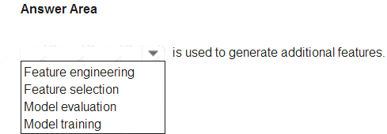

1. Mastered
2. Not Mastered

### Answer: **A**

**Explanation:**

Reference:

https://docs.microsoft.com/en-us/azure/machine-learning/team-data-science-process/create-features

### NEW QUESTION 4

* (Exam Topic 1)

Match the types of AI workloads to the appropriate scenarios.

To answer, drag the appropriate workload type from the column on the left to its scenario on the right. Each workload type may be used once, more than once, or not at all.

NOTE: Each correct selection is worth one point.

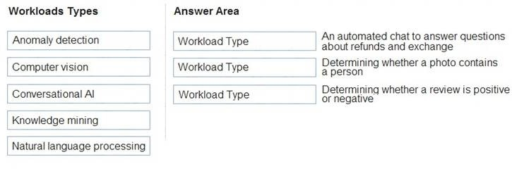

1. Mastered
2. Not Mastered

### Answer: **A**

**Explanation:**

Box 3: Natural language processing

Natural language processing (NLP) is used for tasks such as sentiment analysis, topic detection, language detection, key phrase extraction, and document categorization.

Reference:

https://docs.microsoft.com/en-us/azure/architecture/data-guide/technology-choices/natural-language-processing

### NEW QUESTION 5

* (Exam Topic 2)

Which type of machine learning should you use to predict the number of gift cards that will be sold next month?

1. classification
2. regression
3. clustering

### Answer: **C**

**Explanation:**

Clustering, in machine learning, is a method of grouping data points into similar clusters. It is also called segmentation.

Over the years, many clustering algorithms have been developed. Almost all clustering algorithms use the features of individual items to find similar items. For example, you might apply clustering to find similar people by demographics. You might use clustering with text analysis to group sentences with similar topics or sentiment.

Reference:

https://docs.microsoft.com/en-us/azure/machine-learning/studio-module-reference/machine-learning-initialize-m

### NEW QUESTION 6

* (Exam Topic 2)

You need to predict the income range of a given customer by using the following dataset.

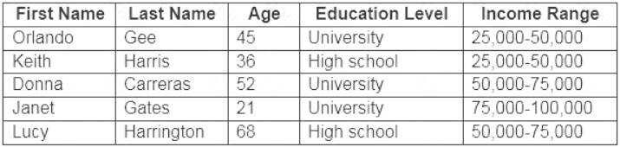

Which two fields should you use as features? Each correct answer presents a complete solution. NOTE: Each correct selection is worth one point.

1. Education Level
2. Last Name
3. Age
4. Income Range
5. First Name

### Answer: **AC**

**Explanation:**

First Name, Last Name, Age and Education Level are features. Income range is a label (what you want to predict). First Name and Last Name are irrelevant in that they have no bearing on income. Age and Education level are the features you should use.

### NEW QUESTION 7

* (Exam Topic 2)

To complete the sentence, select the appropriate option in the answer area.

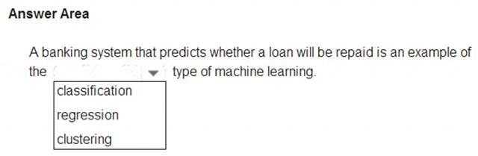

1. Mastered
2. Not Mastered

### Answer: **A**

**Explanation:**

In the most basic sense, regression refers to prediction of a numeric target.

Example: Regression Model: A Boosted Decision Tree algorithm was used to create and train the model for predicting the repayment rate. Reference:

https://gallery.azure.ai/Experiment/Student-Loan-Repayment-Rate-Prediction

### NEW QUESTION 1

- (Exam Topic 1)

You are building an AI system.

Which task should you include to ensure that the service meets the Microsoft transparency principle for responsible AI?

1. Ensure that all visuals have an associated text that can be read by a screen reader.
2. Enable autoscaling to ensure that a service scales based on demand.
3. Provide documentation to help developers debug code.
4. Ensure that a training dataset is representative of the population.

### Answer: **C**

**Explanation:**

Reference:

https://docs.microsoft.com/en-us/learn/modules/responsible-ai-principles/4-guiding-principles

### NEW QUESTION 2

* (Exam Topic 1)

A company employs a team of customer service agents to provide telephone and email support to customers. The company develops a webchat bot to provide automated answers to common customer queries.

Which business benefit should the company expect as a result of creating the webchat bot solution?

1. increased sales
2. a reduced workload for the customer service agents
3. improved product reliability

### Answer: **B**

**NEW QUESTION 3**

* (Exam Topic 1)

To complete the sentence, select the appropriate option in the answer area.

1. Mastered
2. Not Mastered

### Answer: **A**

**Explanation:**

Privacy and security.

As AI becomes more prevalent, protecting privacy and securing important personal and business information is becoming more critical and complex. With AI, privacy and data security issues require especially close attention because access to data is essential for AI systems to make accurate and informed predictions and decisions about people. AI systems must comply with privacy laws that require transparency about the collection, use, and storage of data and mandate that consumers have appropriate controls to choose how their data is used. At Microsoft, we are continuing to research privacy and security breakthroughs (see next unit) and invest in robust compliance processes to ensure that data collected and used by our AI systems is handled responsibly.

Reference:

https://docs.microsoft.com/en-us/learn/modules/responsible-ai-principles/4-guiding-principles

### NEW QUESTION 4

* (Exam Topic 1)

You build a machine learning model by using the automated machine learning user interface (UI). You need to ensure that the model meets the Microsoft transparency principle for responsible AI. What should you do?

1. Set Validation type to Auto.
2. Enable Explain best model.
3. Set Primary metric to accuracy.
4. Set Max concurrent iterations to 0.

### Answer: **B**

**Explanation:**

Model Explain Ability.

Most businesses run on trust and being able to open the ML “black box” helps build transparency and trust. In heavily regulated industries like healthcare and banking, it is critical to comply with regulations and best practices. One key aspect of this is understanding the relationship between input variables (features) and model output. Knowing both the magnitude and direction of the impact each feature (feature importance) has on the predicted value helps better understand and explain the model. With model explain ability, we enable you to understand feature importance as part of automated ML runs.

Reference:

https://azure.microsoft.com/en-us/blog/new-automated-machine-learning-capabilities-in-azure-machine-learning

### NEW QUESTION 5

* (Exam Topic 1)

To complete the sentence, select the appropriate option in the answer area.

1. Mastered
2. Not Mastered

### Answer: **A**

**Explanation:**

Reference:

https://docs.microsoft.com/en-us/azure/cognitive-services/computer-vision/concept-object-detection

### NEW QUESTION 6

* (Exam Topic 1)

Match the types of AI workloads to the appropriate scenarios.

To answer, drag the appropriate workload type from the column on the left to its scenario on the right. Each workload type may be used once, more than once, or not at all.

NOTE: Each correct selection is worth one point.

1. Mastered
2. Not Mastered

### Answer: **A**

**Explanation:**

Reference:

https://docs.microsoft.com/en-us/learn/paths/get-started-with-artificial-intelligence-on-azure/

### NEW QUESTION 7

* (Exam Topic 2)

Which metric can you use to evaluate a classification model?

1. true positive rate
2. mean absolute error (MAE)
3. coefficient of determination (R2)
4. root mean squared error (RMSE)

### Answer: **A**

**Explanation:**

What does a good model look like?

An ROC curve that approaches the top left corner with 100% true positive rate and 0% false positive rate will be the best model. A random model would display as a flat line from the bottom left to the top right corner. Worse than random would dip below the y=x line.

Reference:

https://docs.microsoft.com/en-us/azure/machine-learning/how-to-understand-automated-ml#classification

### NEW QUESTION 8

* (Exam Topic 2)

To complete the sentence, select the appropriate option in the answer area.

1. Mastered
2. Not Mastered

### Answer: **A**

**Explanation:**

In machine learning, if you have labeled data, that means your data is marked up, or annotated, to show the target, which is the answer you want your machine learning model to predict.

In general, data labeling can refer to tasks that include data tagging, annotation, classification, moderation, transcription, or processing. Reference:

[https://www.cloudfactory.com/data-labeling-guide](http://www.cloudfactory.com/data-labeling-guide)

### NEW QUESTION 9

* (Exam Topic 2)

Which type of machine learning should you use to predict the number of gift cards that will be sold next month?

1. classification
2. regression
3. clustering

### Answer: **C**

**Explanation:**

Clustering, in machine learning, is a method of grouping data points into similar clusters. It is also called segmentation.

Over the years, many clustering algorithms have been developed. Almost all clustering algorithms use the features of individual items to find similar items. For example, you might apply clustering to find similar people by demographics. You might use clustering with text analysis to group sentences with similar topics or sentiment.

Reference:

https://docs.microsoft.com/en-us/azure/machine-learning/studio-module-reference/machine-learning-initialize-m

### NEW QUESTION 10

* (Exam Topic 2)

You need to predict the income range of a given customer by using the following dataset.

Which two fields should you use as features? Each correct answer presents a complete solution. NOTE: Each correct selection is worth one point.

1. Education Level
2. Last Name
3. Age
4. Income Range
5. First Name

### Answer: **AC**

**Explanation:**

First Name, Last Name, Age and Education Level are features. Income range is a label (what you want to predict). First Name and Last Name are irrelevant in that they have no bearing on income. Age and Education level are the features you should use.

### NEW QUESTION 10

* (Exam Topic 2)

To complete the sentence, select the appropriate option in the answer area.

1. Mastered
2. Not Mastered

### Answer: **A**

**Explanation:**

In the most basic sense, regression refers to prediction of a numeric target.

Example: Regression Model: A Boosted Decision Tree algorithm was used to create and train the model for predicting the repayment rate. Reference:

# NEW QUESTION 1

- (Exam Topic 1)

You are designing an AI system that empowers everyone, including people who have hearing, visual, and other impairments. This is an example of which Microsoft guiding principle for responsible AI?

1. fairness
2. inclusiveness
3. reliability and safety
4. accountability

# Answer: **B**

**Explanation:**

Inclusiveness: At Microsoft, we firmly believe everyone should benefit from intelligent technology, meaning it must incorporate and address a broad range of human needs and experiences. For the 1 billion people with disabilities around the world, AI technologies can be a game-changer.

Reference:

https://docs.microsoft.com/en-us/learn/modules/responsible-ai-principles/4-guiding-principles

# NEW QUESTION 2

* (Exam Topic 1)

A company employs a team of customer service agents to provide telephone and email support to customers. The company develops a webchat bot to provide automated answers to common customer queries.

Which business benefit should the company expect as a result of creating the webchat bot solution?

1. increased sales
2. a reduced workload for the customer service agents
3. improved product reliability

# Answer: **B**

**NEW QUESTION 3**

* (Exam Topic 1)

To complete the sentence, select the appropriate option in the answer area.

1. Mastered
2. Not Mastered

# Answer: **A**

**Explanation:**

Reliability and safety: To build trust, it's critical that AI systems operate reliably, safely, and consistently under normal circumstances and in unexpected conditions. These systems should be able to operate as they were originally designed, respond safely to unanticipated conditions, and resist harmful manipulation.

Reference:

https://docs.microsoft.com/en-us/learn/modules/responsible-ai-principles/4-guiding-principles

# NEW QUESTION 4

* (Exam Topic 1)

Your company is exploring the use of voice recognition technologies in its smart home devices. The company wants to identify any barriers that might unintentionally leave out specific user groups.

This an example of which Microsoft guiding principle for responsible AI?

1. accountability
2. fairness
3. inclusiveness
4. privacy and security

# Answer: **C**

**Explanation:**

Reference:

https://docs.microsoft.com/en-us/learn/modules/responsible-ai-principles/4-guiding-principles

# NEW QUESTION 5

* (Exam Topic 1)

For each of the following statements, select Yes if the statement is true. Otherwise, select No. NOTE: Each correct selection is worth one point.

1. Mastered
2. Not Mastered

# Answer: **A**

**Explanation:**

Box 1: No

Box 2: Yes

Box 3: Yes

Anomaly detection encompasses many important tasks in machine learning: Identifying transactions that are potentially fraudulent. Learning patterns that indicate that a network intrusion has occurred. Finding abnormal clusters of patients.

Checking values entered into a system. Reference:

https://docs.microsoft.com/en-us/azure/machine-learning/studio-module-reference/anomaly-detection

# NEW QUESTION 6

* (Exam Topic 1)

You are developing a model to predict events by using classification.

You have a confusion matrix for the model scored on test data as shown in the following exhibit.

Use the drop-down menus to select the answer choice that completes each statement based on the information presented in the graphic. NOTE: Each correct selection is worth one point.

1. Mastered
2. Not Mastered

# Answer: **A**

**Explanation:**

Box 1: 11

TP = True Positive.

The class labels in the training set can take on only two possible values, which we usually refer to as positive or negative. The positive and negative instances that a classifier predicts correctly are called true positives (TP) and true negatives (TN), respectively. Similarly, the incorrectly classified instances are called false positives (FP) and false negatives (FN).

Box 2: 1,033

FN = False Negative Reference:

https://docs.microsoft.com/en-us/azure/machine-learning/studio/evaluate-model-performance

# NEW QUESTION 7

* (Exam Topic 1)

What are three Microsoft guiding principles for responsible AI? Each correct answer presents a complete solution. NOTE: Each correct selection is worth one point.

1. knowledgeability
2. decisiveness
3. inclusiveness
4. fairness
5. opinionatedness
6. reliability and safety

**Answer:** CDF

# Explanation:

Reference:

https://docs.microsoft.com/en-us/learn/modules/responsible-ai-principles/4-guiding-principles

# NEW QUESTION 8

* (Exam Topic 1)

Match the types of AI workloads to the appropriate scenarios.

To answer, drag the appropriate workload type from the column on the left to its scenario on the right. Each workload type may be used once, more than once, or not at all.

NOTE: Each correct selection is worth one point.

1. Mastered
2. Not Mastered

# Answer: **A**

**Explanation:**

Box 3: Natural language processing

Natural language processing (NLP) is used for tasks such as sentiment analysis, topic detection, language detection, key phrase extraction, and document categorization.

Reference:

https://docs.microsoft.com/en-us/azure/architecture/data-guide/technology-choices/natural-language-processing

# NEW QUESTION 9

* (Exam Topic 2)

You use Azure Machine Learning designer to publish an inference pipeline.

Which two parameters should you use to consume the pipeline? Each correct answer presents part of the solution. NOTE: Each correct selection is worth one point.

1. the model name
2. the training endpoint
3. the authentication key
4. the REST endpoint

# Answer: **AD**

**Explanation:**

A: The trained model is stored as a Dataset module in the module palette. You can find it under My Datasets. Azure Machine Learning designer lets you visually connect datasets and modules on an interactive canvas to

create machine learning models.

D: You can consume a published pipeline in the Published pipelines page. Select a published pipeline and find the REST endpoint of it. Reference:

https://docs.microsoft.com/en-us/azure/machine-learning/how-to-run-batch-predictions-designer https://docs.microsoft.com/en-us/azure/machine-learning/concept- designer

# NEW QUESTION 10

* (Exam Topic 2)

You need to predict the income range of a given customer by using the following dataset.Which two fields should you use as features? Each correct answer presents a complete solution. NOTE: Each correct selection is worth one point.

1. Education Level
2. Last Name
3. Age
4. Income Range
5. First Name

# Answer: **AC**

**Explanation:**

First Name, Last Name, Age and Education Level are features. Income range is a label (what you want to predict). First Name and Last Name are irrelevant in that they have no bearing on income. Age and Education level are the features you should use.

# NEW QUESTION 10

* (Exam Topic 2)

To complete the sentence, select the appropriate option in the answer area.

1. Mastered
2. Not Mastered

# Answer: **A**

**Explanation:**

In the most basic sense, regression refers to prediction of a numeric target.

Example: Regression Model: A Boosted Decision Tree algorithm was used to create and train the model for predicting the repayment rate. Reference:

https://gallery.azure.ai/Experiment/Student-Loan-Repayment-Rate-Prediction

# NEW QUESTION 14

* (Exam Topic 2)

For each of the following statements, select Yes if the statement is true. Otherwise, select No. NOTE: Each correct selection is worth one point.

1. Mastered

B) Not Mastered

**Answer:** A

## NEW QUESTION 1

- (Exam Topic 1)

You are building an AI system.

Which task should you include to ensure that the service meets the Microsoft transparency principle for responsible AI?

1. Ensure that all visuals have an associated text that can be read by a screen reader.
2. Enable autoscaling to ensure that a service scales based on demand.
3. Provide documentation to help developers debug code.
4. Ensure that a training dataset is representative of the population.

## Answer: **C**

**Explanation:**

Reference:

https://docs.microsoft.com/en-us/learn/modules/responsible-ai-principles/4-guiding-principles

## NEW QUESTION 2

* (Exam Topic 1)

A company employs a team of customer service agents to provide telephone and email support to customers. The company develops a webchat bot to provide automated answers to common customer queries.

Which business benefit should the company expect as a result of creating the webchat bot solution?

1. increased sales
2. a reduced workload for the customer service agents
3. improved product reliability

## Answer: **B**

**NEW QUESTION 3**

* (Exam Topic 1)

For a machine learning progress, how should you split data for training and evaluation?

1. Use features for training and labels for evaluation.
2. Randomly split the data into rows for training and rows for evaluation.
3. Use labels for training and features for evaluation.
4. Randomly split the data into columns for training and columns for evaluation.

## Answer: **D**

**Explanation:**

In Azure Machine Learning, the percentage split is the available technique to split the data. In this technique, random data of a given percentage will be split to train and test data.

Reference:

[https://www.sqlshack.com/prediction-in-azure-machine-learning/](http://www.sqlshack.com/prediction-in-azure-machine-learning/)

## NEW QUESTION 4

* (Exam Topic 1)

To complete the sentence, select the appropriate option in the answer area.

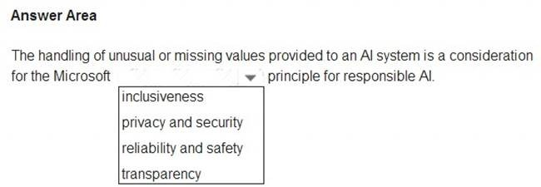

1. Mastered
2. Not Mastered

## Answer: **A**

**Explanation:**

Privacy and security.

As AI becomes more prevalent, protecting privacy and securing important personal and business information is becoming more critical and complex. With AI, privacy and data security issues require especially close attention because access to data is essential for AI systems to make accurate and informed predictions and decisions about people. AI systems must comply with privacy laws that require transparency about the collection, use, and storage of data and mandate that consumers have appropriate controls to choose how their data is used. At Microsoft, we are continuing to research privacy and security breakthroughs (see next unit) and invest in robust compliance processes to ensure that data collected and used by our AI systems is handled responsibly.

Reference:

https://docs.microsoft.com/en-us/learn/modules/responsible-ai-principles/4-guiding-principles

## NEW QUESTION 5

* (Exam Topic 1)

You build a machine learning model by using the automated machine learning user interface (UI). You need to ensure that the model meets the Microsoft transparency principle for responsible AI. What should you do?

1. Set Validation type to Auto.
2. Enable Explain best model.
3. Set Primary metric to accuracy.
4. Set Max concurrent iterations to 0.

## Answer: **B**

**Explanation:**

Model Explain Ability.

Most businesses run on trust and being able to open the ML “black box” helps build transparency and trust. In heavily regulated industries like healthcare and banking, it is critical to comply with regulations and best practices. One key aspect of this is understanding the relationship between input variables (features) and model output. Knowing both the magnitude and direction of the impact each feature (feature importance) has on the predicted value helps better understand and explain the model. With model explain ability, we enable you to understand feature importance as part of automated ML runs.

Reference:

https://azure.microsoft.com/en-us/blog/new-automated-machine-learning-capabilities-in-azure-machine-learning

## NEW QUESTION 6

* (Exam Topic 1)

To complete the sentence, select the appropriate option in the answer area.

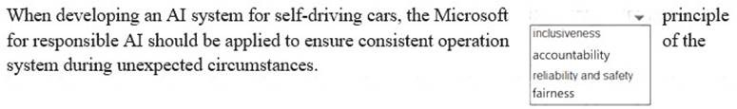

1. Mastered
2. Not Mastered

## Answer: **A**

**Explanation:**

Reliability and safety: To build trust, it's critical that AI systems operate reliably, safely, and consistently under normal circumstances and in unexpected conditions. These systems should be able to operate as they were originally designed, respond safely to unanticipated conditions, and resist harmful manipulation.

Reference:

https://docs.microsoft.com/en-us/learn/modules/responsible-ai-principles/4-guiding-principles

## NEW QUESTION 7

* (Exam Topic 1)

Match the Microsoft guiding principles for responsible AI to the appropriate descriptions.

To answer, drag the appropriate principle from the column on the left to its description on the right. Each principle may be used once, more than once, or not at all. NOTE: Each correct selection is worth one point.

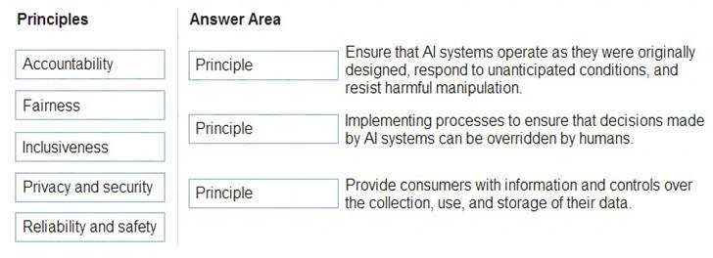

1. Mastered
2. Not Mastered

## Answer: **A**

**Explanation:**

Box 1: Reliability and safety

To build trust, it's critical that AI systems operate reliably, safely, and consistently under normal circumstances and in unexpected conditions. These systems should be able to operate as they were originally designed, respond safely to unanticipated conditions, and resist harmful manipulation.

Box 2: Fairness

Fairness: AI systems should treat everyone fairly and avoid affecting similarly situated groups of people in different ways. For example, when AI systems provide guidance on medical treatment, loan applications, or employment, they should make the same recommendations to everyone with similar symptoms, financial circumstances, or professional qualifications.

We believe that mitigating bias starts with people understanding the implications and limitations of AI predictions and recommendations. Ultimately, people should supplement AI decisions with sound human judgment and be held accountable for consequential decisions that affect others.

Box 3: Privacy and security

As AI becomes more prevalent, protecting privacy and securing important personal and business information is becoming more critical and complex. With AI, privacy and data security issues require especially close attention because access to data is essential for AI systems to make accurate and informed predictions and decisions about people. AI systems must comply with privacy laws that require transparency about the collection, use, and storage of data and mandate that consumers have appropriate controls to choose how their data is used

Reference:

https://docs.microsoft.com/en-us/learn/modules/responsible-ai-principles/4-guiding-principles

## NEW QUESTION 8

* (Exam Topic 1)

What are three Microsoft guiding principles for responsible AI? Each correct answer presents a complete solution. NOTE: Each correct selection is worth one point.

1. knowledgeability
2. decisiveness
3. inclusiveness
4. fairness
5. opinionatedness
6. reliability and safety

**Answer:** CDF

## Explanation:

Reference:

https://docs.microsoft.com/en-us/learn/modules/responsible-ai-principles/4-guiding-principles

## NEW QUESTION 9

* (Exam Topic 1)

Match the types of AI workloads to the appropriate scenarios.

To answer, drag the appropriate workload type from the column on the left to its scenario on the right. Each workload type may be used once, more than once, or not at all.

NOTE: Each correct selection is worth one point.



1. Mastered
2. Not Mastered

## Answer: **A**

**Explanation:**

Box 3: Natural language processing

Natural language processing (NLP) is used for tasks such as sentiment analysis, topic detection, language detection, key phrase extraction, and document categorization.

Reference:

https://docs.microsoft.com/en-us/azure/architecture/data-guide/technology-choices/natural-language-processing

## NEW QUESTION 10

* (Exam Topic 2)

For each of the following statements, select Yes if the statement is true. Otherwise, select No. NOTE: Each correct selection is worth one point.

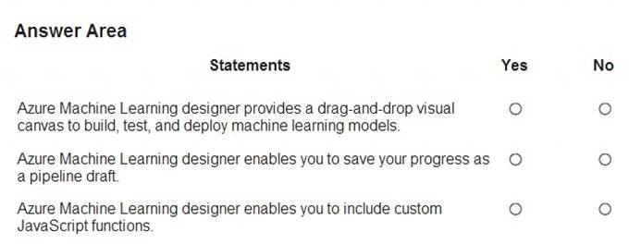

1. Mastered
2. Not Mastered

## Answer: **A**

**Explanation:**

Box 1: Yes

Azure Machine Learning designer lets you visually connect datasets and modules on an interactive canvas to create machine learning models. Box 2: Yes

With the designer you can connect the modules to create a pipeline draft.

As you edit a pipeline in the designer, your progress is saved as a pipeline draft. Box 3: No Reference:

https://docs.microsoft.com/en-us/azure/machine-learning/concept-designer

## NEW QUESTION 10

* (Exam Topic 2)

Which type of machine learning should you use to predict the number of gift cards that will be sold next month?

1. classification
2. regression
3. clustering

## Answer: **C**

**Explanation:**

Clustering, in machine learning, is a method of grouping data points into similar clusters. It is also called segmentation.

Over the years, many clustering algorithms have been developed. Almost all clustering algorithms use the features of individual items to find similar items. For example, you might apply clustering to find similar people by demographics. You might use clustering with text analysis to group sentences with similar topics or sentiment.

Reference:

https://docs.microsoft.com/en-us/azure/machine-learning/studio-module-reference/machine-learning-initialize-m

## NEW QUESTION 15

* (Exam Topic 2)

To complete the sentence, select the appropriate option in the answer area.



1. Mastered
2. Not Mastered

## Answer: **A**

### NEW QUESTION 1

- (Exam Topic 1)

You are building an AI system.

Which task should you include to ensure that the service meets the Microsoft transparency principle for responsible AI?

1. Ensure that all visuals have an associated text that can be read by a screen reader.
2. Enable autoscaling to ensure that a service scales based on demand.
3. Provide documentation to help developers debug code.
4. Ensure that a training dataset is representative of the population.

### Answer: **C**

**Explanation:**

Reference:

https://docs.microsoft.com/en-us/learn/modules/responsible-ai-principles/4-guiding-principles

### NEW QUESTION 2

- (Exam Topic 1)

For a machine learning progress, how should you split data for training and evaluation?

1. Use features for training and labels for evaluation.
2. Randomly split the data into rows for training and rows for evaluation.
3. Use labels for training and features for evaluation.
4. Randomly split the data into columns for training and columns for evaluation.

### Answer: **D**

**Explanation:**

In Azure Machine Learning, the percentage split is the available technique to split the data. In this technique, random data of a given percentage will be split to train and test data.

Reference:

[https://www.sqlshack.com/prediction-in-azure-machine-learning/](http://www.sqlshack.com/prediction-in-azure-machine-learning/)

### NEW QUESTION 3

- (Exam Topic 1)

You run a charity event that involves posting photos of people wearing sunglasses on Twitter. You need to ensure that you only retweet photos that meet the following requirements: Include one or more faces.

Contain at least one person wearing sunglasses. What should you use to analyze the images?

1. the Verify operation in the Face service
2. the Detect operation in the Face service
3. the Describe Image operation in the Computer Vision service
4. the Analyze Image operation in the Computer Vision service

### Answer: **B**

**Explanation:**

Reference:

https://docs.microsoft.com/en-us/azure/cognitive-services/face/overview

### NEW QUESTION 4

- (Exam Topic 1)

To complete the sentence, select the appropriate option in the answer area.

1. Mastered
2. Not Mastered

### Answer: **A**

**Explanation:**

Reference:

https://docs.microsoft.com/en-us/azure/machine-learning/team-data-science-process/create-features

### NEW QUESTION 5

- (Exam Topic 1)

You build a machine learning model by using the automated machine learning user interface (UI). You need to ensure that the model meets the Microsoft transparency principle for responsible AI. What should you do?

1. Set Validation type to Auto.
2. Enable Explain best model.
3. Set Primary metric to accuracy.
4. Set Max concurrent iterations to 0.

### Answer: **B**

**Explanation:**

Model Explain Ability.

Most businesses run on trust and being able to open the ML “black box” helps build transparency and trust. In heavily regulated industries like healthcare and banking, it is critical to comply with regulations and best practices. One key aspect of this is understanding the relationship between input variables (features) and model output. Knowing both the magnitude and direction of the impact each feature (feature importance) has on the predicted value helps better understand and explain the model. With model explain ability, we enable you to understand feature importance as part of automated ML runs.

Reference:

https://azure.microsoft.com/en-us/blog/new-automated-machine-learning-capabilities-in-azure-machine-learning

### NEW QUESTION 6

- (Exam Topic 1)

Your company is exploring the use of voice recognition technologies in its smart home devices. The company wants to identify any barriers that might unintentionally leave out specific user groups.

This an example of which Microsoft guiding principle for responsible AI?

1. accountability
2. fairness
3. inclusiveness
4. privacy and security

### Answer: **C**

**Explanation:**

Reference:

https://docs.microsoft.com/en-us/learn/modules/responsible-ai-principles/4-guiding-principles

### NEW QUESTION 7

- (Exam Topic 2)

For each of the following statements, select Yes if the statement is true. Otherwise, select No. NOTE: Each correct selection is worth one point.

## NEW QUESTION 2

- (Exam Topic 1)

You run a charity event that involves posting photos of people wearing sunglasses on Twitter. You need to ensure that you only retweet photos that meet the following requirements: Include one or more faces.

Contain at least one person wearing sunglasses. What should you use to analyze the images?

1. the Verify operation in the Face service
2. the Detect operation in the Face service
3. the Describe Image operation in the Computer Vision service
4. the Analyze Image operation in the Computer Vision service

## Answer: **B**

**Explanation:**

Reference:

https://docs.microsoft.com/en-us/azure/cognitive-services/face/overview

## NEW QUESTION 3

- (Exam Topic 1)

Your company is exploring the use of voice recognition technologies in its smart home devices. The company wants to identify any barriers that might unintentionally leave out specific user groups.

This an example of which Microsoft guiding principle for responsible AI?

1. accountability
2. fairness
3. inclusiveness
4. privacy and security

## Answer: **C**

**Explanation:**

Reference:

https://docs.microsoft.com/en-us/learn/modules/responsible-ai-principles/4-guiding-principles

## NEW QUESTION 4

- (Exam Topic 1)

Match the Microsoft guiding principles for responsible AI to the appropriate descriptions.

To answer, drag the appropriate principle from the column on the left to its description on the right. Each principle may be used once, more than once, or not at all. NOTE: Each correct selection is worth one point.



1. Mastered
2. Not Mastered

## Answer: **A**

**Explanation:**

Box 1: Reliability and safety

To build trust, it's critical that AI systems operate reliably, safely, and consistently under normal circumstances and in unexpected conditions. These systems should be able to operate as they were originally designed, respond safely to unanticipated conditions, and resist harmful manipulation.

Box 2: Fairness

Fairness: AI systems should treat everyone fairly and avoid affecting similarly situated groups of people in different ways. For example, when AI systems provide guidance on medical treatment, loan applications, or employment, they should make the same recommendations to everyone with similar symptoms, financial circumstances, or professional qualifications.

We believe that mitigating bias starts with people understanding the implications and limitations of AI predictions and recommendations. Ultimately, people should supplement AI decisions with sound human judgment and be held accountable for consequential decisions that affect others.

Box 3: Privacy and security

As AI becomes more prevalent, protecting privacy and securing important personal and business information is becoming more critical and complex. With AI, privacy and data security issues require especially close attention because access to data is essential for AI systems to make accurate and informed predictions and decisions about people. AI systems must comply with privacy laws that require transparency about the collection, use, and storage of data and mandate that consumers have appropriate controls to choose how their data is used

Reference:

https://docs.microsoft.com/en-us/learn/modules/responsible-ai-principles/4-guiding-principles

## NEW QUESTION 5

- (Exam Topic 2)

For each of the following statements, select Yes if the statement is true. Otherwise, select No. NOTE: Each correct selection is worth one point.



1. Mastered
2. Not Mastered

## Answer: **A**

**Explanation:**

Box 1: Yes

Azure Machine Learning designer lets you visually connect datasets and modules on an interactive canvas to create machine learning models. Box 2: Yes

With the designer you can connect the modules to create a pipeline draft.

As you edit a pipeline in the designer, your progress is saved as a pipeline draft. Box 3: No Reference:

https://docs.microsoft.com/en-us/azure/machine-learning/concept-designer

## NEW QUESTION 6

- (Exam Topic 2)

Which metric can you use to evaluate a classification model?

1. true positive rate
2. mean absolute error (MAE)
3. coefficient of determination (R2)
4. root mean squared error (RMSE)

## Answer: **A**

**Explanation:**

What does a good model look like?

An ROC curve that approaches the top left corner with 100% true positive rate and 0% false positive rate will be the best model. A random model would display as a flat line from the bottom left to the top right corner. Worse than random would dip below the y=x line.

Reference:

https://docs.microsoft.com/en-us/azure/machine-learning/how-to-understand-automated-ml#classification

## NEW QUESTION 7

- (Exam Topic 2)

Which type of machine learning should you use to predict the number of gift cards that will be sold next month?

1. classification
2. regression
3. clustering

## Answer: **C**

**Explanation:**

Clustering, in machine learning, is a method of grouping data points into similar clusters. It is also called segmentation.

Over the years, many clustering algorithms have been developed. Almost all clustering algorithms use the features of individual items to find similar items. For example, you might apply clustering to find similar people by demographics. You might use clustering with text analysis to group sentences with similar topics or sentiment.

Reference:

https://docs.microsoft.com/en-us/azure/machine-learning/studio-module-reference/machine-learning-initialize-m

## NEW QUESTION 8

- (Exam Topic 2)

You use Azure Machine Learning designer to publish an inference pipeline.

Which two parameters should you use to consume the pipeline? Each correct answer presents part of the solution. NOTE: Each correct selection is worth one point.

1. the model name
2. the training endpoint
3. the authentication key
4. the REST endpoint

## Answer: **AD**

1. Mastered
2. Not Mastered

### Answer: **A**

**Explanation:**

Box 1: Yes

Azure Machine Learning designer lets you visually connect datasets and modules on an interactive canvas to create machine learning models. Box 2: Yes

You are designing an AI system that empowers everyone, including people who have hearing, visual, and other impairments. This is an example of which Microsoft guiding principle for responsible AI?

1. fairness
2. inclusiveness
3. reliability and safety
4. accountability

## Answer: **B**

**Explanation:**

Inclusiveness: At Microsoft, we firmly believe everyone should benefit from intelligent technology, meaning it must incorporate and address a broad range of human needs and experiences. For the 1 billion people with disabilities around the world, AI technologies can be a game-changer.

Reference:

https://docs.microsoft.com/en-us/learn/modules/responsible-ai-principles/4-guiding-principles

## NEW QUESTION 2

- (Exam Topic 1)

You are building an AI system.

Which task should you include to ensure that the service meets the Microsoft transparency principle for responsible AI?

1. Ensure that all visuals have an associated text that can be read by a screen reader.
2. Enable autoscaling to ensure that a service scales based on demand.
3. Provide documentation to help developers debug code.
4. Ensure that a training dataset is representative of the population.

## Answer: **C**

**Explanation:**

Reference:

https://docs.microsoft.com/en-us/learn/modules/responsible-ai-principles/4-guiding-principles

## NEW QUESTION 3

* (Exam Topic 1)

A company employs a team of customer service agents to provide telephone and email support to customers. The company develops a webchat bot to provide automated answers to common customer queries.

Which business benefit should the company expect as a result of creating the webchat bot solution?

1. increased sales
2. a reduced workload for the customer service agents
3. improved product reliability

## Answer: **B**

**NEW QUESTION 4**

* (Exam Topic 1)

To complete the sentence, select the appropriate option in the answer area.



1. Mastered
2. Not Mastered

## Answer: **A**

**Explanation:**

Reference:

https://docs.microsoft.com/en-us/azure/machine-learning/team-data-science-process/create-features

## NEW QUESTION 5

* (Exam Topic 1)

You build a machine learning model by using the automated machine learning user interface (UI). You need to ensure that the model meets the Microsoft transparency principle for responsible AI. What should you do?

1. Set Validation type to Auto.
2. Enable Explain best model.
3. Set Primary metric to accuracy.
4. Set Max concurrent iterations to 0.

## Answer: **B**

**Explanation:**

Model Explain Ability.

Most businesses run on trust and being able to open the ML “black box” helps build transparency and trust. In heavily regulated industries like healthcare and banking, it is critical to comply with regulations and best practices. One key aspect of this is understanding the relationship between input variables (features) and model output. Knowing both the magnitude and direction of the impact each feature (feature importance) has on the predicted value helps better understand and explain the model. With model explain ability, we enable you to understand feature importance as part of automated ML runs.

Reference:

https://azure.microsoft.com/en-us/blog/new-automated-machine-learning-capabilities-in-azure-machine-learning

## NEW QUESTION 6

* (Exam Topic 1)

To complete the sentence, select the appropriate option in the answer area.



1. Mastered
2. Not Mastered

## Answer: **A**

**Explanation:**

Reliability and safety: To build trust, it's critical that AI systems operate reliably, safely, and consistently under normal circumstances and in unexpected conditions. These systems should be able to operate as they were originally designed, respond safely to unanticipated conditions, and resist harmful manipulation.

Reference:

https://docs.microsoft.com/en-us/learn/modules/responsible-ai-principles/4-guiding-principles

## NEW QUESTION 7

* (Exam Topic 1)

For each of the following statements, select Yes if the statement is true. Otherwise, select No. NOTE: Each correct selection is worth one point.

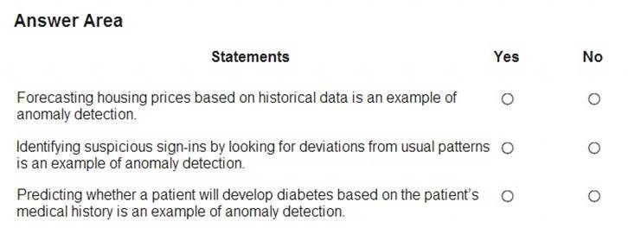

1. Mastered
2. Not Mastered

## Answer: **A**

**Explanation:**

Box 1: No

Box 2: Yes

Box 3: Yes

Anomaly detection encompasses many important tasks in machine learning: Identifying transactions that are potentially fraudulent. Learning patterns that indicate that a network intrusion has occurred. Finding abnormal clusters of patients.

Checking values entered into a system. Reference:

https://docs.microsoft.com/en-us/azure/machine-learning/studio-module-reference/anomaly-detection

## NEW QUESTION 8

* (Exam Topic 1)

To complete the sentence, select the appropriate option in the answer area.

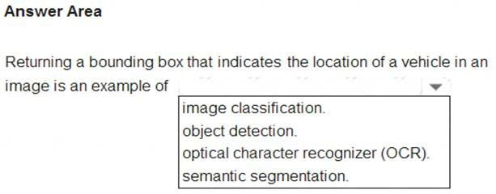

1. Mastered
2. Not Mastered

## Answer: **A**

**Explanation:**

Reference:

https://docs.microsoft.com/en-us/azure/cognitive-services/computer-vision/concept-object-detection

## NEW QUESTION 9

* (Exam Topic 1)

What are three Microsoft guiding principles for responsible AI? Each correct answer presents a complete solution. NOTE: Each correct selection is worth one point.

1. knowledgeability
2. decisiveness
3. inclusiveness
4. fairness
5. opinionatedness
6. reliability and safety

**Answer:** CDF

## Explanation:

Reference:

https://docs.microsoft.com/en-us/learn/modules/responsible-ai-principles/4-guiding-principles

## NEW QUESTION 10

* (Exam Topic 1)

Match the types of AI workloads to the appropriate scenarios.

To answer, drag the appropriate workload type from the column on the left to its scenario on the right. Each workload type may be used once, more than once, or not at all.

NOTE: Each correct selection is worth one point.

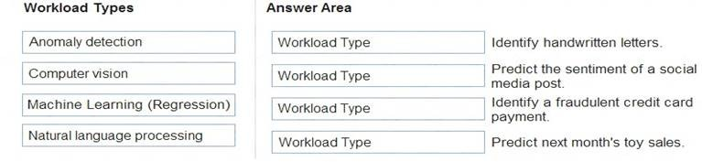

1. Mastered
2. Not Mastered

## Answer: **A**

**Explanation:**

Reference:

https://docs.microsoft.com/en-us/learn/paths/get-started-with-artificial-intelligence-on-azure/

## NEW QUESTION 10

* (Exam Topic 2)

Which two components can you drag onto a canvas in Azure Machine Learning designer? Each correct answer presents a complete solution. NOTE: Each correct selection is worth one point.

- (Exam Topic 1)

You run a charity event that involves posting photos of people wearing sunglasses on Twitter. You need to ensure that you only retweet photos that meet the following requirements: Include one or more faces.

Contain at least one person wearing sunglasses. What should you use to analyze the images?

1. the Verify operation in the Face service
2. the Detect operation in the Face service
3. the Describe Image operation in the Computer Vision service
4. the Analyze Image operation in the Computer Vision service

### Answer: **B**

**Explanation:**

Reference:

https://docs.microsoft.com/en-us/azure/cognitive-services/face/overview

### NEW QUESTION 2

- (Exam Topic 1)

To complete the sentence, select the appropriate option in the answer area.

1. Mastered
2. Not Mastered

### Answer: **A**

**Explanation:**

Privacy and security.

As AI becomes more prevalent, protecting privacy and securing important personal and business information is becoming more critical and complex. With AI, privacy and data security issues require especially close attention because access to data is essential for AI systems to make accurate and informed predictions and decisions about people. AI systems must comply with privacy laws that require transparency about the collection, use, and storage of data and mandate that consumers have appropriate controls to choose how their data is used. At Microsoft, we are continuing to research privacy and security breakthroughs (see next unit) and invest in robust compliance processes to ensure that data collected and used by our AI systems is handled responsibly.

Reference:

https://docs.microsoft.com/en-us/learn/modules/responsible-ai-principles/4-guiding-principles

### NEW QUESTION 3

- (Exam Topic 1)

You build a machine learning model by using the automated machine learning user interface (UI). You need to ensure that the model meets the Microsoft transparency principle for responsible AI. What should you do?

1. Set Validation type to Auto.
2. Enable Explain best model.
3. Set Primary metric to accuracy.
4. Set Max concurrent iterations to 0.

### Answer: **B**

**Explanation:**

Model Explain Ability.

Most businesses run on trust and being able to open the ML “black box” helps build transparency and trust. In heavily regulated industries like healthcare and banking, it is critical to comply with regulations and best practices. One key aspect of this is understanding the relationship between input variables (features) and model output. Knowing both the magnitude and direction of the impact each feature (feature importance) has on the predicted value helps better understand and explain the model. With model explain ability, we enable you to understand feature importance as part of automated ML runs.

Reference:

https://azure.microsoft.com/en-us/blog/new-automated-machine-learning-capabilities-in-azure-machine-learning

### NEW QUESTION 4

- (Exam Topic 1)

Match the Microsoft guiding principles for responsible AI to the appropriate descriptions.

To answer, drag the appropriate principle from the column on the left to its description on the right. Each principle may be used once, more than once, or not at all. NOTE: Each correct selection is worth one point.

1. Mastered
2. Not Mastered

### Answer: **A**

**Explanation:**

Box 1: Reliability and safety

To build trust, it's critical that AI systems operate reliably, safely, and consistently under normal circumstances and in unexpected conditions. These systems should be able to operate as they were originally designed, respond safely to unanticipated conditions, and resist harmful manipulation.

Box 2: Fairness

Fairness: AI systems should treat everyone fairly and avoid affecting similarly situated groups of people in different ways. For example, when AI systems provide guidance on medical treatment, loan applications, or employment, they should make the same recommendations to everyone with similar symptoms, financial circumstances, or professional qualifications.

We believe that mitigating bias starts with people understanding the implications and limitations of AI predictions and recommendations. Ultimately, people should supplement AI decisions with sound human judgment and be held accountable for consequential decisions that affect others.

Box 3: Privacy and security

As AI becomes more prevalent, protecting privacy and securing important personal and business information is becoming more critical and complex. With AI, privacy and data security issues require especially close attention because access to data is essential for AI systems to make accurate and informed predictions and decisions about people. AI systems must comply with privacy laws that require transparency about the collection, use, and storage of data and mandate that consumers have appropriate controls to choose how their data is used

Reference:

https://docs.microsoft.com/en-us/learn/modules/responsible-ai-principles/4-guiding-principles

### NEW QUESTION 5

- (Exam Topic 1)

To complete the sentence, select the appropriate option in the answer area.

1. Mastered
2. Not Mastered

### Answer: **A**

**Explanation:**

Reference:

https://docs.microsoft.com/en-us/azure/cognitive-services/computer-vision/concept-object-detection

### NEW QUESTION 6

- (Exam Topic 1)

You are developing a model to predict events by using classification.

You have a confusion matrix for the model scored on test data as shown in the following exhibit.

Use the drop-down menus to select the answer choice that completes each statement based on the information presented in the graphic. NOTE: Each correct selection is worth one point.

1. Mastered
2. Not Mastered

### Answer: **A**

**Explanation:**

Box 1: 11

TP = True Positive.

The class labels in the training set can take on only two possible values, which we usually refer to as positive or negative. The positive and negative instances that a classifier predicts correctly are called true positives (TP) and true negatives (TN), respectively. Similarly, the incorrectly classified instances are called false positives (FP) and false negatives (FN).

Box 2: 1,033

FN = False Negative Reference:

https://docs.microsoft.com/en-us/azure/machine-learning/studio/evaluate-model-performance

### NEW QUESTION 7

- (Exam Topic 2)

For each of the following statements, select Yes if the statement is true. Otherwise, select No. NOTE: Each correct selection is worth one point.

1. Mastered
2. Not Mastered

### Answer: **A**

**Explanation:**

Box 1: Yes

Azure Machine Learning designer lets you visually connect datasets and modules on an interactive canvas to create machine learning models. Box 2: Yes

With the designer you can connect the modules to create a pipeline draft.

As you edit a pipeline in the designer, your progress is saved as a pipeline draft. Box 3: No Reference:

https://docs.microsoft.com/en-us/azure/machine-learning/concept-designer

### NEW QUESTION 8

- (Exam Topic 2)

Which metric can you use to evaluate a classification model?

1. true positive rate
2. mean absolute error (MAE)
3. coefficient of determination (R2)
4. root mean squared error (RMSE)

### Answer: **A**

**Explanation:**

What does a good model look like?

An ROC curve that approaches the top left corner with 100% true positive rate and 0% false positive rate will be the best model. A random model would display as a flat line from the bottom left to the top right corner. Worse than random would dip below the y=x line.

Reference:

https://docs.microsoft.com/en-us/azure/machine-learning/how-to-understand-automated-ml#classification

### NEW QUESTION 9

- (Exam Topic 2)

Which type of machine learning should you use to predict the number of gift cards that will be sold next month?

1. classification
2. regression
3. clustering

### Answer: **C**

**Explanation:**

Clustering, in machine learning, is a method of grouping data points into similar clusters. It is also called segmentation.

ver the years, many clustering algorithms have been developed. Almost all clustering algorithms use the features of individual items to find similar items. For example, you might apply clustering to find similar people by demographics. You might use clustering with text analysis to group sentences with similar topics or sentiment.

Reference:

https://docs.microsoft.com/en-us/azure/machine-learning/studio-module-reference/machine-learning-initialize-m

### NEW QUESTION 10

- (Exam Topic 2)

You need to predict the income range of a given customer by using the following dataset.

Which two fields should you use as features? Each correct answer presents a complete solution. NOTE: Each correct selection is worth one point.

1. Education Level
2. Last Name
3. Age
4. Income Range
5. First Name

### Answer: **AC**

**Explanation:**

First Name, Last Name, Age and Education Level are features. Income range is a label (what you want to predict). First Name and Last Name are irrelevant in that they have no bearing on income. Age and Education level are the features you should use.

### NEW QUESTION 10

- (Exam Topic 2)

To complete the sentence, select the appropriate option in the answer area.

1. Mastered
2. Not Mastered

### Answer: **A**

**Explanation:**

In the most basic sense, regression refers to prediction of a numeric target.

Example: Regression Model: A Boosted Decision Tree algorithm was used to create and train the model for predicting the repayment rate. Reference:

https://gallery.azure.ai/Experiment/Student-Loan-Repayment-Rate-Prediction

1. dataset
2. compute
3. pipeline
4. module

## Answer: **AD**

**Explanation:**

You can drag-and-drop datasets and modules onto the canvas. Reference:

https://docs.microsoft.com/en-us/azure/machine-learning/concept-designer

## NEW QUESTION 12

* (Exam Topic 2)

You need to predict the income range of a given customer by using the following dataset.



Which two fields should you use as features? Each correct answer presents a complete solution. NOTE: Each correct selection is worth one point.

1. Education Level
2. Last Name
3. Age
4. Income Range
5. First Name

## Answer: **AC**

**Explanation:**

First Name, Last Name, Age and Education Level are features. Income range is a label (what you want to predict). First Name and Last Name are irrelevant in that they have no bearing on income. Age and Education level are the features you should use.With the designer you can connect the modules to create a pipeline draft.

As you edit a pipeline in the designer, your progress is saved as a pipeline draft. Box 3: No Reference:

https://docs.microsoft.com/en-us/azure/machine-learning/concept-designer

### NEW QUESTION 8

- (Exam Topic 2)

Which metric can you use to evaluate a classification model?

1. true positive rate
2. mean absolute error (MAE)
3. coefficient of determination (R2)
4. root mean squared error (RMSE)

### Answer: **A**

**Explanation:**

What does a good model look like?

An ROC curve that approaches the top left corner with 100% true positive rate and 0% false positive rate will be the best model. A random model would display as a flat line from the bottom left to the top right corner. Worse than random would dip below the y=x line.

Reference:

https://docs.microsoft.com/en-us/azure/machine-learning/how-to-understand-automated-ml#classification

### NEW QUESTION 9

- (Exam Topic 2)

To complete the sentence, select the appropriate option in the answer area.

1. Mastered
2. Not Mastered

### Answer: **A**

**Explanation:**

In machine learning, if you have labeled data, that means your data is marked up, or annotated, to show the target, which is the answer you want your machine learning model to predict.

In general, data labeling can refer to tasks that include data tagging, annotation, classification, moderation, transcription, or processing. Reference:

[https://www.cloudfactory.com/data-labeling-guide](http://www.cloudfactory.com/data-labeling-guide)

### NEW QUESTION 10

- (Exam Topic 2)

You use Azure Machine Learning designer to publish an inference pipeline.

Which two parameters should you use to consume the pipeline? Each correct answer presents part of the solution. NOTE: Each correct selection is worth one point.

1. the model name
2. the training endpoint
3. the authentication key
4. the REST endpoint

### Answer: **AD**

**Explanation:**

A: The trained model is stored as a Dataset module in the module palette. You can find it under My Datasets. Azure Machine Learning designer lets you visually connect datasets and modules on an interactive canvas to

create machine learning models.

D: You can consume a published pipeline in the Published pipelines page. Select a published pipeline and find the REST endpoint of it. Reference:

https://docs.microsoft.com/en-us/azure/machine-learning/how-to-run-batch-predictions-designer https://docs.microsoft.com/en-us/azure/machine-learning/concept- designer